**Class 3 Summer Term Newsletter**

**Miss Latham**

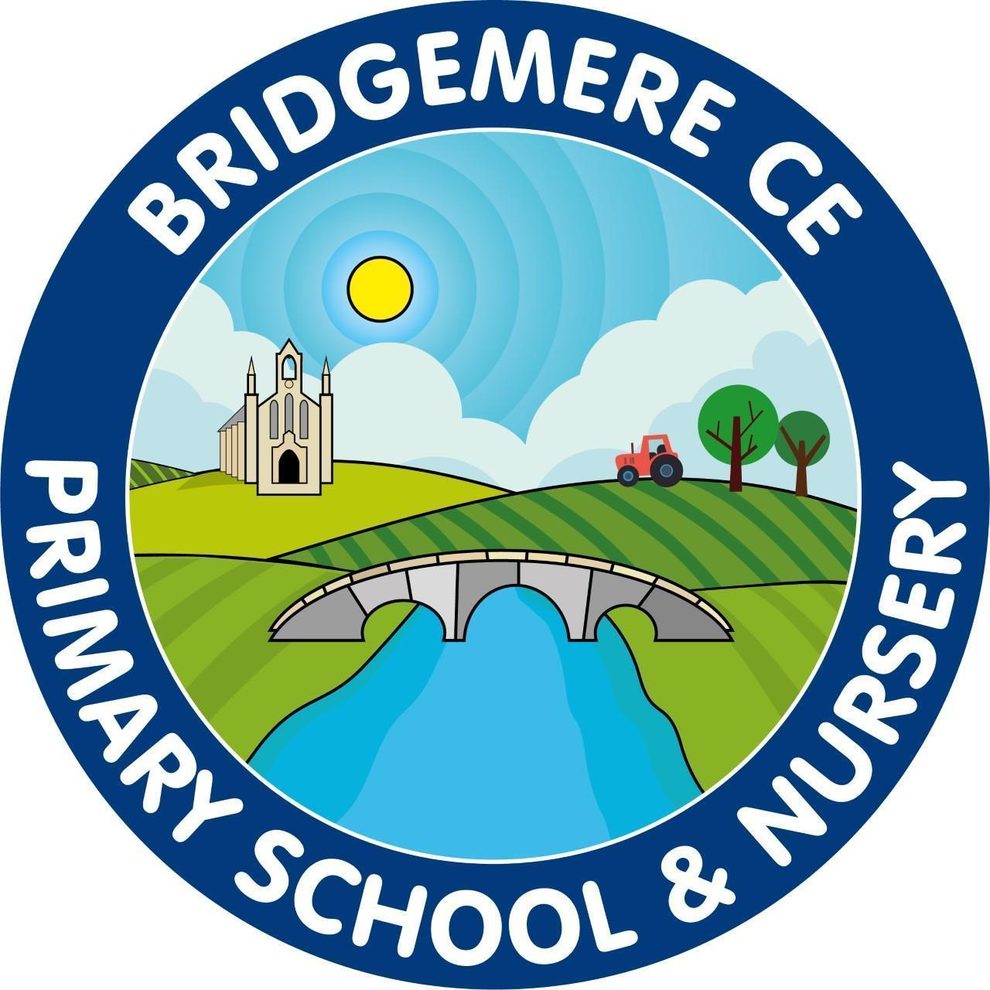

Dear Parents,

How time has flown! We’re already into the Summer term. I hope you’ve all had an enjoyable Easter break and had plenty of opportunities to relax.

**Reading**

In Class 3 we continue to use Accelerated Reader to maintain and enthuse our brilliant readers. This still requires your child to read every day for a minimum of 15 minutes as compulsory. When books are read and understood fully; even if this means reading smaller books twice, your child will complete an online comprehension test. We strive for your children to do their best, however, we do have an expectation of understanding a text with a minimum of 80% accuracy.

In Key Stage Two we love competition, so Class 3 are being encouraged to meet their reading targets for an end of the year reward. Alongside this, children who have 4-5 signatures for reading in their diary weekly, they receive 3 team points for their teams.

I must note that at the end of Spring term your children all showed improvements in their reading with many achieving improved reading scores. However, few met their expected targets. Therefore, in KS2 we will be getting firmer with children who are not reading at home and they will need to make this time up during the school day.

**English**

During our English learning this term we will focus on consolidating our grammatical language and skills when writing narrative and non-fictional written pieces. As a class, we continue to work on our handwriting and presentation as these can dramatically change our individual outcomes. Most children have taken this challenge on greatly and this shows within work.

**P.E**

PE lessons will continue to be on a Monday and Thursday for this half term. Please make sure your child has the appropriate PE kit when attending school on Thursdays (as the previous PE letter has noted). Our focus this term will be applying skills into athletics, tennis, rounders and cricket.

As last term, children will also have a forest school session at the end of each half term. This allows the children experiences and learning that they otherwise may not be able to have within our classroom environment.

Please make sure your child’s PE kit and school uniform are **clearly** labelled.

**Other learning**

This term our foundation learning will be ‘Europe’ followed by ‘Ancient Greece’ where we will practise our historical and geographical skills linking these to our previous knowledge and understanding of other countries and other ancient civilisations. We will look at significant events and timelines to further understand these monumental events. In Science we will be focusing on animals, including humans and using this knowledge to learn about our digestive system and our role in food chains. Lately we will look at electricity, using components to create circuits and better understand how electricity works. In RE we will look at churches, comparing churches around the world and learning about religious buildings related to world faiths.

**Wider Opportunities**

Again this year, we will welcome Kevin back to teach our children Music, in preparation for ‘Come and Play at the Halle’. Last year, the children thoroughly enjoyed these lessons and the trip to Manchester, so they asked if we could go again!

Further letters and consent forms will be given out after half term.

Dates for your diary for class 3:

* April 23rd Easter Bingo
* April 24th - Parent meeting - Year 4 times table check.
* May 19th Sports day - pm
* Week commencing June 9th - Year 4 times table check
* June 13th - Non-uniform day - ROCKSTARS
* June 17th - Come and play with the Halle
* July 21st - 23rd Residential
* July 30th SUMMER!

If you have any concerns or questions at all please use communication diaries as these will be checked daily or ring the office to arrange a meeting.

**Kind Regards**

Miss Latham