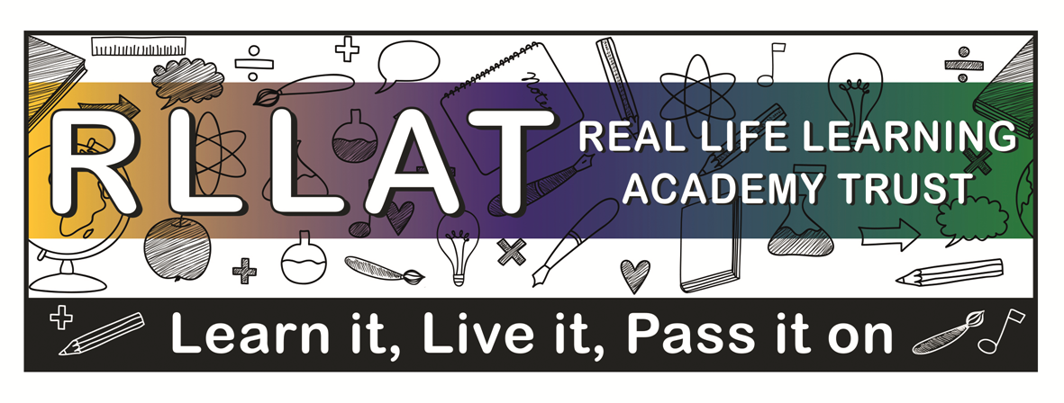

Year 5/6 – Summer Term 2
Topic to be covered: Globalcitizen@work
Music Focus – Composing and Listening

Vocabulary:

Minimalism
Syncopation
Pentatonic scale

People:
Steve Reich
Phillip Glass

Places:
West Coast of America
Events:

Knowledge:

Can children evaluate musical choices in performance and composition and justify them in appropriate musical vocabulary?
Can children understand that minimalism is a style that has affected many different types of expression in a range of media?
Do children understand where minimalism fits into the history of music?
Can they name other composers of this period and compare and contrast to Steve Reich?

Skills:

Can children compose rhythms and melodies in a minimalist style and structure these together in a musical form?
Can children compose and perform multiple layers or rhythms and melodies?
Can children maintain syncopated beats when playing with another performer?

