Bridgemere CE Primary - 2024  ‘I can do all things through Christ who strengthens me’  Philippians 4v13 Summer Term 202 20232023 |  |  | 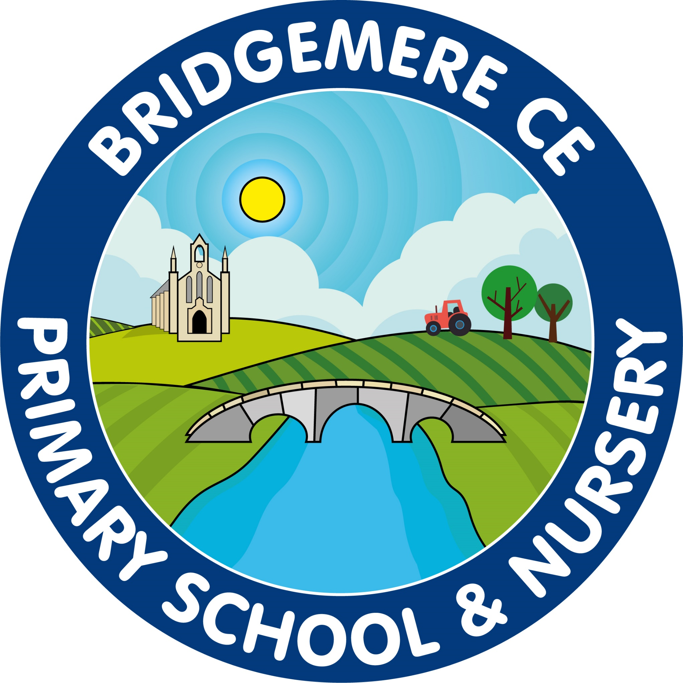
  As the next half term is so busy here is a list of dates for your notice board at home!    Week beginning 10th June  Year 1 Phonic Screening Test  Year 4 Timestable Test  Tuesday 11th June  Year 3 & 4 Mixed Football Competition 12-4pm  Thursday 13th June  Class 3 ‘Come and Play with the Halle’ Trip  Bridgewater Hall  Friday 14th June  FOB Fathers’ Day Stall 2.45pm  Monday 17th June  Town Sports – Field Events 5-7.30pm  Tuesday 18th June  Class 4 ‘Imperial War Museum’ Trip Salford  Wednesday 19th June  Stay & Play 9.00-10.15am in Class 1  Town Sports – Track Events 5-8pm  Monday 24th June  KS2 Cross Country – 3.30-5pm  Malbank School  Wednesday 26th – Thursday 27th June  Year 6 Brine Leas Transition Days  Year 1 & 2 – Cricket skills 10-12pm |   Monday 1st July  KS2 Cross Country - 3.30-5pm  Crewe Vagrants Sports Club  Wednesday 3rd July  Year 3 & 4 Diamond Cricket Competition  South Cheshire Collage 3.30-5.30pm  Monday 8th – Wednesday 10st July  KS2 Residential – Boreatton  Thursday 11th July  Year 6 Leavers’ Service  Chester Cathedral Service am  Tuesday 16th July  Year 6 Surprise Leavers’ Trip TBC  Wednesday 17th July  Summer term reports to go out  Thursday 18th & Friday 19th July  Class 2 – Residential Foxhowl Delamere  Friday 19th July  Stay & Play 9.00-10.15am in Class 1  Tuesday 23rd July  Bridgemere’s Clebration of Creativity  Meet the teacher – Class 2, 3 & 4 – 3.30pm  Thursday 25th July  Summer Fair – 3.15-5pm  Monday 29th July  Leavers’ Lunch  Leaver’s Service at school – 2pm  Parents Evening to discuss reports 3-5pm  Tuesday 30th July  Break up for summer holidays  As always, if you have any concerns or queries regarding your child’s education, please do not hesitate to contact me.  Caroline Middleton  Head Teacher

