Year 5/6 Spring Term Newsletter
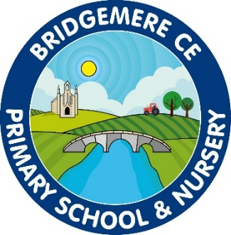
Dear Parents,
I hope that you have all had a lovely Christmas and a restful New Year and that you are looking forward to the year ahead. I am so excited to be back and the children have already made a great start over the first few days. I am sure it won’t be too long before they settle back into routine.

Curriculum
This half term we have a geography focus, we are looking at Northern and Central America. We will be investigating human and physical features of each of these countries as well as being able to name and locate the capital cities and be able to distinguish the difference between a country and a state.

Our English lessons this year will based on two fantastically immersive books, The Book of Lost Adventure by Teddy Keen and The Ways of the Wolf by Smriti Prasadam. The book we look at during Spring 1 will allow us to explore writing a survival guide and a survival narrative. During Spring 2 we will write a documentary narrative followed by a balanced argument.
Our class novel will be The Inheritance Games by Jennifer Lynn Barnes.

In Science our topic in Spring 1 is “Animals including humans”. As part of this topic we will be exploring the human life cycle from foetus to adulthood, as well as understanding the importance of having a healthy body and the role that the heart and blood play. We will also be exploring ‘Light’ in Spring 2 during this time we will be investigating how light travels and experimenting how we can make light bend and curve.
In RE we will be looking at why is the Exodus such a significant event in Jewish and Christian history? And Why do Christians celebrate the Eucharist? As well as exploring multi-faiths such as Judaism, Sikhism, Islam and Hinduism.

Times Tables
It is important that children are learning to recall their times tables at speed. They should be able to count up and back in their tables from 2 – 12. It is so important that they are practicing a set of tables every day to ensure that they have been fully embedded in their working memory. We test every week to see if we can improve our score.

Reading
Your child will need their reading diary in school every day. Please ensure that you record any reading that they do at home in their book. In school we shall ensure that they read for 20 minutes each day as well as a class novel and we are also asking for parents to do the same. Your child will under go a STAR reader test every three weeks, this will determine their target for the Spring Term. It is incredibly important that your child reads everyday as stays consistent with their reading book.

P.E
This term we will have P.E on a Tuesday and Friday. The children will be doing lots of different activities in PE. Please can your child have both their named inside and outside kits in school at all times. Children will be doing daily active 15minutes and will need their trainers in school at all times. Children may not wear any jewellery for P.E and if they have long hair please make sure it is tied back.

General
Please keep an eye on the class page of the school website for up-to-date information. I will also add any class letters I write onto there in case they get lost on the way home. Please also make sure that your child has a water bottle to bring into school each day.
If you have any concerns or questions about your child’s learning please book an appointment to speak to me through the school office. I am looking forward to the weather getting nicer and the nights being brighter.

Kind Regards
Mrs McGarrigle

