Real Life Learning Academy Trust
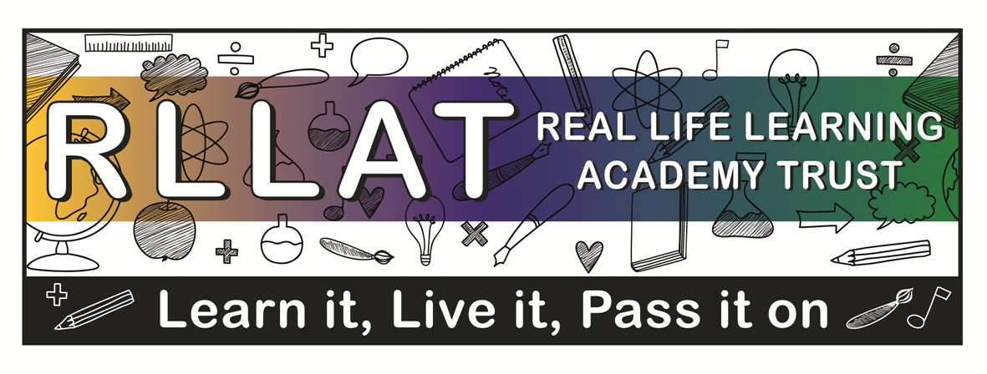
Singapore Maths 2018-19

Introduction:
Across the Real Life Learning Academy Trust, we aim for the children to leave school at the end of Key Stage two with a strong ability to perform a range of mathematical skills and use and apply them across a range of contexts. We achieve this by increasing the children’s number sense, alongside developpping their confdence and independence. A consistent and progressive approach to the teaching of mathematics, following the Singapore Maths approach, provides children with the opportutnity to encounter and dsicuss concepts - in depth. Children follow the CPA approach (contrete, pictorial and abstract) – which allows all learners to access mathematics in their own way, developping both accuracy and understanding, leading in turn to high quality reasoning and masters of mathematics.

Aims:
- Ensure all children in Key Stage 1 and 2 follow the Singapore Maths approach.
- Provide children with opportunities to apply and use maths across a range of different contexts- both within problem solving and real life.
- Ensure that children have a strong number sense through regular practise and consolidation of both times tables and mental calculation skills.
- Ensure that children read, write and use mathematical language with confidence.
- Provide consistent opportunity for children to reason mathimatically – both verbally and in written form.
- Provide a purpose and real life context for the mathematical skills being taught.
- Develop a love of learning for all learnerswithin each and every maths lesson.

Planning and delivery of maths:
Planning is based on the Singapore maths approach. All teachers have access to the online resources as well as textbooks and workbooks to support this.

The general guide for lessons is:
- Exploration (10 minutes)
- Structure (10 minutes)
- Journaling (10 minutes)
- Guided Practice (15 minutes)
- Independent (10 minutes)

All lessons should begin with an In Focus task, a problem that children complete, encouraging high-level thinking and reasoning. Significant time should be spent on this task and questioning should develop both reasoning and multiple ways of solving the same problem. Group/pair work should be encouraged at this stage. Children should be supported through the CPA approach. Decisions on differentiation are made by class teachers and teaching assistants – based on the individual needs of the children and concept being delivered.

Teaching should encourage finding multiple ways of finding an answer. Embracing this philosophy will enable children to choose methods that work best for them when solving problems independently. Children should then write their ideas and explanations for the problem within their Journals.

All children should progress onto Guided Practice, which should be completed with the teacher and class, as a model for the independent work.

Then, children progress onto their independent work in their workbooks. This should then be marked in green pen by the teacher. Teachers should place a tick and green dot by any question that is incorrect, and children given time to correct them. Blue pen can be used in workbooks and journals for corrections. Children should complete challenges in pencil to keep journals neat.

To extend pupils further, for instance, those children who finish their independent work quickly or to aid the structure for mixed age classes, teachers can use:Testbase, Mathsframe, NRICH or White Rose Maths hub resources to provide more in depth reasoning practise. These resources can also be used for occasional consolidation lessons, for concepts the children need more practise with before moving onto the next chapter.

All the objectives in the Singapore maths scheme must be taught for that year group- a long term overview with the objectives has been given to staff.

Throughout the year, Year 2 and Year 6 will have additional reasoning evidence in their journals, in preparation for their SATS in May.

There should also be opportunities to use mathematical skills in real life by extending maths across the curriculum – particularly in the area of science.
Presentation:
Teachers should have high expectations of presentation in the journals. They will be ticked to acknowledge they have been read and if there are misconceptions a (VS) verbal support or (T) for support in that session orthe next. Teachers can also use an (I) if a child has completed a specific question independently. Children can also be given mountain symbols if the teacher would like to challenge further within a lesson.

4/9/17
Journal 1:4 – Can I add groups together?
Problem: Sophie needs help adding 3 bunches of flowers together. How will I help her?

There should be evidence of Singapore maths every day in Journals and missed lessons need to be accounted for in the journal e.g. supply, trips etc. These can be written in by the children/teacher or a note placed inside by the teacher.
Children should not be writing out the problem and drawing/colouring pictures- they should already be printed out and stuck into the journals to promote neatness and provide them with enough learning time. They should be encouraged to underline with a ruler and write one number into each box.
Inclusion:
Use of the CPA approach enables access for all leaners on a daily basis. It is expected that, unless a child is significantly behind his/her peers, he/she will be accessing the same problem each day. Differentiation takes place through the CPA approach and the methods/explanations they discover.

Some children will have TA support during lessons. It is vitally important that they support learning and further question, rather than solve problems for the children. They shouldfeedback assessment information following each lesson.

Assessment:
Following each chapter there is a ‘review’ which needs to be completed independently by the child. This will then inform the teacher whether a child is meeting those objectives and achieving GD, expected or emerging. A greater depth child will be achieving the reviews with no errors and showing confidence with explanations/reasoning in their journals. The reviews will then aid staff to complete their assessment grids for each objective. There are also ‘Revision’ sections after a few chapters, which will also be a further way to assess the children, a few weeks after a section of work and to check their understanding.

