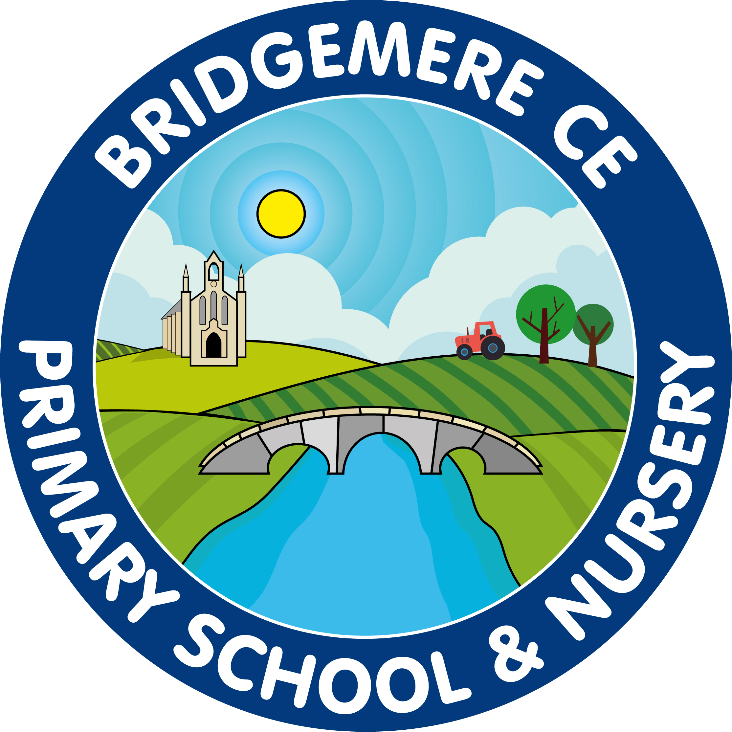
Bridgemere CE (Aided) Primary School
Bridgemere Lane, Bridgemere,
Nantwich, Cheshire, CW5 7PX

Head Teacher – Mrs Caroline Middleton
 | 01270 520271  admin@bridgemerece.cheshire.sch.uk  www.bridgemereschool.co.uk
31 July 2026

Dear Parents/carers,
It is my pleasure to welcome you to a new academic year at Bridgemere CE Primary and sincerely hope you have had a good break.

The current LA Covid guidelines for schools from September allows for a more normal start to the school year. The children will be able to move freely around school and also during play and dinnertimes. We will resume worship once again in the hall and dinnertimes will revert to normal with all children accessing the dinner hall at staggered times.
We will still be maintaining increased levels of cleaning throughout the day and the focus on hand washing and general hygiene will remain a priority.

School will reopen for children on Friday 3rd September 2021.

We will be continuing the drop off system in the morning from the times of 8.30-8.40am.
Registration will take place at 8.45am.

If you arrive at school after 8.40am and find the side gate closed please escort your child to the main entrance where they can go directly to their class. Your child will be marked down as late if they arrive in class after the register has closed.

The school day will finish for all children at 3.15pm.
Please continue to use the one-way system around the school to collect your child.
For safeguarding reasons, the side gate will be closed at 3.25pm.

If you find yourself running late either in the morning or for pick up, please inform the office.

Boost: After School Club and Breakfast Club
Boost will continue to run at the normal hours:
7.30am – 8.30am
3.15pm – 6.00pm
If using Breakfast and After School Club, please park in the parent’s car park and drop and collect your child/ren from the main entrance.

PE kit and other belongings
On Friday 3rd please can all children bring their PE kits into school. These will stay in school, unless there is an absolute need for it to be sent home. Please can all children also bring in a pair of wellington boots that can stay in school. Playtimes and dinnertimes may be on the field from time to time. I know we still have quite a few still left in school from summer term.

With regards to other items being brought into school, children should only fetch in a water bottle, lunch box and coat. We will be resuming hot snack at morning break but until we send out further information regarding what will be provided and the cost please feel free to send a small, healthy snack with your child each day.
As a healthy school please as parents can you encourage your child to only bring water to school in their water bottles. A drink of juice with a packed lunch or dinnertime is fine.
Children can, if they wish, fetch in a small school bag also. All other resources will be provided by school. Please do not send in any other items.

Responding to a symptomatic child
When a child or staff member develops symptoms compatible with coronavirus (COVID-19), they will be sent home and told to book to have a test to see if they have COVID-19.
Tests can be booked by visiting NHS.UK or by contacting NHS 119 via telephone.

Up until the results of the test are known the child or adult presenting with symptoms should self-isolate. Where the child or staff member tests negative they can then return to school.

Where the child tests positive the other members of the class do not need to self-isolate unless they then develop symptoms. As part of the national test and trace programme, if other cases are detected within the school, Public Health England’s local health protection teams will conduct a rapid investigation and will liaise with the Headteacher and advise the school on the most appropriate action to take. In some cases, a larger number of other children may be asked to self-isolate at home as a precautionary measure.

Government Guidance from August 16th 2021:
If staff or pupils have been in contact or live with someone who has tested positive:
- Those who are under-18 or who have been fully vaccinated at least two weeks before will no longer have to self-isolate.
- Those who are fully vaccinated will be asked by the app if they have received both jabs and if so will be advised – but not legally required – to take one PCR test as soon as possible to make sure they haven’t contracted the virus.
- If the test is negative, and they don’t develop symptoms, they won’t need to take another PCR test.
- Anyone who tests positive or develops symptoms will still need to self-isolate, regardless of their vaccination status.

Under no circumstances should you send any child with the following symptoms into school:

- A continuous cough
- A high temperature
- A loss of smell or taste

If your child presents with any of these symptoms, please book a test immediately and notify the school as soon as the result is known.

If you have travelled abroad over the holiday period children should not come into school and should quarantine if they have recently visited countries where testing and/or quarantine is required unless they are exempt.

Hygiene and Hand Washing
One of the best ways to mitigate against the contraction of Covid 19 is through increased hand washing. Children will be encouraged to wash their hands frequently for 20 seconds under running water at set points throughout the day. Increased cleaning will obviously be taking place and the school will using a fogger at the beginning of week to kill any lingering germs before the start of a new week. Children will also be encouraged to follow “catch it, bin it, kill it” approach. There will be tissues, sanitisation points and wipes available in all classrooms and children will continue their practice from the summer term.

School Attendance
Once again, we had an amazing 97.9% attendance in the summer term and I am optimistic we will have the same attendance this term. Well done to all those children who received a 100% attendance certificate in July, I shall look forward to presenting some more this coming December!

School Curriculum
On the return to school on Friday 3rd September, we will be continuing to deliver a rich and balanced curriculum. Each class will be embracing their ‘learning in context’ as they embark on new topics of interest. Please refer to the school website for details of your child’s learning on their class page.

Thank you to all the parents who completed our questionnaire back in the summer term. As you know, we endeavour to make our school the best it can be for all of our children so your feedback is invaluable.

I am looking forward to welcoming all the children back on Friday and being back together as a school. Please do not hesitate to contact me if you have any questions or queries regarding your child

Many thanks

Caroline Middleton

Headteacher

