Rationale for PSHE/RSE
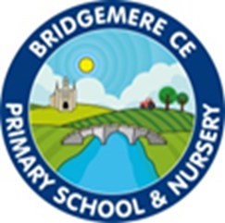
‘I can do all things through Christ who strengthens me' – Philippians 4v13

We have a vision for everyone at Bridgemere to be lifelong learners; trying their best, enduring tough times with hope and courage and being open to new experiences.
We believe that God helps us to grow, especially through challenges, we therefore value resilience. In order to flourish, we aim to support every child and adult with the diverse challenges of everyday life.

perseverance, creativity, trust, compassion, friendship, community, responsibility, thankfulness

Education that prepares for life today, and tomorrow.

What we teach in the classroom will help our pupils foster lifelong aspirations, goals and values.
With this in mind, PSHE education isn’t just another school subject. It’s a chance to give every child and young person an equal opportunity to develop the skills and knowledge they need to thrive now and in the future.
This includes helping them to deal with critical issues they face every day such as friendships, emotional wellbeing and change. And giving them a solid foundation for whatever challenging opportunities lie ahead, so they can face a world full of uncertainty with hope.
From making informed decisions about alcohol to succeeding in their first job, PSHE education helps pupils prepare for all the opportunities, challenges, life decisions and responsibilities they'll face.
This in turn achieves a 'virtuous circle', whereby pupils with better health and wellbeing can achieve better academically, and enjoy greater success.

RSE is about the emotional, social and cultural development of pupils, and involves learning about relationships, sexual health, sexuality, healthy lifestyles, diversity and personal identity.
RSE involves a combination of sharing information, and exploring issues and values.
RSE is not about the promotion of sexual activity.

