Rationale for Design & Technology
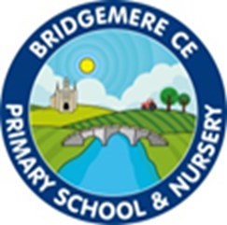
I can do all things through Christ who strengthens me' – Philippians 4v13

We have a vision for everyone at Bridgemere to be lifelong learners; trying their best, enduring tough times with hope and courage and being open to new experiences.
We believe that God helps us to grow, especially through challenges, we therefore value resilience. In order to flourish, we aim to support every child and adult with the diverse challenges of everyday life.

perseverance, creativity, trust, compassion, friendship, community, responsibility, thankfulness

‘Project on a Page’ – DT Association

The D&T Association is very aware of the priority that primary schools attach to children’s achievement in English and mathematics. The Cambridge Primary Review indicated that primary schools with a broad, balanced and well-managed curriculum often achieve the highest standards in these subjects at the end of Key Stage 2. The Review attributes this to the role of the broader curriculum in providing meaningful contexts for children to develop and apply their learning in these subjects. However, genuine breadth and balance requires depth and quality in the teaching and learning of each subject in the curriculum. Projects on a Page ensures that D&T makes a high-quality contribution to a broad and balanced primary curriculum, helping to raise standards in English and mathematics. Research suggests D&T is one of primary-aged children’s favourite subjects. Projects on a Page maximises their enjoyment by providing scope for teachers to meet children’s needs and interests through creative and motivating projects within a range of contexts.

