Rationale for Art
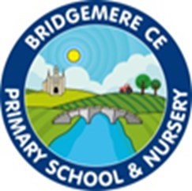
I can do all things through Christ who strengthens me' – Philippians 4v13

We have a vision for everyone at Bridgemere to be lifelong learners; trying their best, enduring tough times with hope and courage and being open to new experiences.
We believe that God helps us to grow, especially through challenges, we therefore value resilience. In order to flourish, we aim to support every child and adult with the diverse challenges of everyday life.

perseverance, creativity, trust, compassion, friendship, community, responsibility, thankfulness

Art education has been proven to have remarkable impacts on academic, social, and
emotional outcomes, helping us develop empathy as we learn more about societies, cultures and history. Engagement with art helps us stretch our minds beyond the boundaries of the printed text or the rules of what is provable to encompass visual spatial learning and develop motor skills.
Art at Bridgemere Primary School is taught through thematic units in a cross curricular approach. Through our art lessons, the children learn to express themselves confidently and creatively.
Inclusive learning experiences ensure that SEN children are fully supported to reach their potential. The opportunities provided will enable the children to create end products that they are proud of, and foster the resilience to hone and refine their skills. Children learn that inspiration can come in any form from the world around them.
In art, we learn about the mediums of collage, textiles, photography, drawing, painting, 3D form and sculpture, as well as mixed media.

