Bridgemere CE Primary Newsletter  ‘I can do all things through Christ who strengthens me’  Philippians 4v13 September 2022 |  |  | 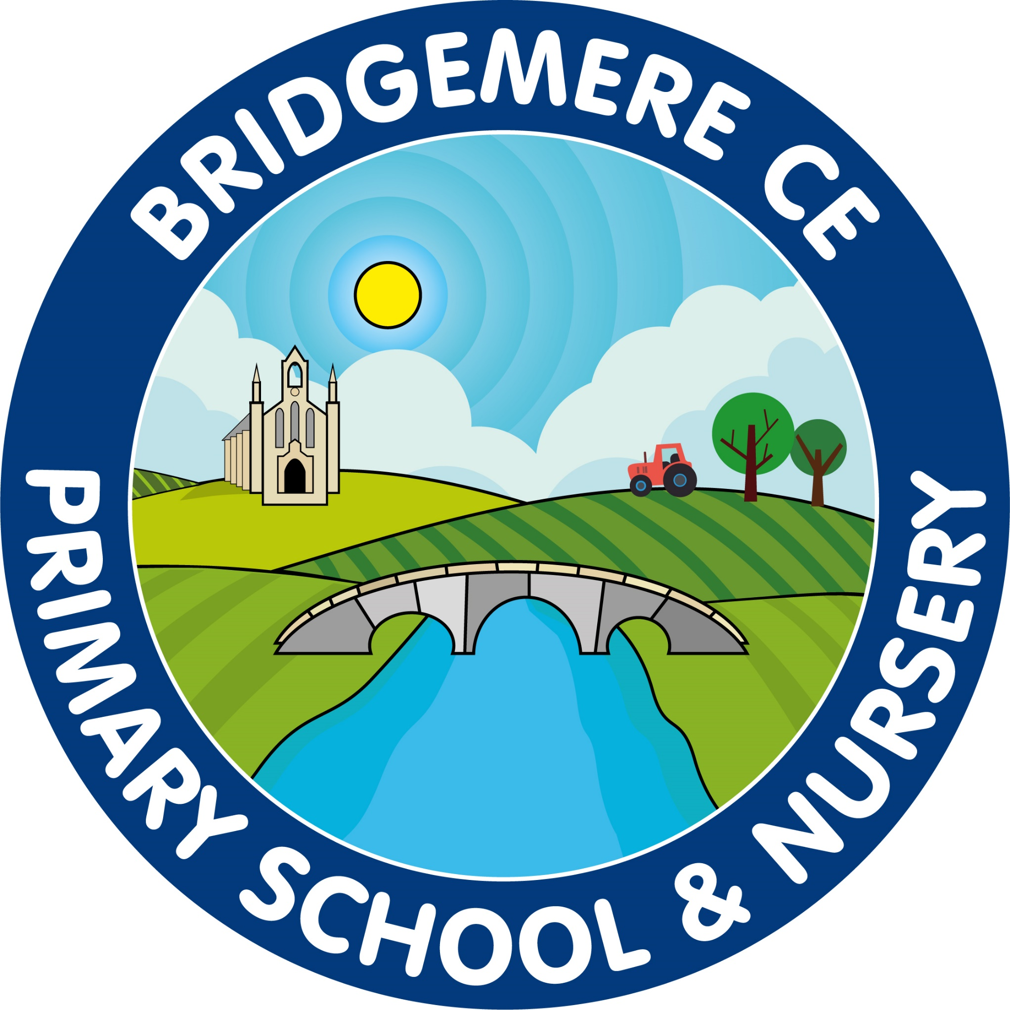  Dates coming up:  School opens  Monday 5th September  Clubs start – week beginning Monday 12th September  Monday 19th September- Class 3’s trip to Chester  Thursday 22nd September –  Academy school photos – individual and siblings  Thursday 20th October– Celebration of Learning – 3.00-3.30pm in classrooms  Friday 21st October – break up for half term  Monday 31st October – INSET Day  Tuesday 1st November – Children return to school
Welcome back…    Welcome back everyone and a special welcome to our new pupils and parents. It has been so lovely to see how well the children have settled into their new classes this week. They all look very smart in their new school uniforms and are ready to embrace the term ahead!  Congratulations….    to Mr Lyons who is expecting his first baby in January. This is lovely news for him and his wife Amy.  Friends of Bridgemere News  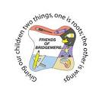  The winners of June's Lottery Club draw were 1st prize to Mrs Hak, 2nd Martin Brindley and 3rd to Carolyn Kinghorn. July's winners were 1st prize to Mrs Brenda Dale, 2nd Mrs Jarrett and 3rd to Mrs Driver and August's winners were 1st prize to Jon Furber, 2nd Susan Beck and 3rd to Keith Williamson. Thanks for all your support!    Our end of year Summer Fair raised a tremendous £520! A massive Thank You to everyone, who helped make it a great afternoon and attended.  Our Summer Raffle raised an additional £356! Thank you very much to all the local businesses who kindly donated raffle prizes.  We’ve excited to announce that FOB have contributed £3,000 towards the School’s new library and £896 towards the refurbished Class 1 outdoor area. | ‘Celebration of Learning’    There will be an opportunity at the end of this half term for your child to share their learning with you. It will take place in classrooms on Thursday 20th October 3.00-3.30pm. This will be extra to Parents’ Evening, which will take place the week beginning Monday 7th November. Once again, there will be the opportunity to have online appointment at Parents’ Evening so this Celebration of Learning would be a great chance to see children’s work.  Clubs  Clubs will start again the week beginning 12th September. Letters will go out this week with further information.  Madame Pritchard will continue to run ‘French Club’ on a Monday for KS1 and Wednesday for KS2. If there are any children who would like to begin one of these groups please email her –  frenchwithfaye@gmail.com  Mega Boost    Tuesday 13th September: ‘Come and make a fridge cake’  Tuesday 20th September: Construction Club  Tuesday 27th September: ‘Come and make a bird feeder’  Tuesday 4th October: Indoor games night  Tuesday 11th October: ‘Come and make a lava lamp’  Tuesday 18th October: Film night  Each session will cost £5.00. If a sibling also wishes to attend the same session this will be at a reduced cost of £4.50. Please note that if your child is not already attending Boost there will be a one off registration fee of £10 per family.  A letter has been sent home with the booking form attached.  As always, if you have any concerns or queries regarding your child’s education, please do not hesitate to contact me.  Caroline Middleton  Head Teacher

