Bridgemere CE Primary Newsletter  ‘I can do all things through Christ who strengthens me’  Philippians 4v13 October 2022 |  |  | 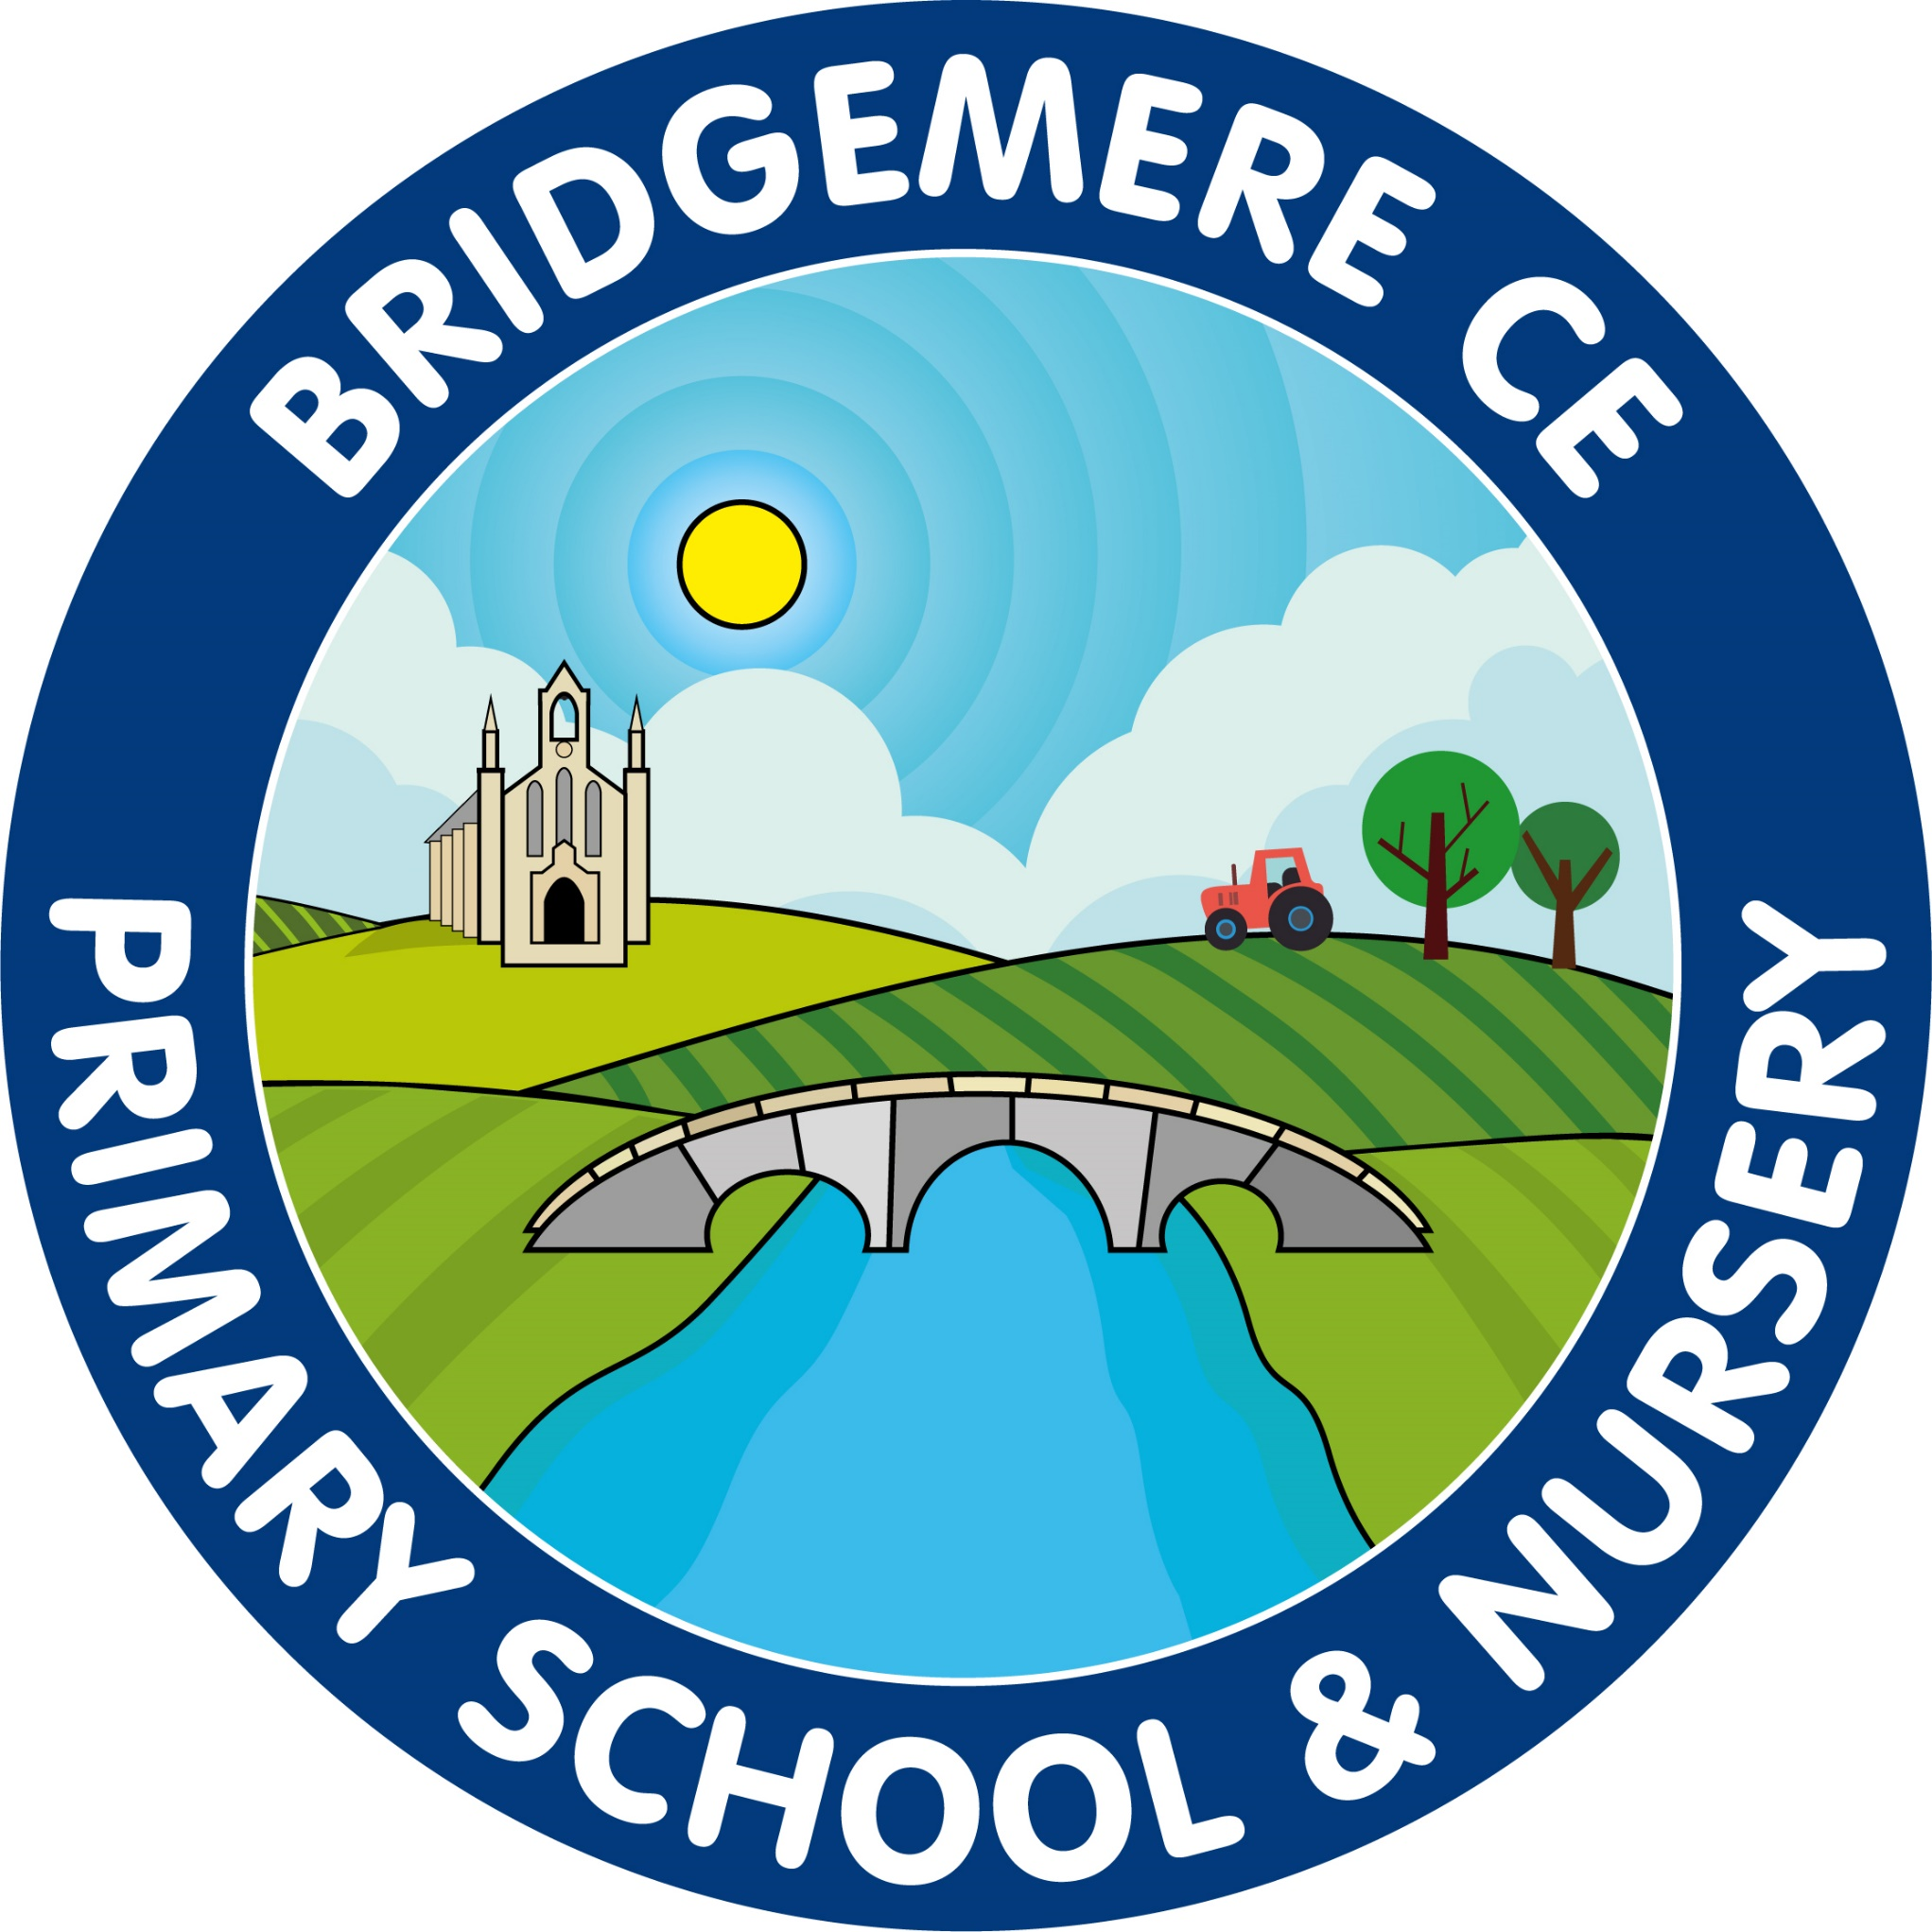  Dates coming up:  Tuesday 11th October-  Class 4 trip to Shrewsbury Prison  Wednesday 12th October – Harvest Service at St John’s Doddington 2pm  Thursday 20th October– Celebration of Learning – 3.00-3.30pm in classrooms  Friday 21st October – break up for half term  Monday 31st October – INSET Day  Tuesday 1st November – Children return to school  Tuesday 8th November – Parents’ Evening Remote / on-line meetings  4.00-6.00pm  Wednesday 9th November-  Face to face Parents’ Evening at school  3.30-7.00pm
Harvest Service    Our Harvest Service will take place on Wednesday 12th October at St John's Church - Doddington at 2pm. We would like to invite you to come and join out thanksgiving celebration.  We will be walking from school at 1.15pm and would love as many parents to accompany us through the Doddington Estate to St John's.  We will be collecting any food donations at school from Monday 10th October to Friday 14th to continue to support the Nantwich Foodbank. Caroline Brown the Community Liaison has been in touch and has specifically asked for the following donations for their wish list.  Cartons of Long Life Milk / Fruit Juice/  Biscuits, Chocolate & Sweet Treats  Jars of Pasta/Curry Sauce /Jam  Rice Pudding /Custard /Shampoo  Tinned Fruit /Shower Gel  We have recently been blessed with very generous donations of Pasta, Baked Beans and  Breakfast Cereal and as such these are not currently on our wish list.  I know that in past years you have always been so generous so thank you once again for supporting our local families in need.  On Friday 14th October our Head boy and Head girl will be delivering the donations to Nantwich Foodbank and finding out where the donations go.  Re-Roofing Works    Thank you for your continued support with the re-roofing of the main school building. This week the re-roofing has started. The contractors will be working through half term and hopefully will be completed by the 18th November.  Running Track    We are very pleased to announce that we are going to have a running track installed around our school field. This is something we have wanted to do for a long time and last year’s School Council were very keen for us to get this completed before the wet weather comes. Installation will being on 17th October, so that week will be very busy with contractors on site! | Head boy & Head girl    We are proud to announce that our new Head boy and Head girl for this academic year is Fraser and Claudia.    Head of the School Council this academic year:  Oscar & Max  Class Representatives:  Class 4:Paxton & Marnie  Class 3:Sebastian & Isla  Class 2:Tabitha & William  Class 1: Jordaina & Louie  Ethos Council    Class 4: Alfie & Molly  Class 3:Camille & Ava  Class 2:Jack & Nancy  Class 1: Joshua & Annie  ‘Celebration of Learning’    There will be an opportunity at the end of this half term for your child to share their learning with you. It will take place in classrooms on Thursday 20th October 3.00-3.30pm. This will be extra to Parents’ Evening, which will take place the week beginning Monday 7th November. Once again, there will be the opportunity to have online appointment at Parents’ Evening so this Celebration of Learning would be a great chance to see children’s work.  As always, if you have any concerns or queries regarding your child’s education, please do not hesitate to contact me.  Caroline Middleton  Head Teacher

