Bridgemere CE Primary Newsletter  ‘I can do all things through Christ who strengthens me’  Philippians 4v13 November 2022 |  |  | 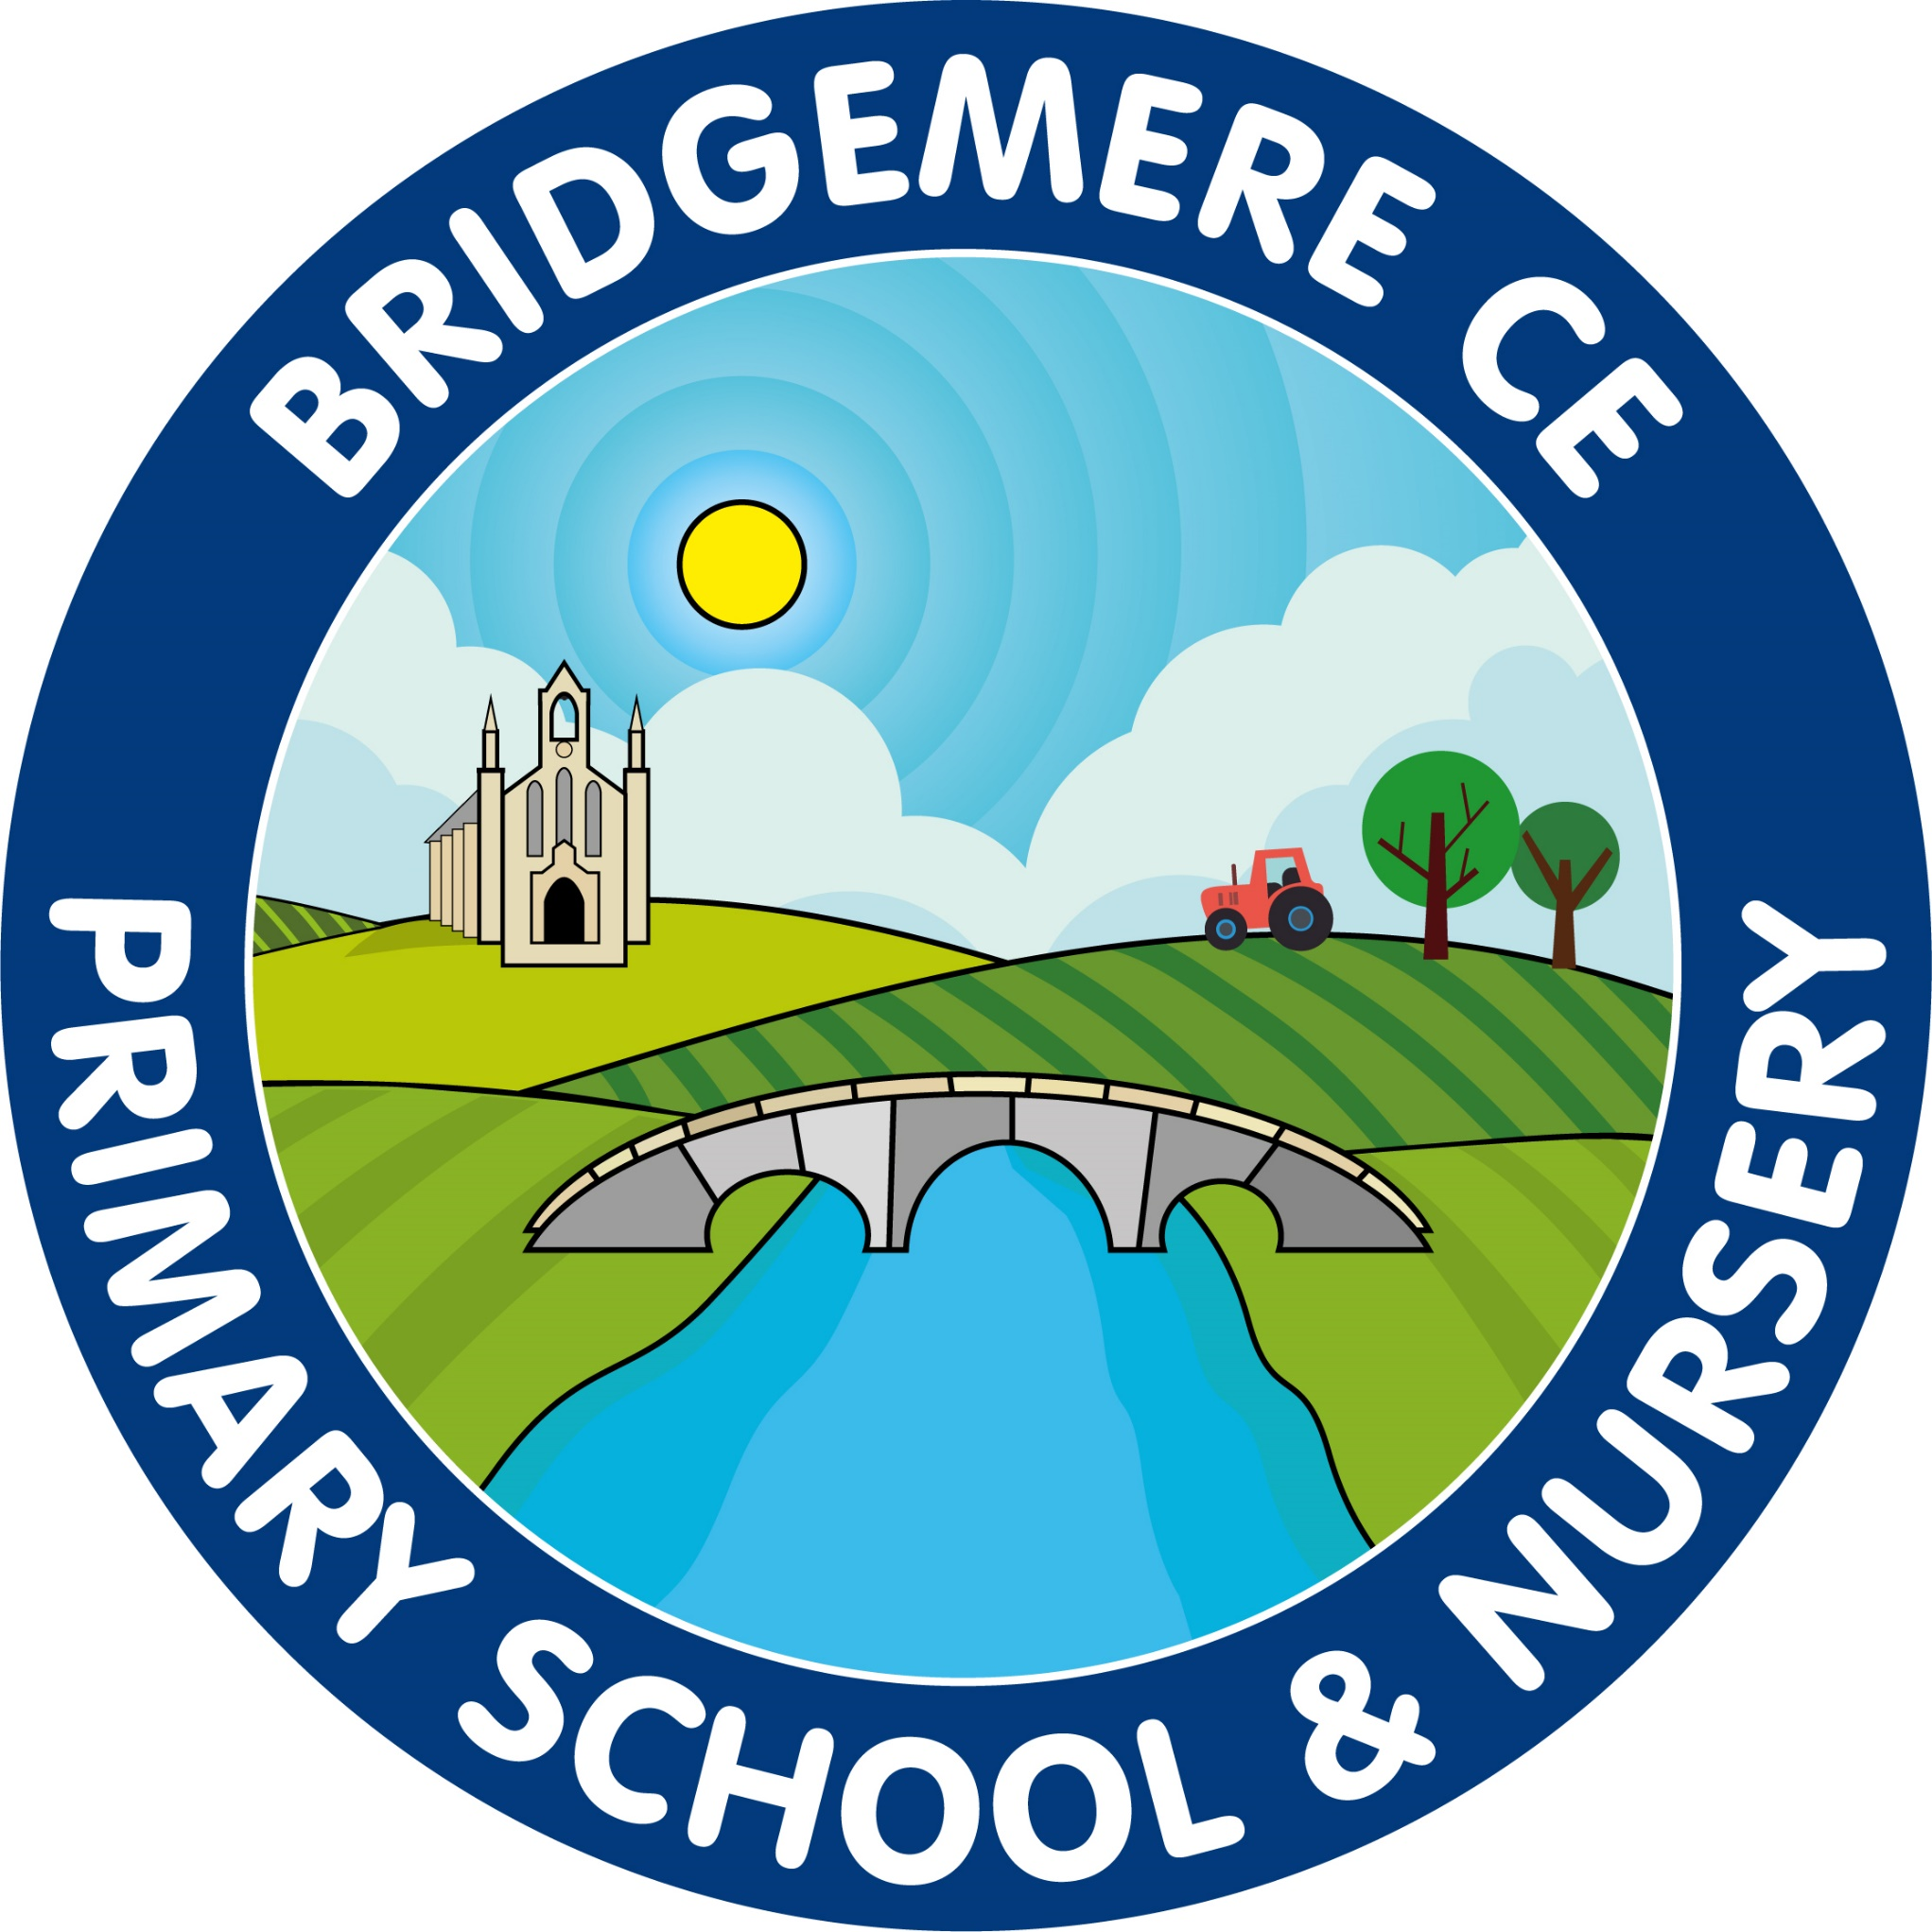  Dates coming up:  Tuesday 1st November – Children return to school  Thursday 3rd November – Class 2 trip to Nantwich Museum  Tuesday 8th November – Parents’ Evening Remote / on-line meetings  4.00-6.00pm  Stay & Play –  Wednesday 9th November 9.00-10.15am  Wednesday 9th November-  Face to face Parents’ Evening at school  3.30-7.00pm  Monday 14th November – Fluenz Immunisation in school  Tuesday 13th December – Nativity – Class 1 & 2  2pm  Wednesday 14th December – Nativity – Class 1 & 2  5pm  Thursday 15th December – KS2 Carol Service at St John’s Doddington 1.30pm  Christmas Fair – Monday 19th December 3.30pm
Welcome back everyone, hope you have all had an enjoyable half term break and looking forward to the run up to Christmas; it will be here before we know it! We will keep you informed about up coming events and meetings this half term as much as possible as there will be a lot going on.  Parents’ Evening  Parents Evening meetings will take place:  Tuesday 8th November – On-line appointments  Wednesdya 9th November – Face to face appointemnts  If you have not sent your appointmanet slip back to school please do so this week or phone the school office for an appointment.  We will be selling poppies, snapbands, wristbands and reflective clip-on poppies in school on behalf of The Royal British Legion week beginning Monday 7th November. Donations – 50p for a poppy, £1 for other items.  Parent council  Parent Council will be having their first meeting of the acadmeic year this month. If you would like to raise any items for the agenda or be involved please speak to your class representative below:  Class 1: Laura Ayres & Emma Lewis  Class 2: Christy Woods & Emma Minshall  Class 3: Nova Wallace & Laura Hope  Class 4: Gemma Stockdale & Naomi Moss  Running Track  The children have been delighted with the new running track and it certainly is a great asset at play and dinnertimes. We will be continuing to use it as much as possible over the winter months to keep your child/ren as active as possible. | Class 4 Maternity Cover  We are pleased to annouce that Miss Katie O’Leary will be taking the postion of class teacher in Class 4 during Miss Slater’s maternity leave. Miss O’Leary has worked in KS2 for the past 4 years and has experience of KS2 SATs. She will be coming into school to work alongside Miss Slater from Monday 5th December where there will be an opportunity for you to meet Miss O’Leary that afternoon after school.  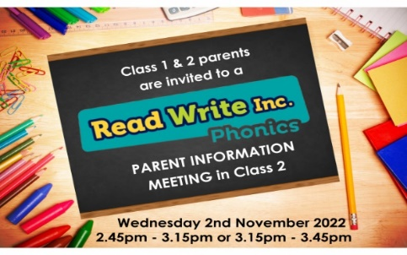  Class 1 & 2 parents: Read, Write Inc Parents’ Meeting is taking place Wednesday 2nd November in Class 2  2.45-3.15pm or 3.15pm-3.45pm. This is a great opportunity for you to understand how we teach your child to read in school and how you can support them further at home.  Re-Roofing Works  Thank you for your continued support with the re-roofing of the main school building. We are pleased to inform you the building work over the half term holiday went as scheduled so we are hoping all work will be completed by the 18th November.  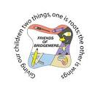  The Friends of Bridgemere are looking for a new Chairperson and Secretary! We are looking for 2 people to take on these exciting roles and bring fresh ideas and enthusiasm to our fund-raising. If you would like to know more about what's involved, please speak to Naomi Moss, Emma Minshall or Sarah Furber or contact the School office. Many thanks!  As always, if you have any concerns or queries regarding your child’s education, please do not hesitate to contact me.  Caroline Middleton  Head Teacher

