Bridgemere CE Primary Newsletter  ‘I can do all things through Christ who strengthens me’  Philippians 4v13 May 2023 |  |  | 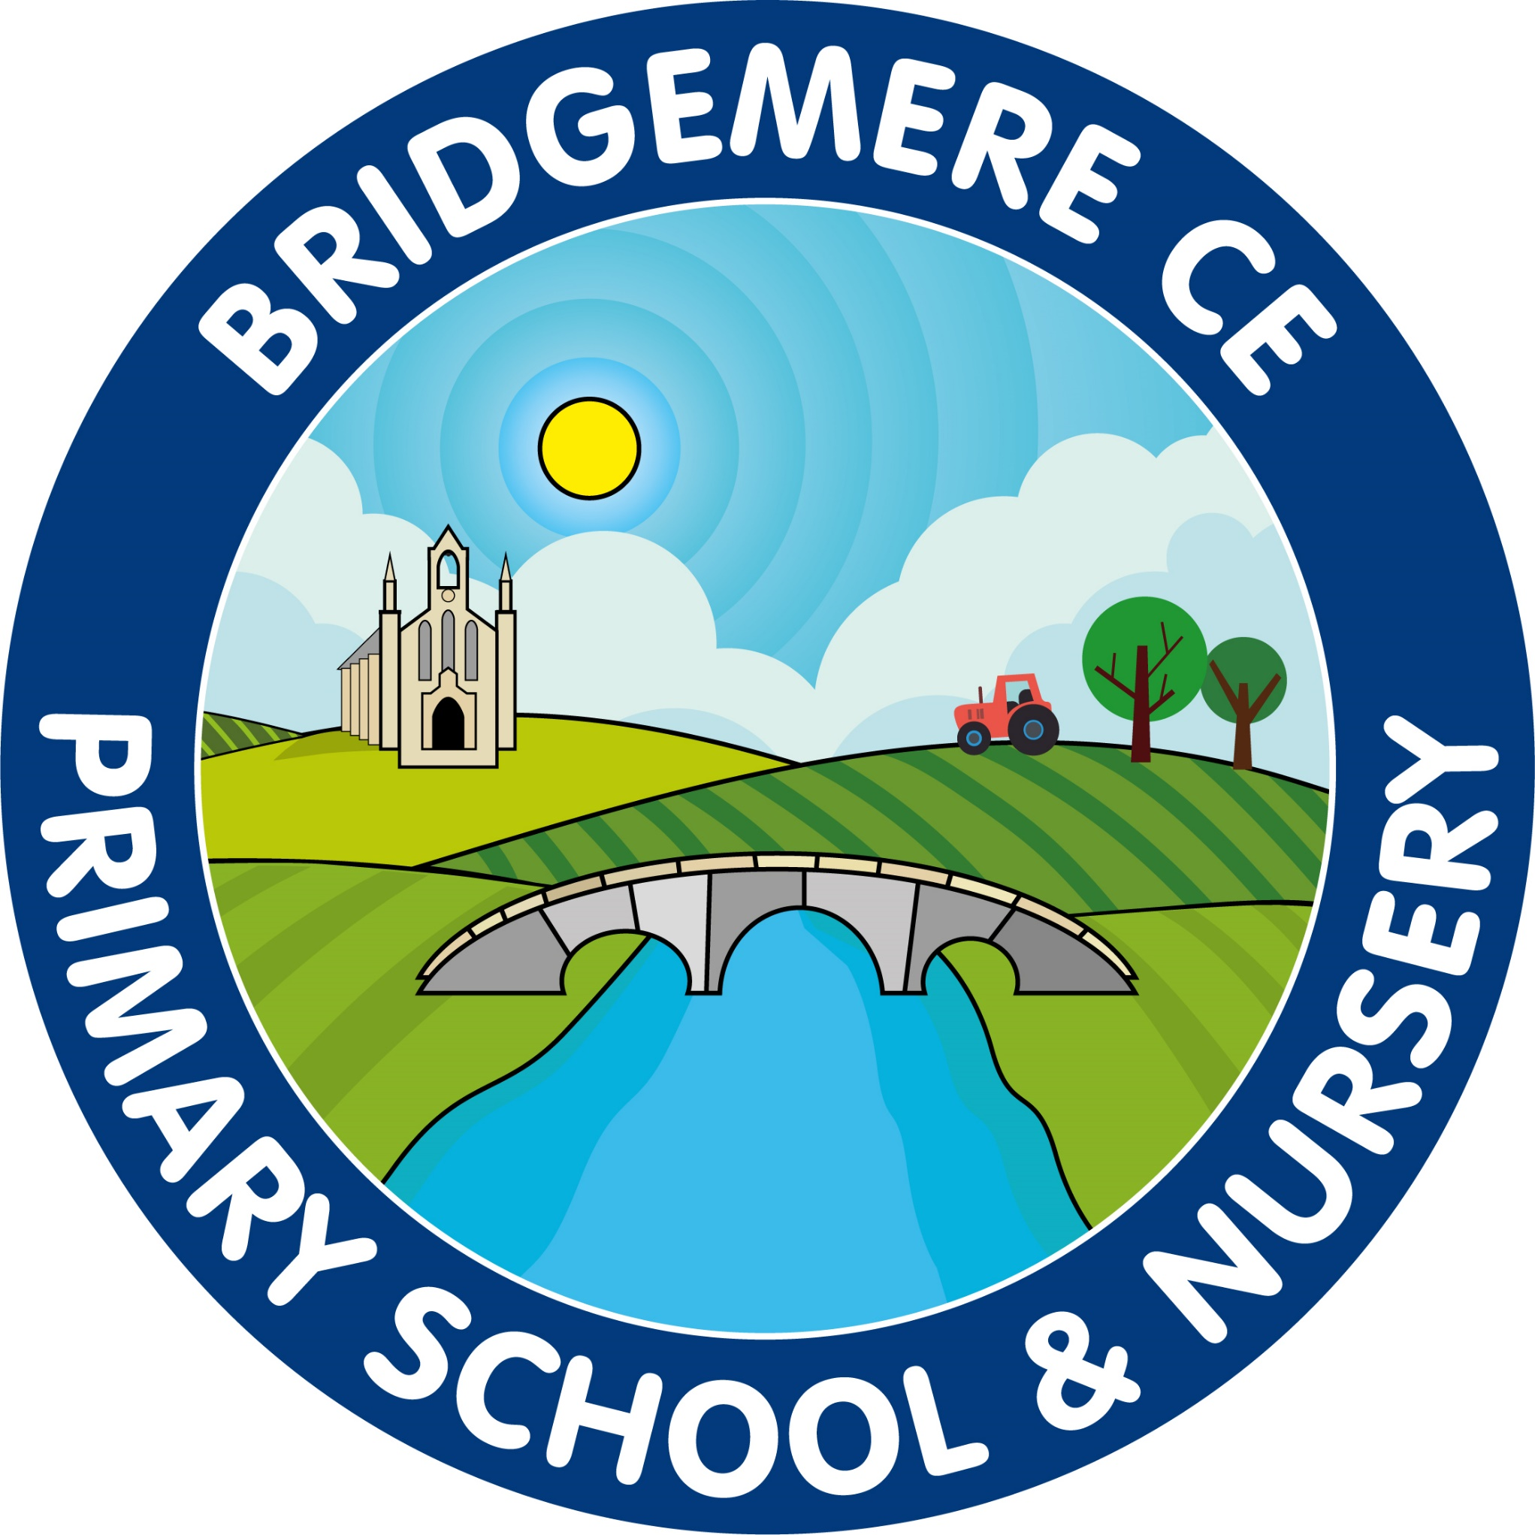  Dates coming up:  KS1 SATs – Monday 15th – Friday 19th May  Class 4 Beeston Trip – Monday 22nd May  Break up for Whit Holiday – Friday 26th May  Return to school –  Monday 12th June  Week beginning 12th June  Year 1 Phonic Screening Test  Year 4 Times table Test  Tuesday 13th June  Class 2 & 3 am Synagogue visit  Thursday 15th June  Class 3 ‘Come and Play with the Halle’ Trip  Friday 16th June  Stay & Play  9.00-10.15am
Dear Parents, Like yourselves I am hoping that the sunny weather will be with us soon! When it eventually arrives please can your child remember to bring a water bottle and sun hat to school to keep them safe.  Please find attached to this newsletter a list of dates. We are so busy after half term I thought it would be useful for you to have at home to keep up with everything that is happening.  KS1 SATs –  (Standard Assessment Tests)  These will take place the week beginnning Monday 15th May. The children in Year 2 will be tested in reading, maths and spelling, punctuation and grammar.  Year 1 Phonic Screening Test  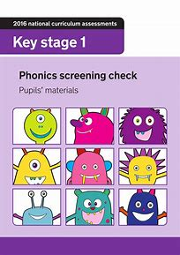  The Year 1 Phonic Screening Tests will take place after half term, week beginning 12th June. Miss Latham has held a parents information meeting regarding the tests but if you wish to discuss anything further do not hesitate to speak to her.  Year 4 Timestable Test  The Year 4 Timestable Tests will also take place after half term, week beginning 12th June.  Please find the link below which is good for practising at home.  https://www.timestables.co.uk/multiplication-tables-check/ | Goodbye Mrs Smart  It is with much sadness we will be saying goodbye to Mrs Smart at the end of this summer term. Mrs Smart has been a great asset to our school covering PPA for the last 3 years and supporting our pupils to reach their potential in their art achievements.  Mrs Smart will still be coming into school in September on planned art days for each class so she will still be able to share her expertise with the children.  We wish Mrs Smart all the best in her retirement and for her plans for the future.  We will notify you as soon as we have secured the new post within school for PPA cover in September.  Friends of Bridgemere  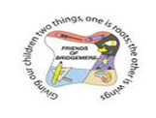  The winners of the Friends of Bridgemere Lottery Club April draw are 1st prize to Mrs Driver, 2nd Mrs Hak & 3rd prize to Keith Williamson. Thank you very much to everyone who’s joined our Lottery Club!  Don't forget we have lots of pre-loved school uniform available to buy for less than £3. Please contact the School office for an order form.  As always, if you have any concerns or queries regarding your child’s education, please do not hesitate to contact me.  Caroline Middleton  Head Teacher

