Bridgemere CE Primary Newsletter  ‘I can do all things through Christ who strengthens me’  Philippians 4v13 May 2022 |  |  | 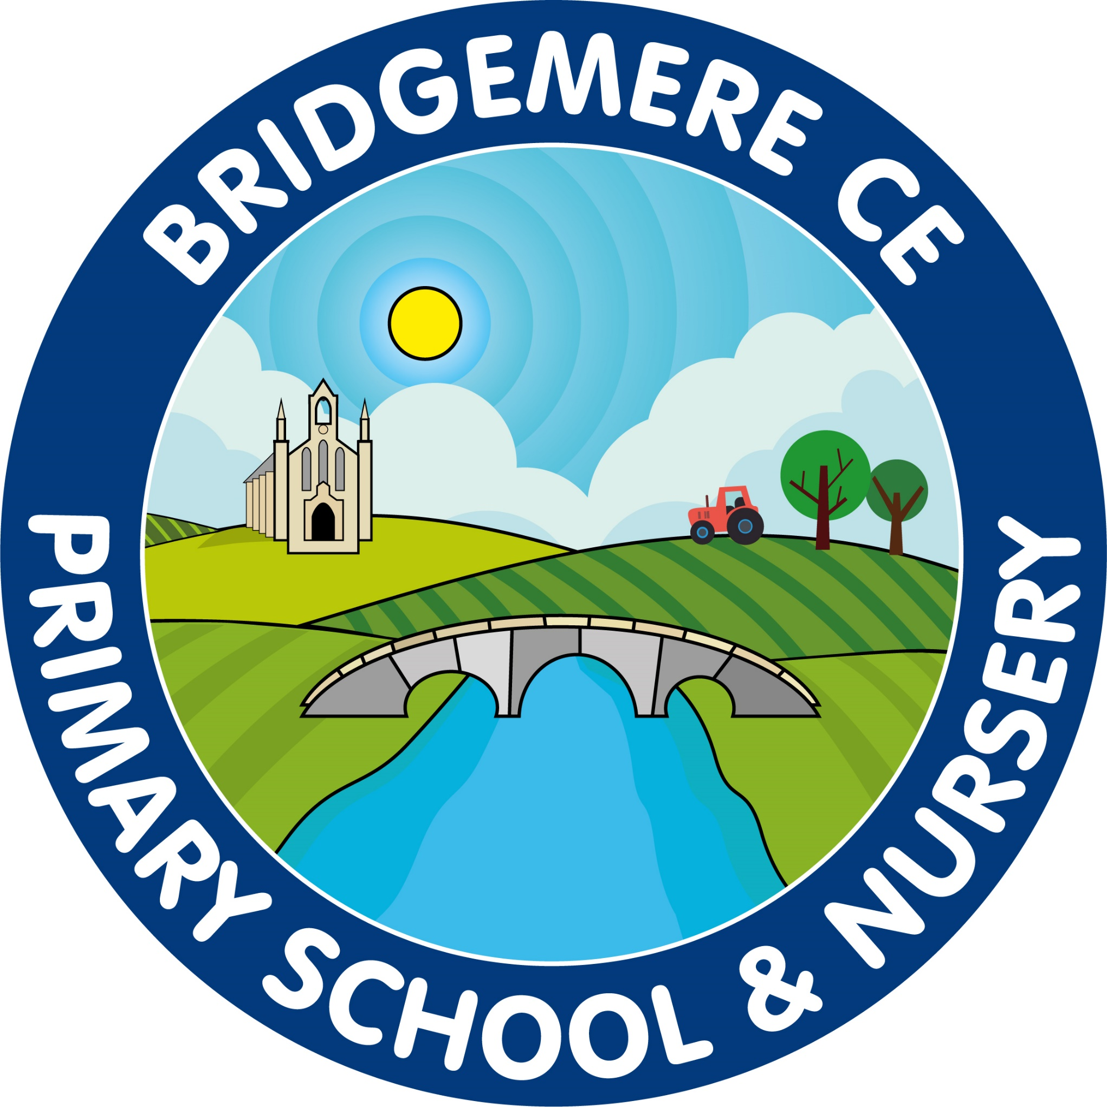  Dates coming up:  KS1 SATs start – 3rd May  KS2 SATs week –Monday 9th May  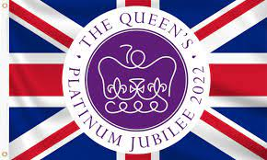  Queen’s Platinum Jubilee – 2 week ‘Learning in context’ starts Monday 16th May  Tuesday 17th May – New school library to be installed  Thursday 26th May – ‘Jubilee Afternoon Tea’ at school  Friday 27th May – Non-uniform day  Street party lunch  Break up for half term – Friday 27th May
I hope you all had an enjoyable bank holiday weekend. Hopefully the weather will continue to get warmer over the coming weeks, please can you ensure your child has a water bottle in school and bring a sunhat. On very hot days you may want to apply suntan lotion on your child before school to protect their skin. We will continue to make sure all children are well hydrated and protected from the sun.  KS1: During the month of May all the Year 2 children will be undertaking their SATs (Standard Assessment Tests) in reading, maths and spelling, punctuation and grammar.  KS2: Year 6 will take their SATs week beginning Monday 9th May. Miss Slater will be running a breakfast club for all Year 6 children from Monday to Thursday, please see the letter that she has sent out.  100km Pembrokeshire Coast Trek for Coppafeel  This June Sam Foyle will set out on a challenging, extraordinary and life-changing trek, all in the name of checking chests! She will be taking on 100km of Pembrokeshire's rugged, unforgiving coastline in a bid to raise funds towards CoppaFeel's life-saving mission. Please use the link below to support Sam and the fantastic work she is doing for breast cancer.  https://www.justgiving.com/fundraising/Sam-Foyle1  Friends Of Bridgemere – FOB  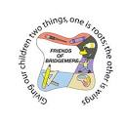  The winners of the April Lottery Club draw are 1st prize to Mrs Dickinson, 2nd Mrs P Cornes and 3rd prize to David Brindley. Thank you to | everyone, who joined the new Lottery Club year. And good luck!  Queen’s Platinum Jubilee  To celebrate the Queen’s Platinum Jubilee as a school we are incorporating this unique event into our learning for the last two weeks of this half term.  Please see the curriculum map overleaf that outlines the learning covered across the school.  On Thursday 26th May Friends of Bridgemere will be hosting an ‘Afternoon Tea Party’ at school for everyone to enjoy. Further details to follow.  On Friday 27th May we will be having a non-uniform day where the children can come in anything red, white and blue and lunch will be served outside street party style.  The children will spend the day taking part in group activities across the school.  To celebrate this momentous occasion, all primary school children across the country will receive a free commemorative book that celebrates the achievements of the United Kingdom and Commonwealth over the last 70 years.  As always, if you have any concerns or queries regarding your child’s education, please do not hesitate to contact me.  Caroline Middleton  Head Teacher

