Bridgemere CE Primary Newsletter  ‘I can do all things through Christ who strengthens me’  Philippians 4v13 March 2023 |  |  | 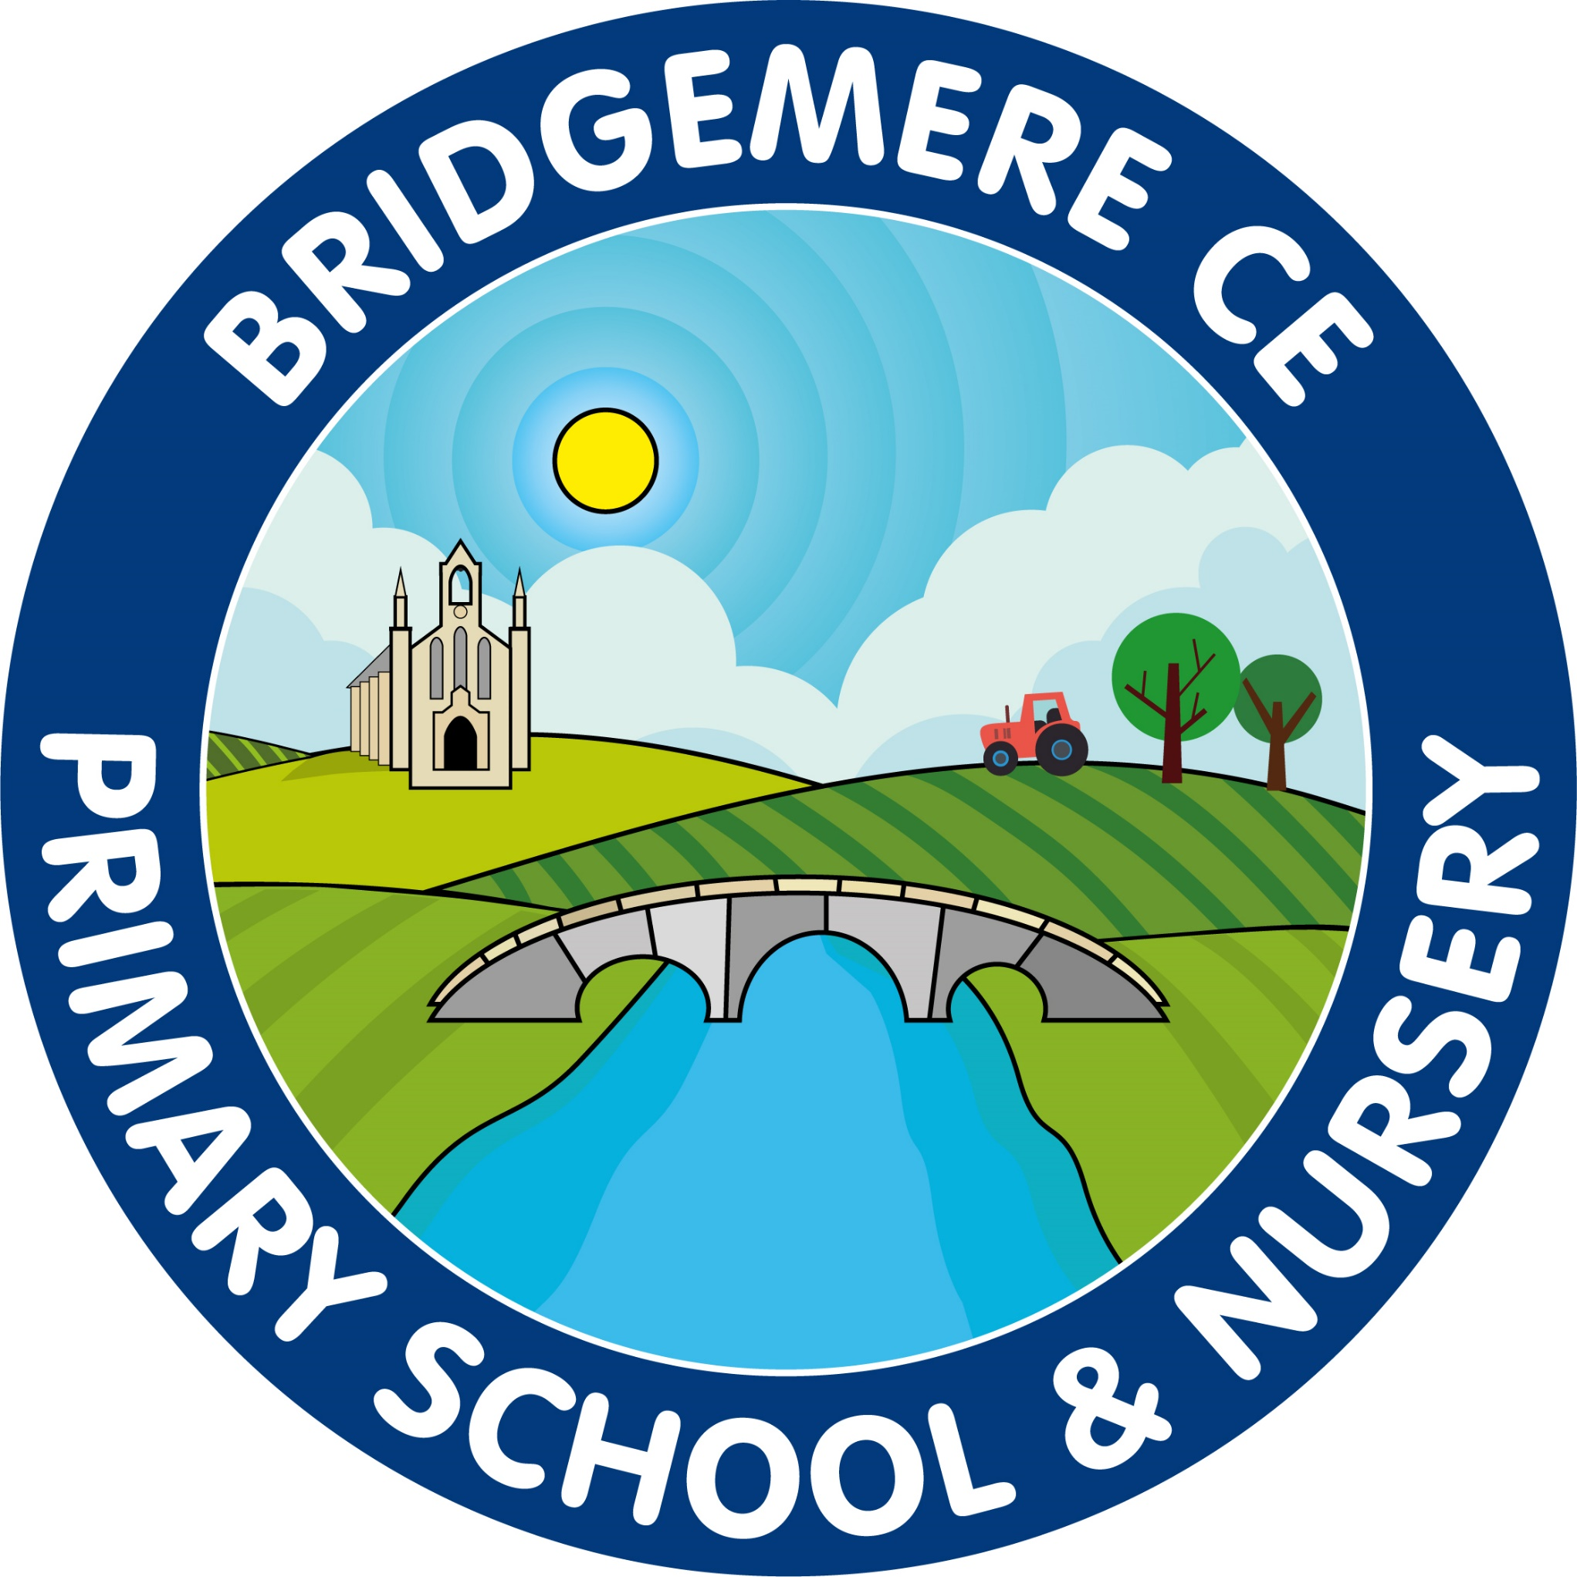  Dates coming up:  Thursday 2nd March –  World Book Day  Friday 3rd March – swimming lessons start for Class 1, 2, 5 & 6  Monday 6th & Wednesday 8th March – Spring Parents’ Evening  Monday 13th March – Science Week  Friday 24th March FOB– Non-uniform Day - exchange for Easter Egg  Tuesday 28th March- Easter Service at St John’s Doddington  Wednesday 29th March -Easter Bingo – 3.30-4.30pm  School closes for Easter holidays –  Friday 31st March
Welcome back after half term, I hope you all managed to get a break and enjoy some time with your families last week.  This half term is a short one; we only have five weeks until we break up for the Easter break. It will be all go here at school!  Drop off – pick up times  A few parents have commented that Bridgemere Lane in the morning is becoming more dangerous with cars waiting to come on to the car park to drop children off.  Please can you drop your child(dren) off as quickly and safely as possible to allow the least amount of congestion.  Please can children exit their cars anywhere down the coned area, this will make things so much more efficient.  Can I also remind parents that the side gates will be locked at 3.25pm each night for safeguarding reasons. Mrs Hollowood takes the children from Boost outside at 3.30pm, therefore please make a quick exit from the school grounds.  Friends of Bridgemere  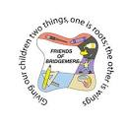  Cake Sales  Our Cake Sales raised a scrumptious £197! Thank you to everyone who donated cakes and supported the event.  Chairperson Vacancy  We need someone (or 2 people) to be our Chairperson to take FOB forwards. If you'd like to learn more about what we do, please speak to our Secretaries,Emma Minshall (mob: 07779 091020) or Kristen Bahry-Webber or Treasurer, Sarah Furber or the School Office.  Pre-Loved School Uniform  If you'd like to buy pre-loved school uniform, please complete our order form (available from the School Office) and return it to the School Office. We'll then check our stock and be in touch with you.  Save the Date!  * Non-Uniform Day in exchange for a chocolate Easter egg: Friday 24th March  * Children's Easter Bingo in School: Wednesday 29th March, 3:30pm - 4:30pm | Spring Parents’ Evening  Parents’ Evening will be taking take place on the following dates:  Monday 6th March – on line  Wednesday 8th March – face to face  Your should have received a time for your appointment in your child’s communication diary, please check. If you have not received an apponintment or would like to make one please phone the office and speak to Mrs Coats.  Parent Council  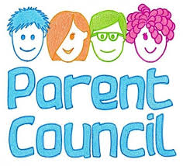  Your class representatives:  Nursery - Emma Lewis – Chair  Reception - Laura Ayres  Year 1 - Emma Minshall  Year 2- Laura Hope  Year 4 - Nova Wallace  Year 5 - Naomi Moss  Year 6 - Gemma Stockdale  If you would like to be the Year 3 parent representative please let Emma Lewis or the office know. Thank you.  Parent Information Meetings  Please find details for Parent Information meeting for the following dates:  Monday 20th March – KS2 SATS – Year 6 Parents – 3.30pm in Class 4  Tuesday 21st March – Year 1 Phonic Test – Year 1 Parents – 3.30pm in Class 2  Thursday 23rd March – KS1 SATS – Year 2 Parents – 3.30pm in Class 2  As always, if you have any concerns or queries regarding your child’s education, please do not hesitate to contact me.  Caroline Middleton  Head Teacher

