Bridgemere CE Primary Newsletter  ‘I can do all things through Christ who strengthens me’  Philippians 4v13 March 2022 |  |  | 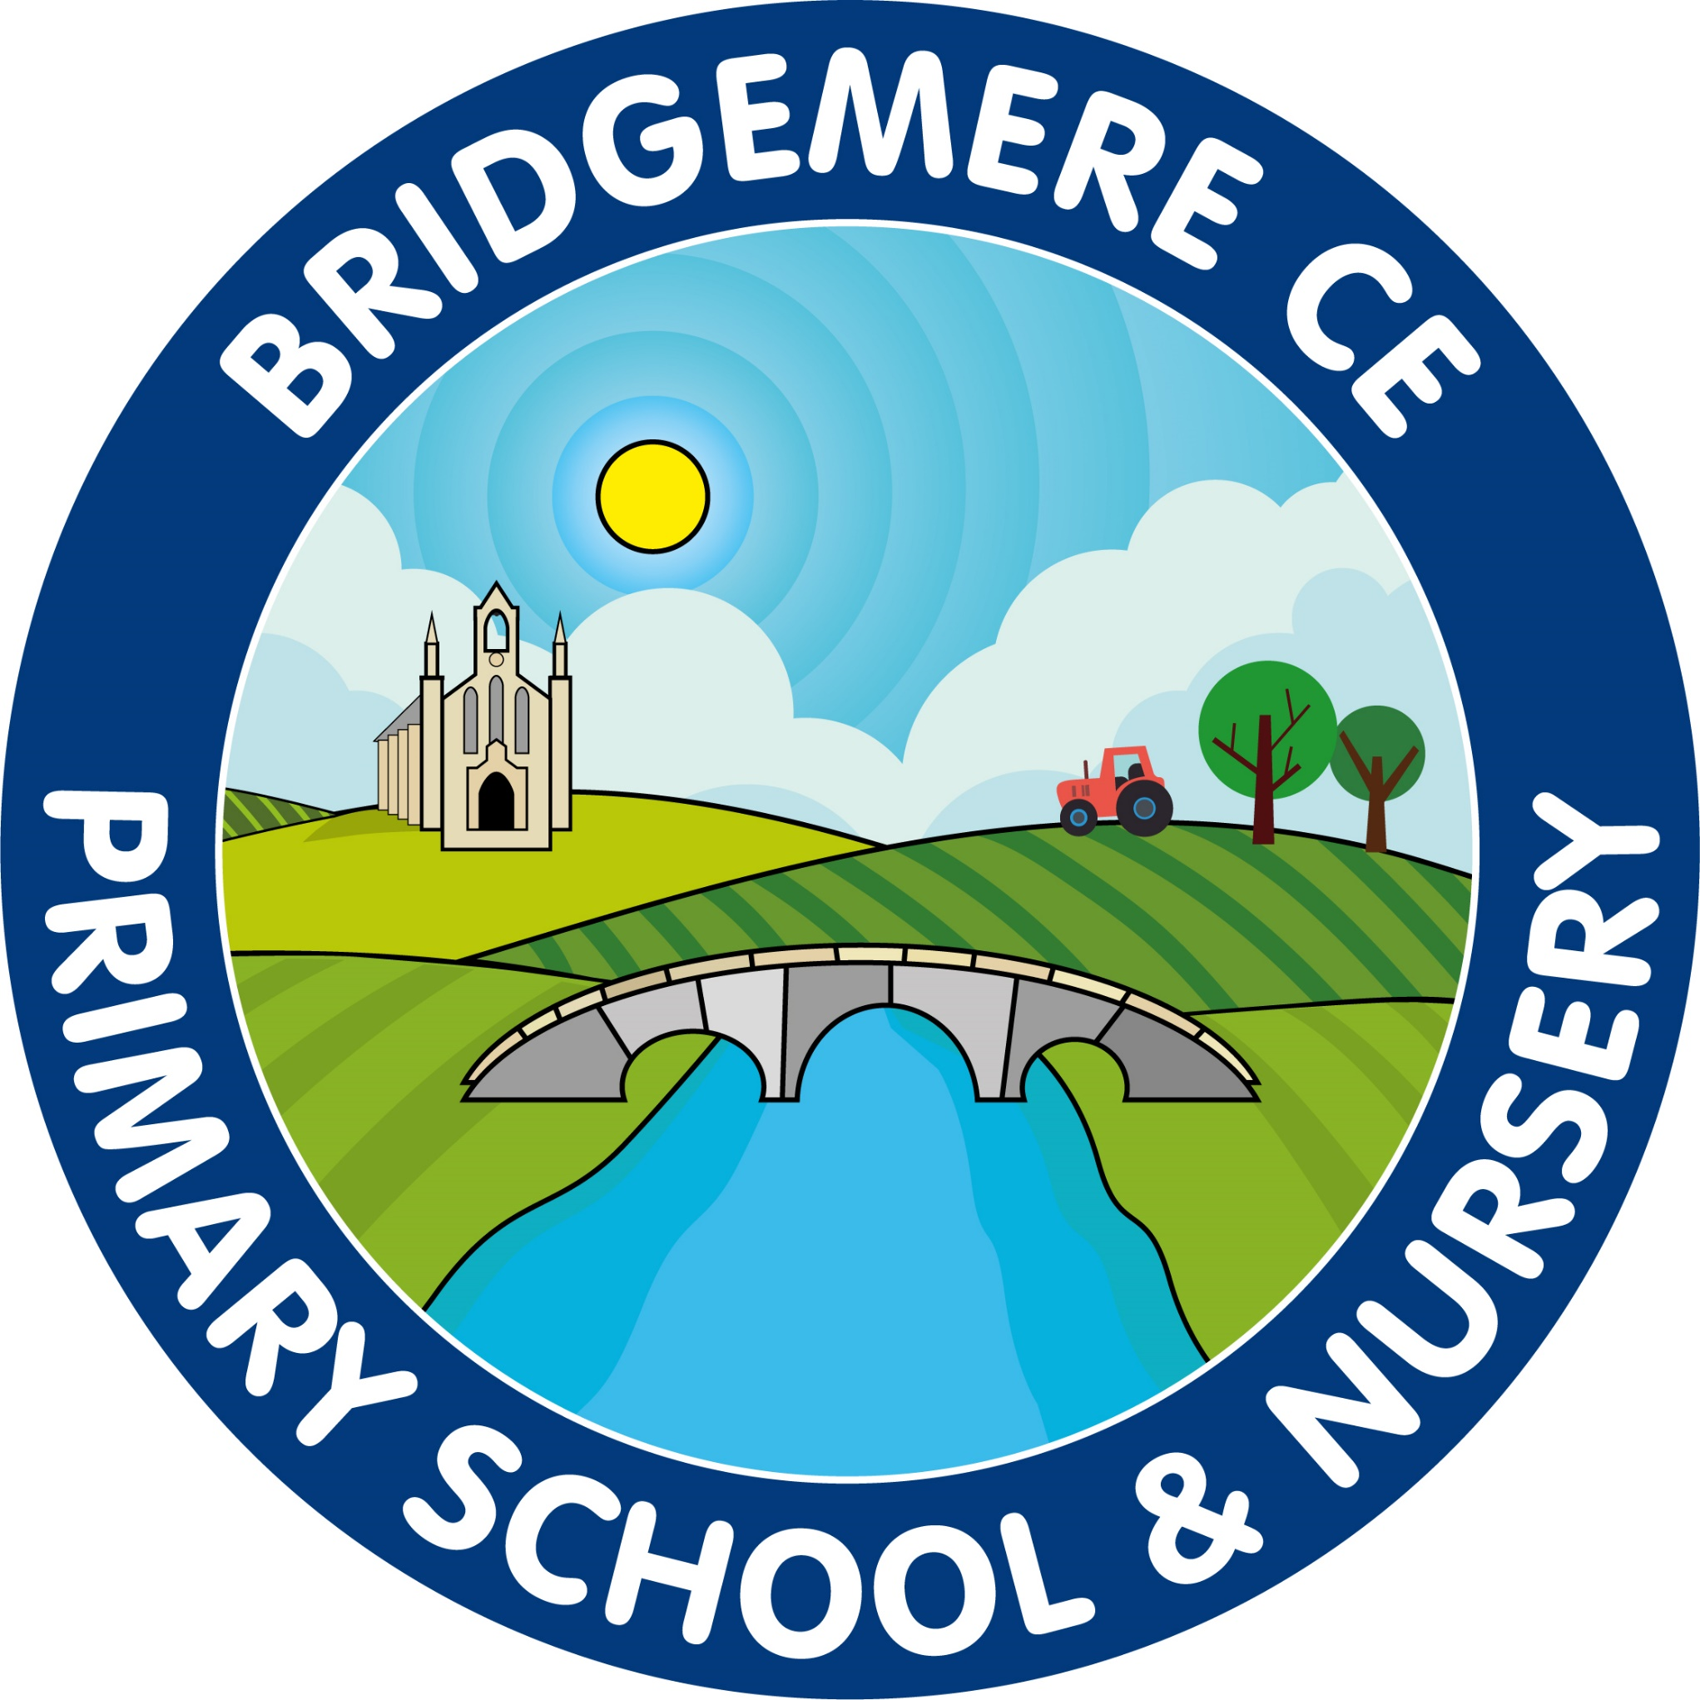  Dates coming up:  14th-18th March –British Science Week  Friday 18th March – Non-Uniform Day in exchange for an Easter Egg  Monday 21st March – World Down’ Syndrome Day – Gingerbread Socks on sale - £1  23rd March – Zoolab am visit for Class 1 & 2  25th March – Easter Bingo  Mothering Sunday Service –  Sunday 27th March @ St John’s Doddington  Wednesday 30th March –Easter Service 2pm  Break up for Easter – school closes  Friday 1st April  School opens for summer term  Tuesday 19th April
Compassion  Our focused Christian value of ‘compassion’ this half term is being explored through how we can show compassion to those around us. This is very relevant and links with our Ukraine Appeal.  Ukraine Donations Appeal  Thank you to everyone who has donated items for the Ukrainan Refugee Appeal, your generosity has been overwheling and as a church school I feel we are reaching out with compassion to those in need.  Please can all donations be in school by next Wednesday 16th March so we can package everything ready for transportation.  It is fabulous that 13 other Nantwich schools have joined us in this appeal, I am not sure where we are going to put all the donations next week, I think the hall may be taken over! What we do not manage to fit in the van(s) we will be sending to the local drop off point in Crewe and Nantwich who will package and transport what we cannot manage.  Please see the email sent for an up to date list of items needed. Many thanks  Thank you to everyone who supported Mrs Rowley in buying a sunflower keyring or bracelet on Friday after school. She raised an amazing £278.50 for the Ukraine Appeal. Thank you for your continued support.  Bridgemere CE Primary Newsletter ‘I can do all things through Christ who strengthens me’ Philippians 4v13 March 2022 Dates coming up: 14th-18th March –British Science Week Friday 18th March – Non-Uniform Day in exchange for an Easter Egg Monday 21st March – World Down’ Syndrome Day – Gingerbread Socks on sale - £1 23rd March – Zoolab am visit for Class 1 & 2 25th March – Easter Bingo Mothering Sunday Service – Sunday 27th March @ St John’s Doddington Wednesday 30th March –Easter Service 2pm Break up for Easter – school closes Friday 1st April School opens for summer term Tuesday 19th April  Friends Of Bridgemere - FOB The winners of the January Lottery Club draw are 1st prize to Jon Furber, 2nd prize Mrs Pat Cornes, 3rd prize Sarah Hardy and 4th prize to Mr Peter Driver. The winners of the February Lottery draw are 1st prize to Sarah-Jane Williamson, 2nd Emma Kent, 3rd Rachael Hodgkins and 4th to Matthew Williamson. Well done everyone! It's nearly the new Lottery Club year, starting on 1st April. More details on how to join our Lottery Club to follow shortly. We made £76 from our recent Valentines sweets sale. Thank you everyone! FOB Easter Events Friday 18th March – Non-Uniform Day in exchange for an Easter Egg Friday 25th March – Easter Bingo at school 3.15-4.30pm Tickets are £2 each. Please confirm if you would like your child to attend by emailing: nomeyw22@yahoo.co.uk. Please send the money for tickets directly to FOB by transferring into their account with your child’s name as the reference. Details below: Acc Name: Friends of Bridgemere School Account Number: 10724826 Sort Code: 54-10-17 World Down Syndrome Day Monday 21st March is World Down Syndrome Day. Please can your child(ren) come to school in fancy or odd socks. We will be selling Gingerbread Sock biscuits on this day for £1 at playtime. The winners of the January Lottery Club draw are 1st prize to Jon Furber, 2nd prize Mrs Pat Cornes, 3rd prize Sarah Hardy and 4th prize to Mr Peter Driver. The winners of the February Lottery draw are 1st prize to Sarah-Jane Williamson, 2nd Emma Kent, 3rd Rachael Hodgkins and 4th to Matthew Williamson. Well done everyone! It's nearly the new Lottery Club year, starting on 1st April. More details on how to join our Lottery Club to follow shortly. FOB Easter Events Friday 18th March – Non-Uniform Day in exchange for an Easter Egg Friday 25th March – Easter Bingo at school 3.15-4.30pm Tickets are £2 each. Please confirm if you would like your child to attend by emailing: nomeyw22@yahoo.co.uk. Please send the money for tickets directly to FOB by transferring into their account with your child’s name as the reference. Details below: Acc Name: Friends of Bridgemere School Account Number: 10724826 Sort Code: 54-10-17 World Down Syndrome Day Monday 21st March is World Down Syndrome Day. Please can your child(ren) come to school in fancy or odd socks. We will be selling Gingerbread Sock biscuits on this day for £1 at playtime. | Goodbye Mrs Wilcox  It is with great sadness that we will be saying goodbye to Mrs Wilcox at the end of this half term. She is very excited to have the opportunity of a new adventure.  Mrs Wilcox has been with Bridgemere School for 9 years and will be greatly missed. We wish her every success for the future.  Lent – Outside Reflection Area  I will be working with the Ethos Council over the next week to create an outside reflection area. They have decided they would like it to be placed under the pagoda in the large playground so that children, staff and parents can access it.  The theme is that we are special and unique in the eyes of God. Under the focal point of the cross we want to create a path made out of stones.  We would like each child to bring in a stone or pebble about the size of their fist which will have the outline of a heart and each child’s finger print in the middle. This represents washing away all things that separate us from God’s love and showing God’s forgiveness and healing love.  The fingerprint recognises that each child is a unique child of God.  We would like this to be an open reflection area, if you would like to add your own stone as a parent, grandparent, governor it will be very much welcomed.  Mother’s Day Service – St John’s Doddington  Rev Alison has invited you all to the Mothering Sunday Service on Sunday 27th March at St. John’s at Doddington church. She would love to see as many of our families as possible.  Easter Service  We will be holding our Easter Service on Wednesday 30th March at 2pm.  This will either take place at St. John’s Doddington or at school. We will let you know closer to the time.  As always, if you have any concerns or queries regarding your child’s education, please do not hesitate to contact me.  Caroline Middleton  Head Teacher

