Bridgemere CE Primary Newsletter  ‘I can do all things through Christ who strengthens me’  Philippians 4v13 June 2023 |  |  | 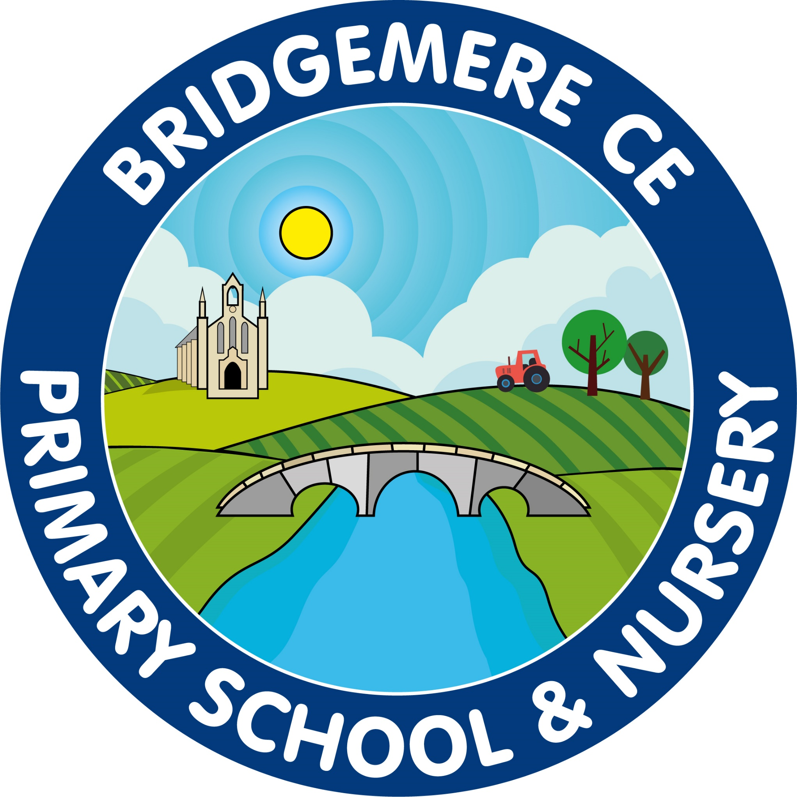  Dates coming up:  Return to school –  Monday 12th June  Week beginning 12th June  Year 1 Phonic Screening Test  Year 4 Times table Test  Tuesday 13th June  Class 2 & 3 am Synagogue visit  Thursday 15th June  Class 3 ‘Come and Play with the Halle’ Trip  Friday 16th June  Stay & Play  9.00-10.15am  Monday 19th June  Reception new starters –  Teddy Bears’ Picnic 2-3pm  Parent Informtion Meeting – 3.30pm  FOB Summer Fair meeting – 10am Bridgemere Garden centre soft paly area
Dear Parents, Now the weather is more like summer, please can you ensure your child comes to school with a water bottle, sun hat and has applied sun cream in the morning.  Please find an updated list of dates attached for the remainder of this term.  Congratulations…..  to Mrs Willington who is expecting her second baby in November. This is lovely news for her and her husband Ross and their little boy Alfie. Mrs Willington will start the autumn term with Class 1 before going on maternity leave at half term in October.  Congratualtions…  to Mr Lyons who has succesfully been appointed as a class teacher at Wittington CE Primary School near Oswestry. He will start his new job in September. Mr Lyons has been a great member of the Bridgemere team for the last four years and will be missed by us all.  This new appointment means that Mr Lyons’ commute to school will be significantly shorter and with the arrival of baby Jasmine in January it means there is a better work life balance for him.  We wish Mr Lyons all the very best in his new appointment.  Staffing for September  It is my pleasure to announce that Mrs Banister will be joining our teaching staff in September. As you will know Mrs Banister is currently our | SENDCO at Bridgemere. She will continue with this role alongside being a class teacher.  Mrs Strettford will be replacing Mrs Smart to cover PPA in September. Mrs Strettford is an experienced teacher who is extremely creative and we welcome her to our Bridgemere staffing team.  School Summer Fair  Our school summer fair will take place on Thursday 13th July from 3.15-5pm on the school field.  We will be having a non-uniform day on Friday 7th July in exchange for tombola prizes.  Thank you to our ‘Friends of Bridgemere’ who kindly give up their time to support the school and organise events to raise money for our children. They do such an amazing job.  They would like to extend their welcome to other parents who would like to volunteer their time. If you would like to join the working party for the summer fair  please join them for a coffee and chat about the Summer Fair on Monday 19th June at Bridgemere Garden Centre soft play area at 10am. Everyone welcome.  Friends of Bridgemere  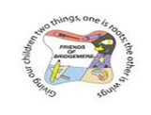  The winners of the FOB Lottery Club draw for May are 1st prize to Mrs Tellwright, 2nd Richard Furber and 3rd to Jack & Dylan Kinghorn.  Don't forget we have lots of pre-loved school uniform available to buy for less than £3. Please contact the School office for an order form.  As always, if you have any concerns or queries regarding your child’s education, please do not hesitate to contact me.  Caroline Middleton  Head Teacher

