Bridgemere CE Primary Newsletter  ‘I can do all things through Christ who strengthens me’  Philippians 4v13 June 2022 |  |  | 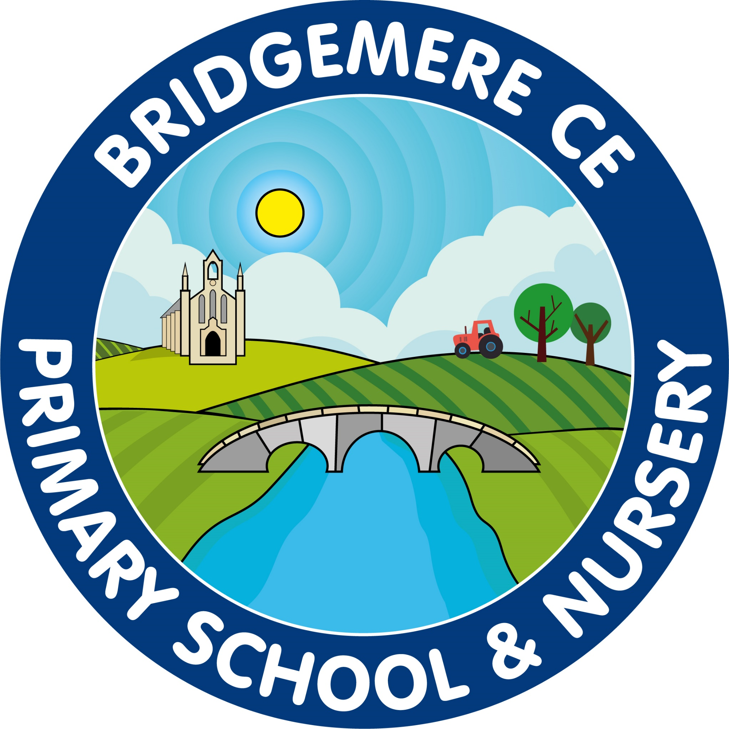  Dates coming up:  Tuesday 5th-Wednesday 6th July  Class 2 Residential to Delamere  Monday 11th July –Sports Day  Wednesday 13th July – Milldale Trip  Monday 18th July – back up Sports Day  Tuesday 19th July – Year 6 Leavers Trip  Thursday 21st July – Summer Fair  Friday 22nd July- Reports out  Tuesday 26th July – Leaver’s Service in school 2pm  Wednesday 27th July – End of term  Thursday 28th July – INSET Day
Now that summer seems to be here please can all children bring a water bottle and sunhat to school each day. On very hot days you may want to apply suntan lotion on your child before school to protect their skin. We will continue to make sure all children are well hydrated and protected from the sun.  Sports Day  Sports Day will take place on Monday 11th July.  In the morning the children will enjoy a range of field events and we would like to invite parents at 1.30pm for the track events. If it rains on this day our back up day is Monday 18th July.  Nursery Transition  We would like to invite all our Nursery children that will be starting Reception in September to a Teddy Bears picnic on the afternoon of Tuesday 19th July. It will be a time where all the children can get to know each other. We will be holding a Parents Meeting at 3.30pm on that day. A letter will be sent out with details very soon  Friends Of Bridgemere – FOB  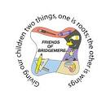  FOB’s ice lolly sale raised £66.65! The money will go towards the Year 6 leaver’s activities. Thanks everyone!  The winners of the May Lottery Club draw are 1st prize to Mr Brindley, 2nd prize to Mr Dickinson and 3rd prize to Emma Minshall.  Our Jubilee Tea Party & cake sale raised a tremendous £212! Thank you all very much for your donations of cakes and money. Thank you all!  Music For Life  Learning a musical instrument has so many benefits and lessons can unlock and develop skills that last a lifetime. Would your child like to try a term taster course in school from September? Find out more and book before 31st July here: www.musicforlife.org.uk/apply-now | Dot Art Winner  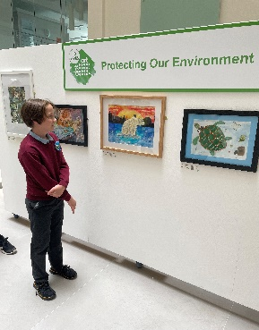  Fantastic news, Roman in Year 5 is the overall Primary winner of the Dot Art Competition 2021. Here he is last week visiting the gallery in Liverpool looking at his winning piece of art work ‘Save the Polar Bears’. Well done Roman this is a fantastic achievement you should be very proud of yourself.  Summer Fair  Our school summer fair will take place on Thursday 21st July. We will be having a non-uniform day on Friday 15th July in exchange for tombola prizes. Please see the FOB posters that will out ASAP for more details.  School Reports  Staff are in the process of writing your child’s end of year report. We will send these out on Friday 22nd July and there will be an opportunity for you to discuss the report on Tuesday 26th July from 4.00-6.00pm. We will send a letter out with the reports with details on how to make an appointment.  As always, if you have any concerns or queries regarding your child’s education, please do not hesitate to contact me.  Caroline Middleton  Head Teacher

