Bridgemere CE Primary Newsletter  ‘I can do all things through Christ who strengthens me’  Philippians 4v13 July 2023 |  |  | 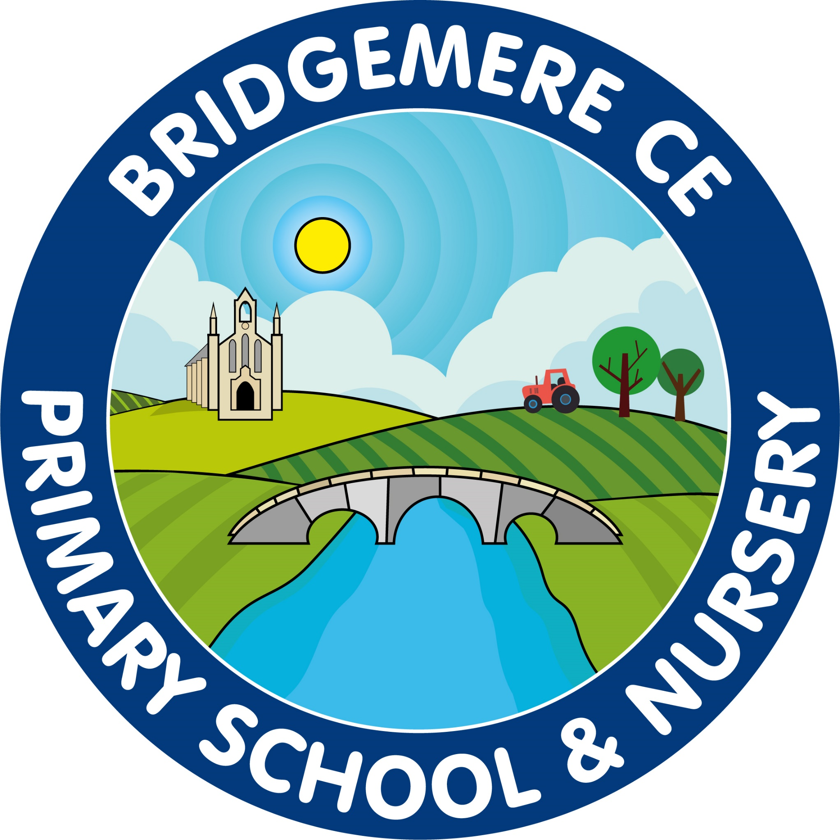  Dates coming up:  Tuesday 11th July  Year 6 – Chester Cathedral Service pm  Wednesday 12th July  Stay & Play 9.00-10.15am in Class 1  Thursday 13th July  Summer Fair – 3.15-5pm  Friday 14th July  Year 6 Surprise Leavers’ Trip  Tuesday 18th July  Leaver’s Service at school – 2pm  Summer reports to go out  Wednesday 19th – Friday 21st July  KS2 residential – Bryntysilio  Monday 24th July  Parents Evening to discuss reports 3-5pm  Tuesday 25th July  Break up for summer holidays  Monday 4th & Tuesday 5th September – INSET Days  Wednesday 6th September -  School reopens for autumn term  Thursday 21st September – Academy Photographs (individual & siblings)
Dear Parents,  I cannot believe this is the last newsletter for this academic year! What an amazing year we have had here at Bridgemere with so many events and celebrations. Thank you so much for your support in everything we do, it makes such a difference to our children to have the amazing support from yourselves.  A sad goodbye to our Year 6 leavers and some families who will be saying goodbye to the primary years. We all wish your children the very best on their journey to high school.  Enjoy the last few weeks and especially the summer break and I look forward to welcoming you back again in September for another year!  Congratualtions…  to Miss O’Leary who has succesfully been appointed as a Year 5 class teacher at Offley Primary Academy in Sandbach.  A big thank you to Miss O’Leary who has done an amazing job covering Miss Slater’s maternity leave in Class 4. She has been a great member of the team and kept up the high expectations of learning for all the children.  We wish Miss O’Leary all the very best in her new appointment.  Staffing for September  Staffing for September 2023 is as follows:  Class 1: Mrs Willington  (Monday, Tuesday, Wednesday)  Mrs Middleton  (Thursday & Friday)  with the support of Mrs Walker (Monday & Tuesday) & Mrs Chandler (Wednesday, Thursday & Friday)  Class 2: Mrs Bannister  with the support of Mrs Hollowood  Class 3: Miss Latham  with the support of Mrs Hollowwod  Class 4: Mrs McGarrigle  with the support of Miss Wilkinson | Parent Questionnaire  Thank you to those parents who have already completed the Parents Questionniare for this year. Each year we send a questionnaire out to children, parents, staff and governors with a view of school improvement, we therfore value your responses.  The link to the questionniare is:  https://forms.office.com/r/beceWFrkTs  School Summer Fair  Our school summer fair will take place on Thursday 13th July from 3.15-5pm on the school field.Please could you kindly donate any cakes or biscuits next week for the event.  A big thank you to our ‘Friends of Bridgemere’ who kindly give up their time to support the school and organise events to raise money for our children. They have done such an amazing job this year.  They would like to extend their welcome to other parents who would like to volunteer their time. Please get in touch if you would like to do so.  Friends of Bridgemere  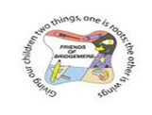  The winners of our June Lottery draw are 1st prize to Carolyn Kinghorn, 2nd Naomi Moss and 3rd to Rebecca Case. The winners of July's draw are 1st prize to Emily Jarrett, 2nd Naomi Moss (again!) and 3rd to Keith Williamson. Well done all!  Don't forget we have lots of pre-loved school uniform available to buy for less than £3. Please contact the School office for an order form.  As always, if you have any concerns or queries regarding your child’s education, please do not hesitate to contact me.  Caroline Middleton  Head Teacher

