Bridgemere CE Primary Newsletter  ‘I can do all things through Christ who strengthens me’  Philippians 4v13 July 2022 |  |  | 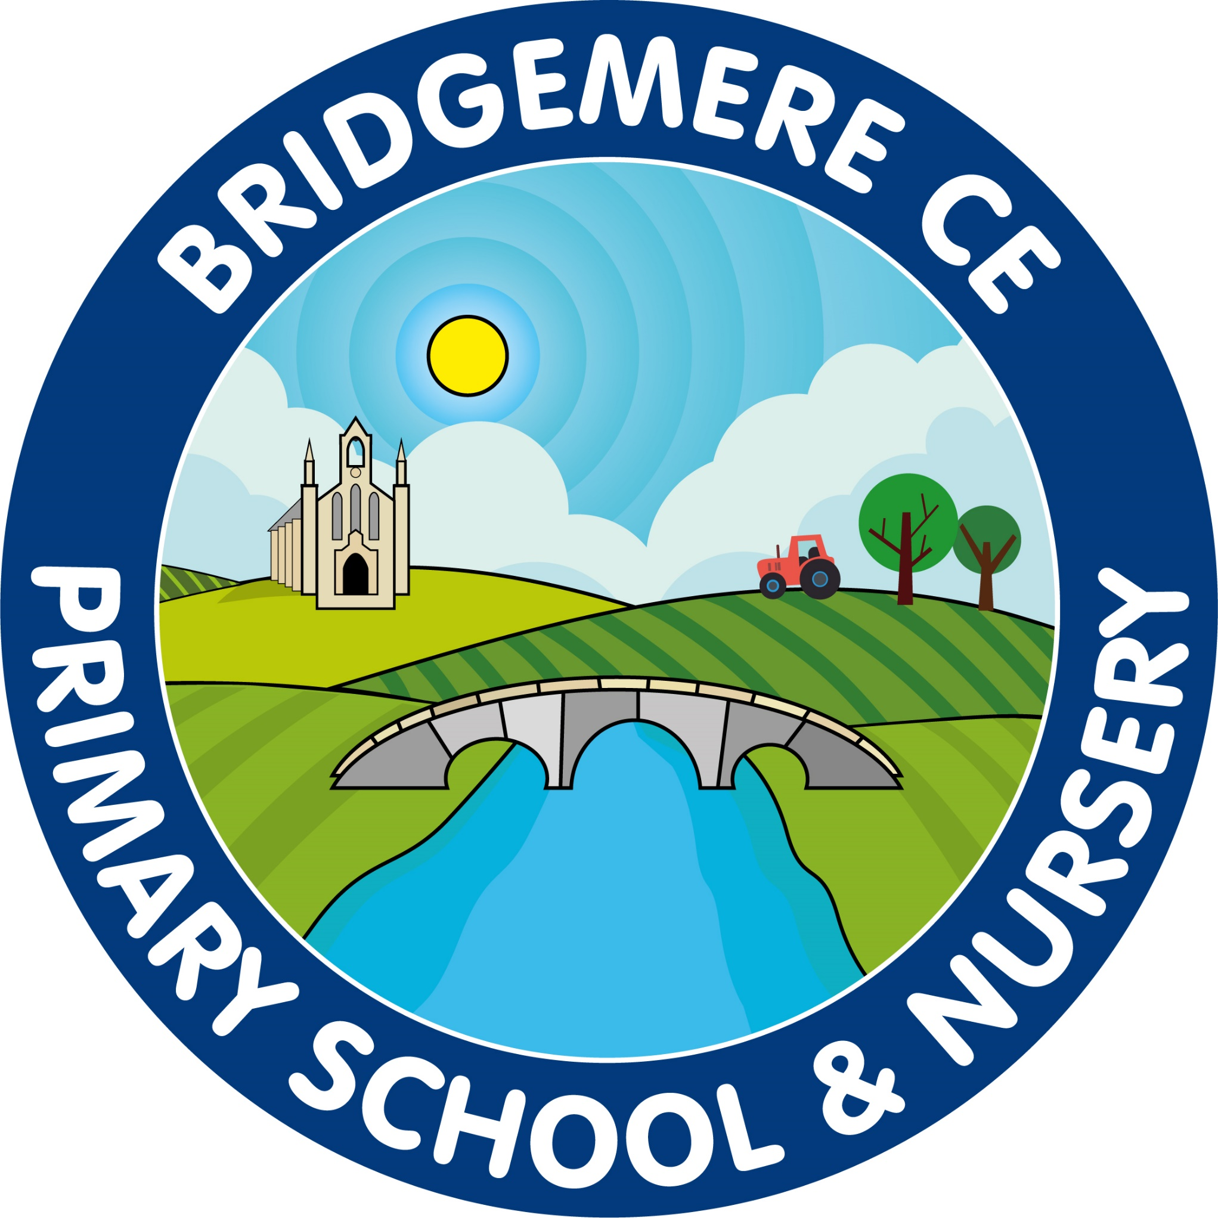  Dates coming up:  Monday 11th July –Sports Day 1.30pm  Wednesday 13th July – Milldale Trip  Monday 18th July – back up Sports Day  Tuesday 19th July – Year 6 Leavers Trip  Thursday 21st July – Summer Fair 3.15 – 5pm  Friday 22nd July- Reports out  Tuesday 26th July – Leaver’s Service in school 2pm  Wednesday 27th July – End of term  Thursday 28th July – INSET Day  Thursday 1st & Friday 2nd September – INSET Days  School opens  Monday 5th September
Staffing 2022-23  Class 1: Mrs Willington (Monday, Tuesday & Wednesday) & Mrs Middleton (Thursday & Friday)  Supported by Mrs Walker (Monday & Tuesday)  Mrs Chandler (Wednesday, Thursday & Friday)  Class 2: Miss Latham  Supported by Mrs Hollowood -am  Class 3: Mr Lyons  Supported by Mrs Hollowood -am  Class 4: Miss Slater  Supported by Miss Wilkinson  Mrs Smart will continue to deliver PPA in each class on a Tuesday and Wednesday.  Congratulations….  to Miss Slater who is expecting her first baby in December. This is lovely news for her and her fiancé Sam. Miss Slater will start the autumn term with Class 4 before going on maternity leave.  Sports Day  Sports Day will take place on Monday 11th July.  In the morning the children will enjoy a range of field events and we would like to invite parents at 1.30pm for the track events.  The weather looks like it is going to be very hot so we will be putting the gazebos up for the children to sit under. Refreshments will be available and ice lollies after school for children.  We will provide chairs for parents, please bring sun cream and plenty to drink! If any parent wishes to bring a gazebo to sit under please phone the office in the morning and we can certainly accommodate this. | Summer Fair  Our school summer fair will take place on Thursday 21st July. We will be having a non-uniform day on Friday 15th July in exchange for tombola prizes. Please see the FOB posters that will out ASAP for more details.  School Reports  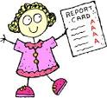  End of year reports will be sent out on Friday 22nd July. There will be an opportunity for you to discuss the report on Tuesday 26th July from 4.00-6.00pm. We will send a letter out with the reports with details on how to make an appointment.  Message from the Chair of Governors  On behalf of the Governor’s I would like to thank all the staff for everything they have done this school year to ensure that all our pupils have had a successful year. Their dedication and professionalism and the hard work put in by all the pupils have enabled the many successes which have been achieved this year.  We also say goodbye to our year 6 and wish them every success in their next school. Have a wonderful summer holiday.  Best wishes, Liz Ford.  Happy Holidays  I would like to take this opportunity to wish everyone a very happy holiday in advance. I hope you all manage to spend much deserved time with friends and family. I wish you all a great break and I look forward to welcoming you back in September.  As always, if you have any concerns or queries regarding your child’s education, please do not hesitate to contact me.  Caroline Middleton  Head Teacher

