Bridgemere CE Primary Newsletter  ‘I can do all things through Christ who strengthens me’  Philippians 4v13 January 2023 |  |  | 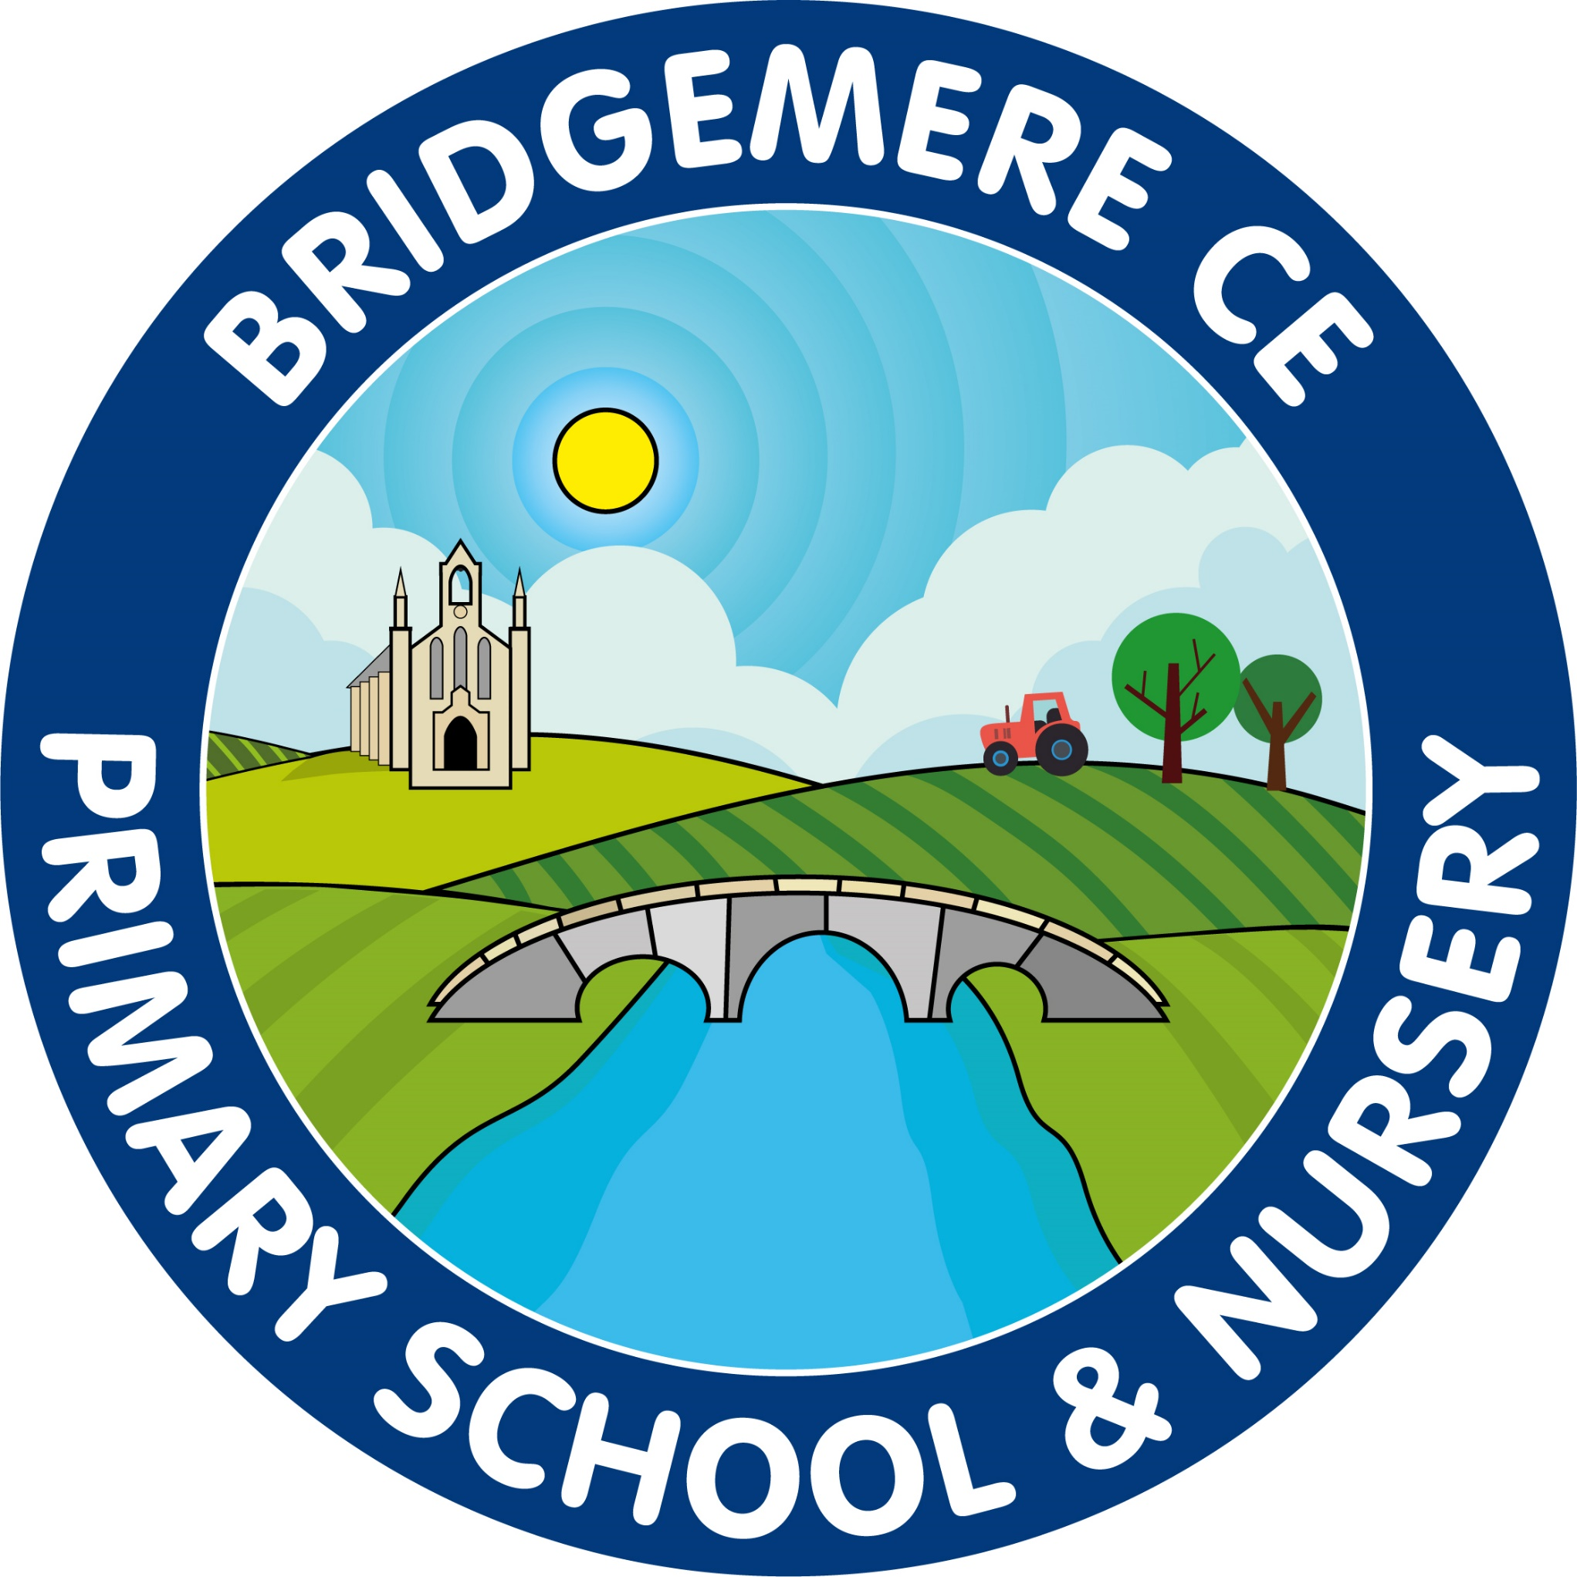  Dates coming up:  Tuesday 3rd January – Inset Day  Wednesday 4th January – School opens  Forest School begins for Class 1  All clubs start (except Dance) from week beginning Monday 9th January  Wednesday 11th January – Stay & Play 9.00-10.15am  Monday 23rd January – Miss Raiswell - Year 3 student from Chester University starts in Class 2  Thursday 16th February – Close for half term  Friday 17th February – Inset Day
Happy New Year  Wishing you all a very happy 2023. I hope you all had a good break and family time over Christmas.  It has been lovely to see all the children returning to school this morning, all eager and ready for the new year. Here’s to a great term and 2023 together at Bridgemere.  Goodbye Mrs Rowley  It with great sadness I wish to inform you that Mrs Rowley will be leaving us at Bridgemere at February half term. From the 16th January Mrs Knott will be covering the office 3 days a week whilst Mrs Rowley is commencing her phased start at her new school. We will inform you of the 2 days Mrs Rowley is in the office if you wish to contact her directly.  I know you will join me in saying that she is a great part of our team here, appreciated by governors and parents and loved by staff and children.  We wish Mrs Rowley all the best in her new appointment at Rode Heath School and wish her every success in the future.  Paternity Cover – Class 3  Mrs Lock will be covering Class 3 when Mr Lyons takes his paternity leave in this month. We will keep you posted with the dates and of course of the exciting news of the new arrival of baby Lyons.  We are still waiting for news regarding baby McGarrigle. Miss Slater has enjoyed her rest over Christmas and is on the final countdown!  We will of course let you know when we hear any news. | The Academy for Performing Arts  We are pleased to annouce that TAFPA will be delivering professional workshops to all our children on a Monday this half term as part of the PE curriculum.  There is also an opportunity for your child to attend extra curricular dance lessons on a Thursday from 3.20-4.05pm. If you are interested please contact TAFPA directly on 01270 821293.  Elf Run  Thank you so much for all your support in raising donations for St Luke’s Hospice before Christmas. The children had so much fun completing their ‘Elf Run’ and together we raised an amazing £1330.40. This is such a great achievement, thank you so much.  ‘Friends of Bridgemere’  Christmas Fair  Our Christmas Hamper Raffle raised a jolly £202! Thank you very much to those who donated all the lovely goodies and bought tickets.  Our Christmas Fair raised a tremendous £656! A big thank you to everyone, who helped at the Fair and attended, the children all had a great time!  As always, if you have any concerns or queries regarding your child’s education, please do not hesitate to contact me.  Caroline Middleton  Head Teacher

