Bridgemere CE Primary Newsletter  ‘I can do all things through Christ who strengthens me’  Philippians 4v13 January 2022 |  |  | 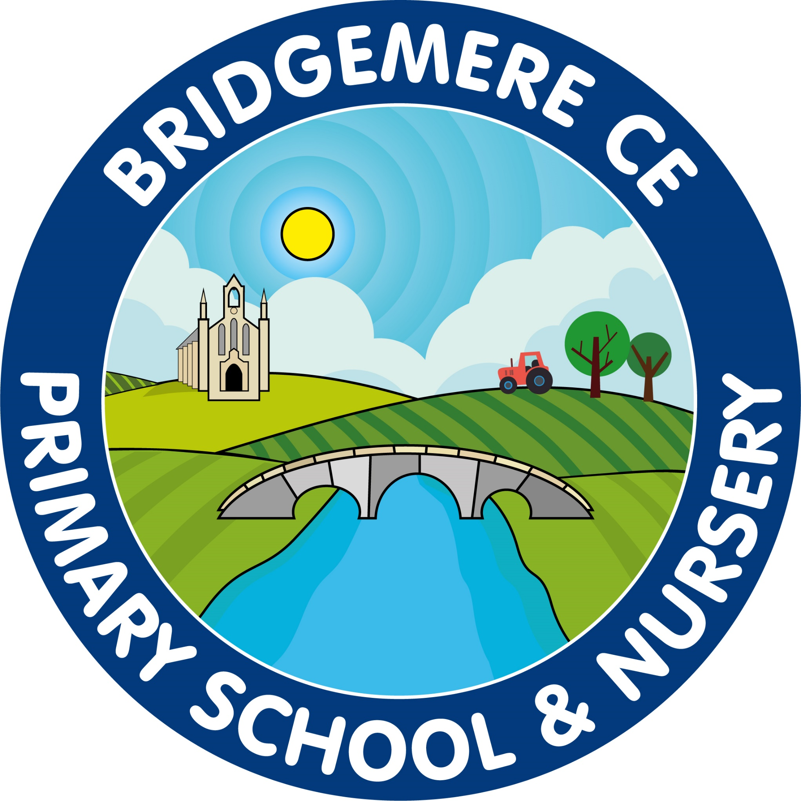  Dates coming up:  Tuesday 8th February – Internet Safety Day  Wednesday 9th February-  Class 2  Delemere – Foxhowl Parent Residential Meeting  Thursday 17th February-  Last day of school before half term  Friday 18th February – Inset Day  Monday 28th February – School open
Dear Parents/Carers  Thank you to all of you for your support while we have been dealing with Covid once again in this new term. Let’s hope that this recent disruption to everyday school life will be the last we see and we can enjoy the prospect of going into the rest of the year able to access the curriculum fully and being Covid free.  From next week all staff will be back at school and Boost sessions will commence once again in the morning and evening.  Anti-Bullying Alliance  Thank you to everyone who has sent their consent forms back to school to allow your child(ren) to take part in the anti-bullying questionnaire.  The children will complete this on-line next week and the data will formulate an action plan for the school.  Class 2 – Parent Residential Meeting Delamere – Foxhowl  Class 2 will have the opportunity this year to attend a residential at the Foxhowl Outdoor Education Centre at Delamere from Tuesday 5th-Wednesday 6th July.  Please look out for the related letter in your child’s reading bag this week.  We will be holding a parent’s information meeting on Wednesday 9th February. At the moment we are hoping to do this at school at 3.25pm. Hopefully we will host it in Class 2 but if we are still experiencing a lot of positive cases it will take place under the sheltered area outside Class 1, we will keep you posted. | FOB  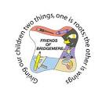  We made a profit of £679 at our Christmas Fair! Well done to everyone who helped and attended! We also made a profit of £71 on Nativity Play & Carol Service refreshments and £220 on the Christmas raffle. Thank you everyone!  PE Sessions  All of the children are enjoying the football and netball sessions on a Friday with Crewe Alex FC. These will continue for the rest of this half term. After half term British Gymnastics will be joining us in school and working with all classes and staff to develop gymnastic skills.  Mega Boost  Our after school club ‘Boost’ will be running the following topic based club each Tuesday from 3.30-4.30pm.  Tuesday 1st February: Chinese New Year Craft Club  Tuesday 8th February: Valentine’s Cooking Club  Tuesday 15th February: Valentine’s Disco  Each session will cost £5.00. If a sibling also wishes to attend the same session this will be at a reduced cost of £4.50.  If you would like your child to attend any of these sessions please contact the school office.  As always, if you have any concerns or queries regarding your child’s education, please do not hesitate to contact me.  Caroline Middleton  Head Teacher

