Bridgemere CE Primary Newsletter  ‘I can do all things through Christ who strengthens me’  Philippians 4v13 February 2022 |  |  | 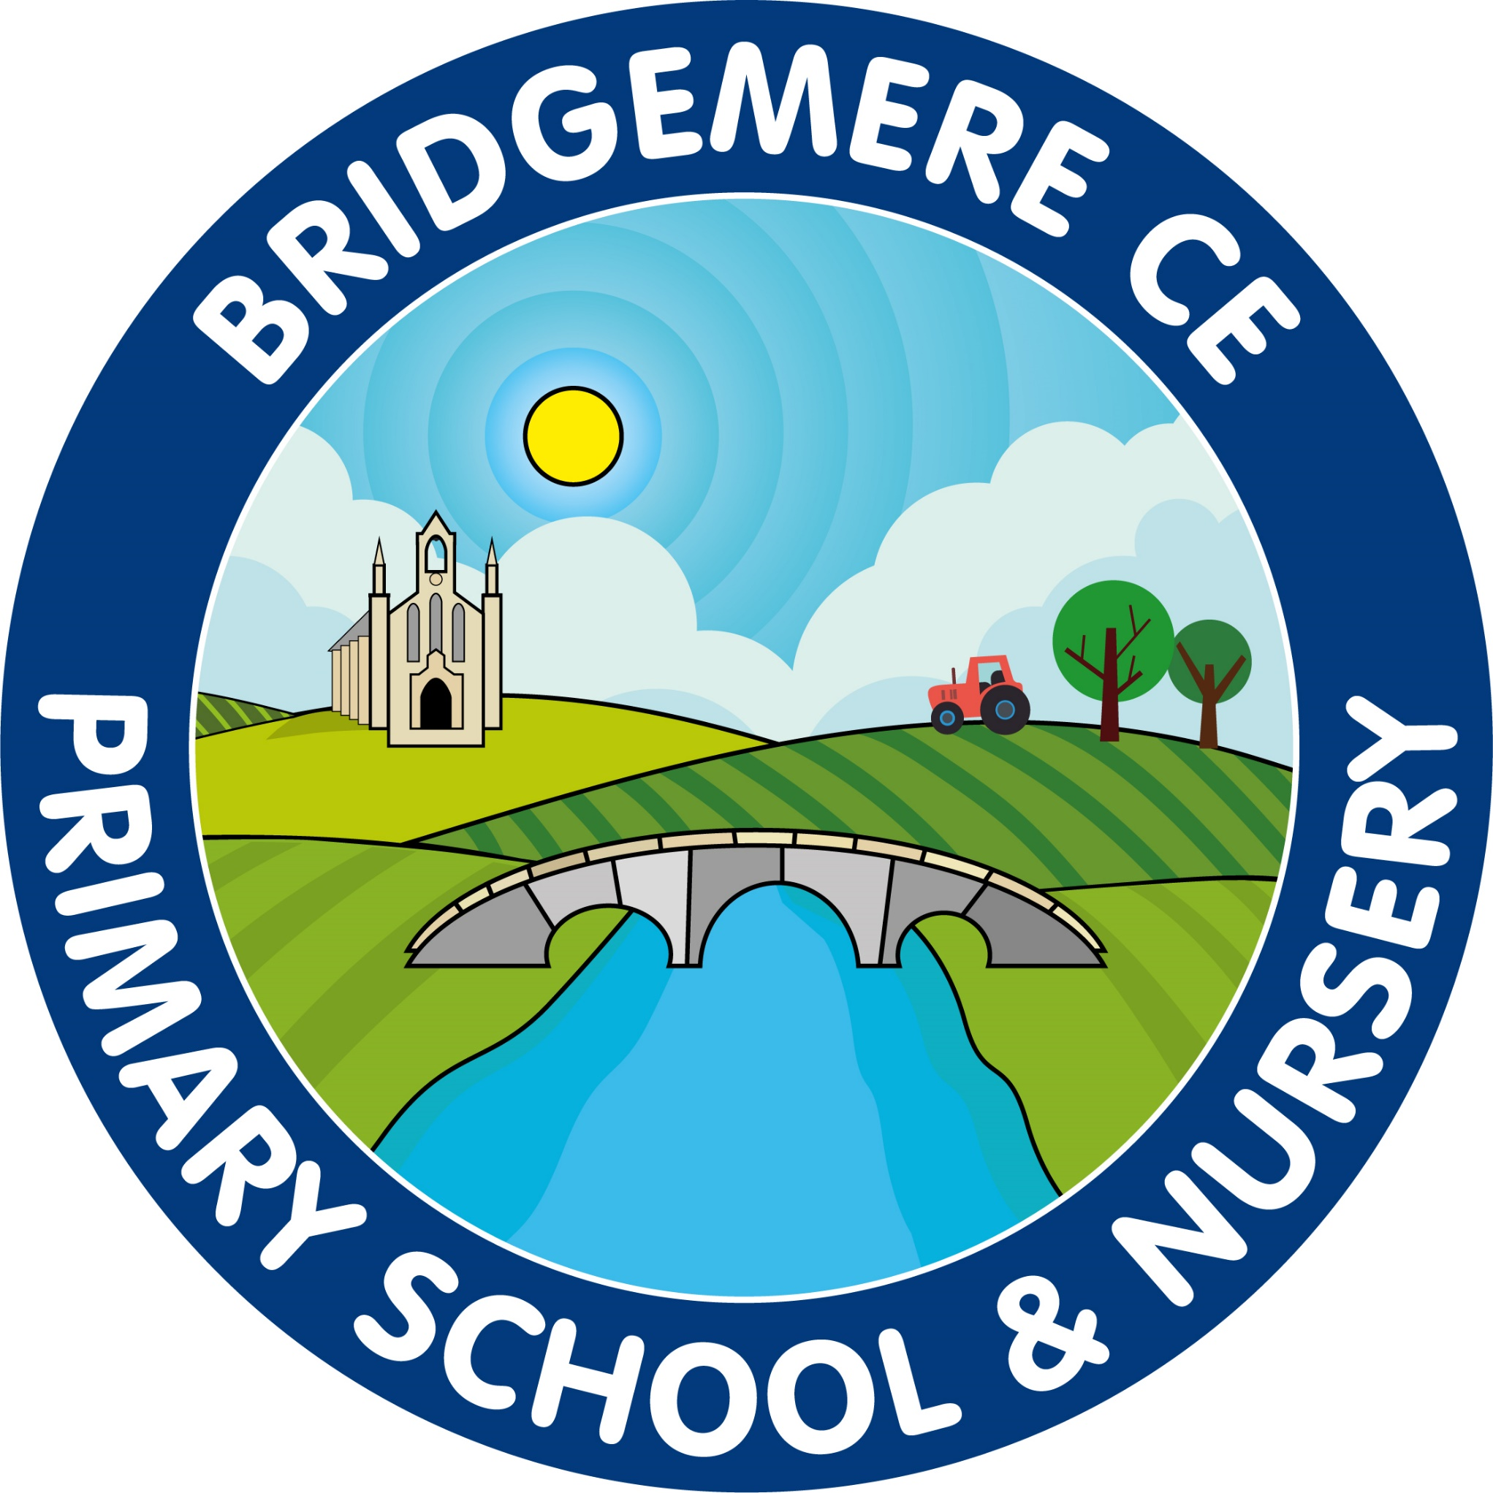  Dates coming up:  Thursday 17th February-  Last day of school before half term  Friday 18th February – Inset Day  Monday 28th February – School open  World Book Week  28th February – 4th March  Daily ‘Secret Reader’ session  2nd March – Book Swap  Reception visit to Nantwich Library – am  7th-9th March –  Parent’s Evening  14th-18th March –British Science Week  23rd March – Zoolab am visit for Class 1 & 2  Mothering Sunday Service –  Sunday 27th March @ St John’s Doddington  Wednesday 30th March –Easter Service 2pm  Break up for Easter – school closes  Friday 1st April
Parent’s Evening  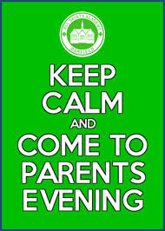  We will be holding our spring term Parent’s Evening the week beginning 7th March. We are hoping that these can be held in school so there is an opportunity for you to see your child’s learning in their books. A letter will be sent out before half term with further information.  Forest School  Class 3 will be the next class participating in our Forest Schools experience. Each session will be on a Wednesday afternoon and led by Rachel Ashley from Outdoor Fun.  The class will take part in Forest School on the following dates: Wednesday pm – 16th February & 2nd , 9th, 16th, 23rd, 30th March  Mega Boost  Our after school club ‘Boost’ will run the following topic based club each Tuesday from 3.30-4.30pm after half term.  Tuesday 1st March: Board Games Club  Tuesday 8th March – Craft Club  Tuesday 15th March: Spring Cooking Club  Tuesday 22nd March: Mother’s Day Club  Tuesday 29th March: End of Spring Term Party  Please fill in the form on line or in your child’s book bag to book their place.  Mother’s Day Service – St John’s Doddington  Rev Alison has invited you all to the Mothering Sunday Service on Sunday 27th March at St. John’s at Doddington church. She would love to see as many of our families as possible to come and celebrate with our community. | World Book Week  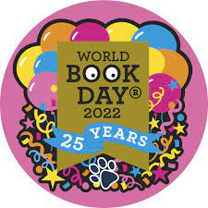  To celebrate 25 years of World Book Day we are planning a week of activities after half term (week commencing 28th February). To promote the love of reading we are inviting parents into school to be SECRET READERS! A secret reader is a parent, grandparent or guardian that visits the class and surprises the children with a story. You can choose your favourite book to read to the class, if you're feeling brave you are welcome to bring props or dress up! We will be having our secret readers in at the end of the day, we would need you to arrive at school for 2:45pm so we can sneak you into the classrooms while the children are in worship.  If you would like to be a secret reader then please email the office on: admin@bridgemerece.cheshire.sch.uk  with your available dates (28th Feb - 4th March) and we will contact you by the end of next week confirming dates.  We will also be holding another book swap event on the Wednesday (2nd). If your child would like to take part in this book swap then please ask them to find a book at home which they no longer want. We will then collect these books in the morning, and each child that has bought a book in will get to choose a new book to keep.  The theme for this year’s World Book Day is magic linked to 25 years of Harry Potter. We are inviting children on the Thursday 3rd March to come dressed up as a character from a magical book. These costumes needn’t be costly and the children often enjoy helping to make their own.  I would like to wish you all a lovely break over half term with friends and family.  As always, if you have any concerns or queries regarding your child’s education, please do not hesitate to contact me.  Caroline Middleton  Head Teacher

