Bridgemere CE Primary Newsletter  ‘I can do all things through Christ who strengthens me’  Philippians 4v13 December 2021 |  |  | 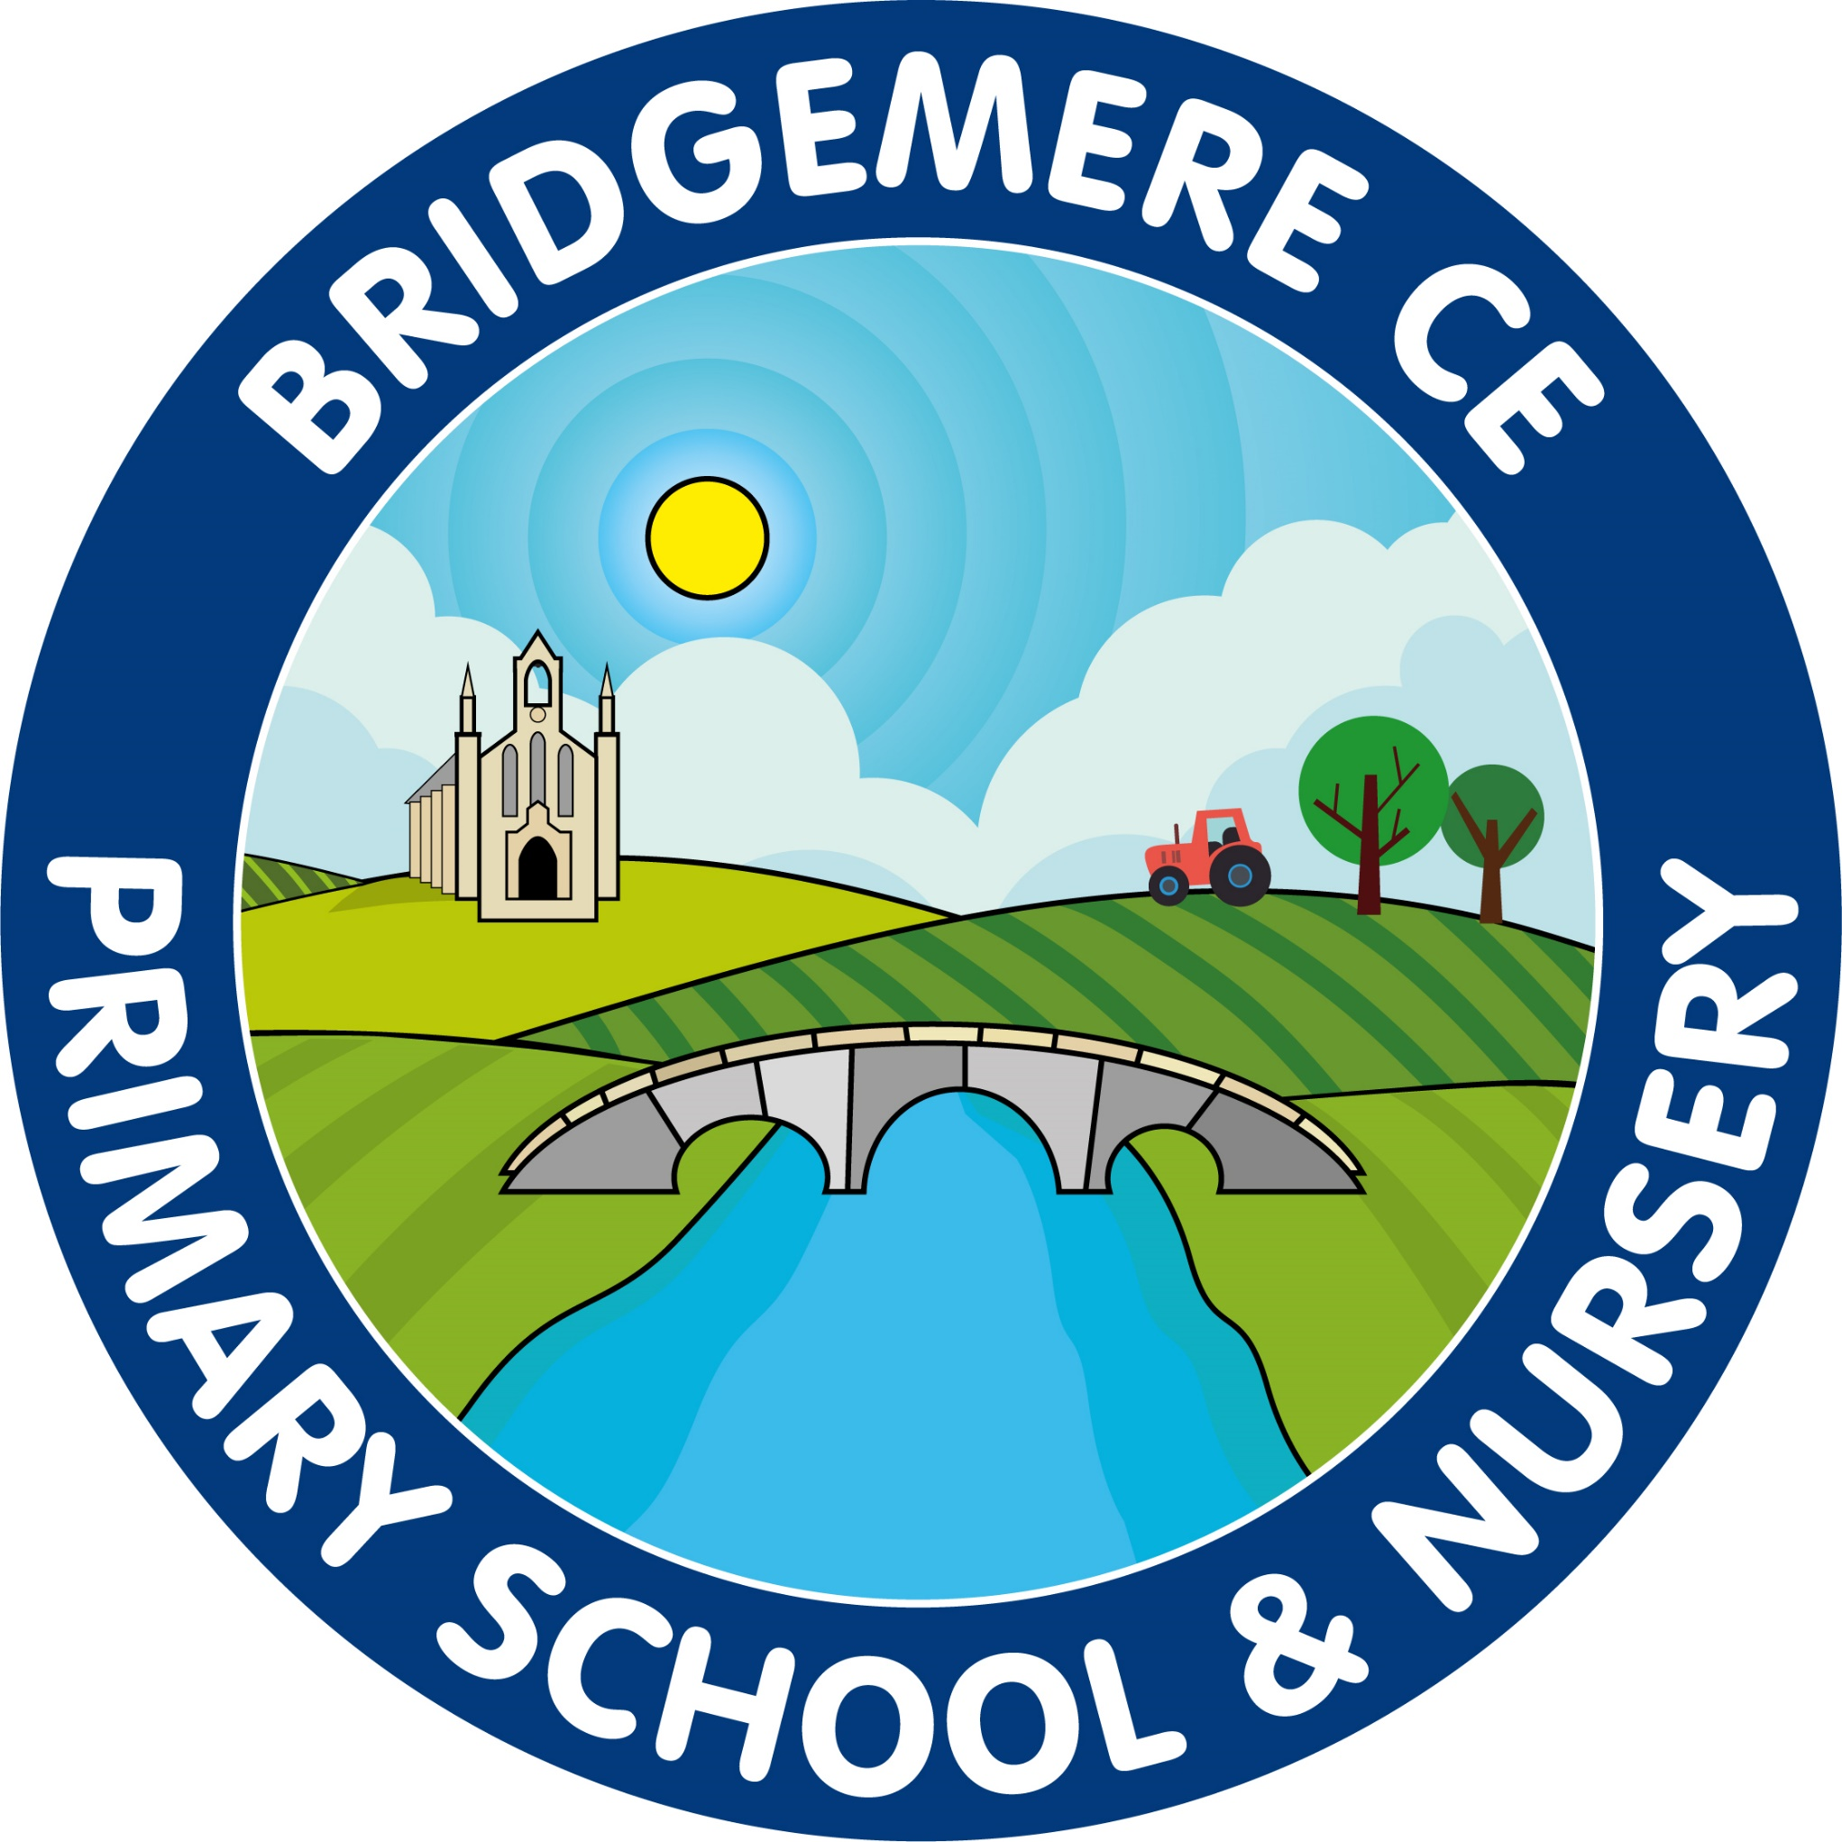  Dates coming up:  Tuesday 14th / Wednesday 15th December  Nativity –  Class 1 & 2  2.30pm  Thursday 16th December  KS2 Carol Service – 11am & 2.30pm  FOB Christmas Fair  3.15pm  Friday 17th December –  Christmas Dinner Day  KS1 and KS2 Christmas Parties  Finish for Christmas  School opens  Tuesday 4th January 2022
Dear Parents/Carers  The sun has come out for our final week at school this year which is a blessing for all the Christmas events that are happening outside.  If you have tickets for the Nativity or the KS2 Carol Service please come at 2.15pm for refreshments. We will open the side gate for you to walk around to the playground.  I would like to thank all the staff for their hard work and commitment this term. They have made a fantastic job creating our own Bethlehem shelter outside for the children to perform under.  Congratulations  Romani Rhodes-Fowles for winning first prize in the Police Commissioner’s Christmas card competition. John Dwyer, the Police and crime Commissioner of Cheshire came into school today to present Romani with her prize. An amazing achievement, well done Romani.  And congratulations to Isobel Stockdale for being a runner up in the Kieron Mullan Christmas card competition. A super result.  And finally well done to our choir for being runner ups in the SilkFM School Christmas Song Competition. You all sang so beautifully and put a smile on so many people’s faces, well done.  FOB  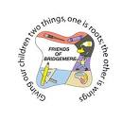  FOB would like to announce Emma Minshall as our new Secretary and Kieran Sawford as our new Social Media Coordinator! You'll both do a great job!  The winners of November's Lottery Club draw were 1st prize to Kate Webb, 2nd Jon Furber, 3rd Mrs Dickinson and 4th Mrs Driver. The December winners were 1st prize to Mr Driver, 2nd Rachael Hodgkins, 3rd Vicki Cornes and 4th Kieran Sawford. Thanks everyone! | Forest School  We are pleased to announce that we are starting our 'Bridgemere Forest School' experience in the new year. Rachel Ashley from Outdoor Fun will be coming into school to lead the sessions each Wednesday afternoon.  From January to July each class will have a 6 week block:  Class 1: Spring Term 1  Class 3: Spring Term 2  Class 2 : Summer Term 1  Class 4 : Summer Term 2  We will write to each class before their sessions begin to set expectations of behaviour and what clothing will be needed.  We are very excited about this new adventure and I am sure you will agree that the children will benefit so much from the outside learning they will receive.  School Christmas Events  FOB Christmas Fair  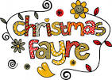  16th December @ 3.15pm  This will take place outside on the large playground with a Christmas market feel.  Please use the hand sanitising station as you arrive and follow the one way system.  Christmas School Dinner  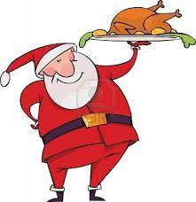  Is this Friday 17th December. No need to pre book your child can just order a dinner on the day  Christmas Parties  Is also this Friday 17th December.  Your child(ren) can come in party clothes on the day. Please can children wear sensible shoes as they will be outside on the playground as usual in the day.  As always, if you have any concerns or queries regarding your child’s education, please do not hesitate to contact me.  Caroline Middleton  Head Teacher

