Bridgemere CE Primary Newsletter  ‘I can do all things through Christ who strengthens me’  Philippians 4v13 April 2023 |  |  | 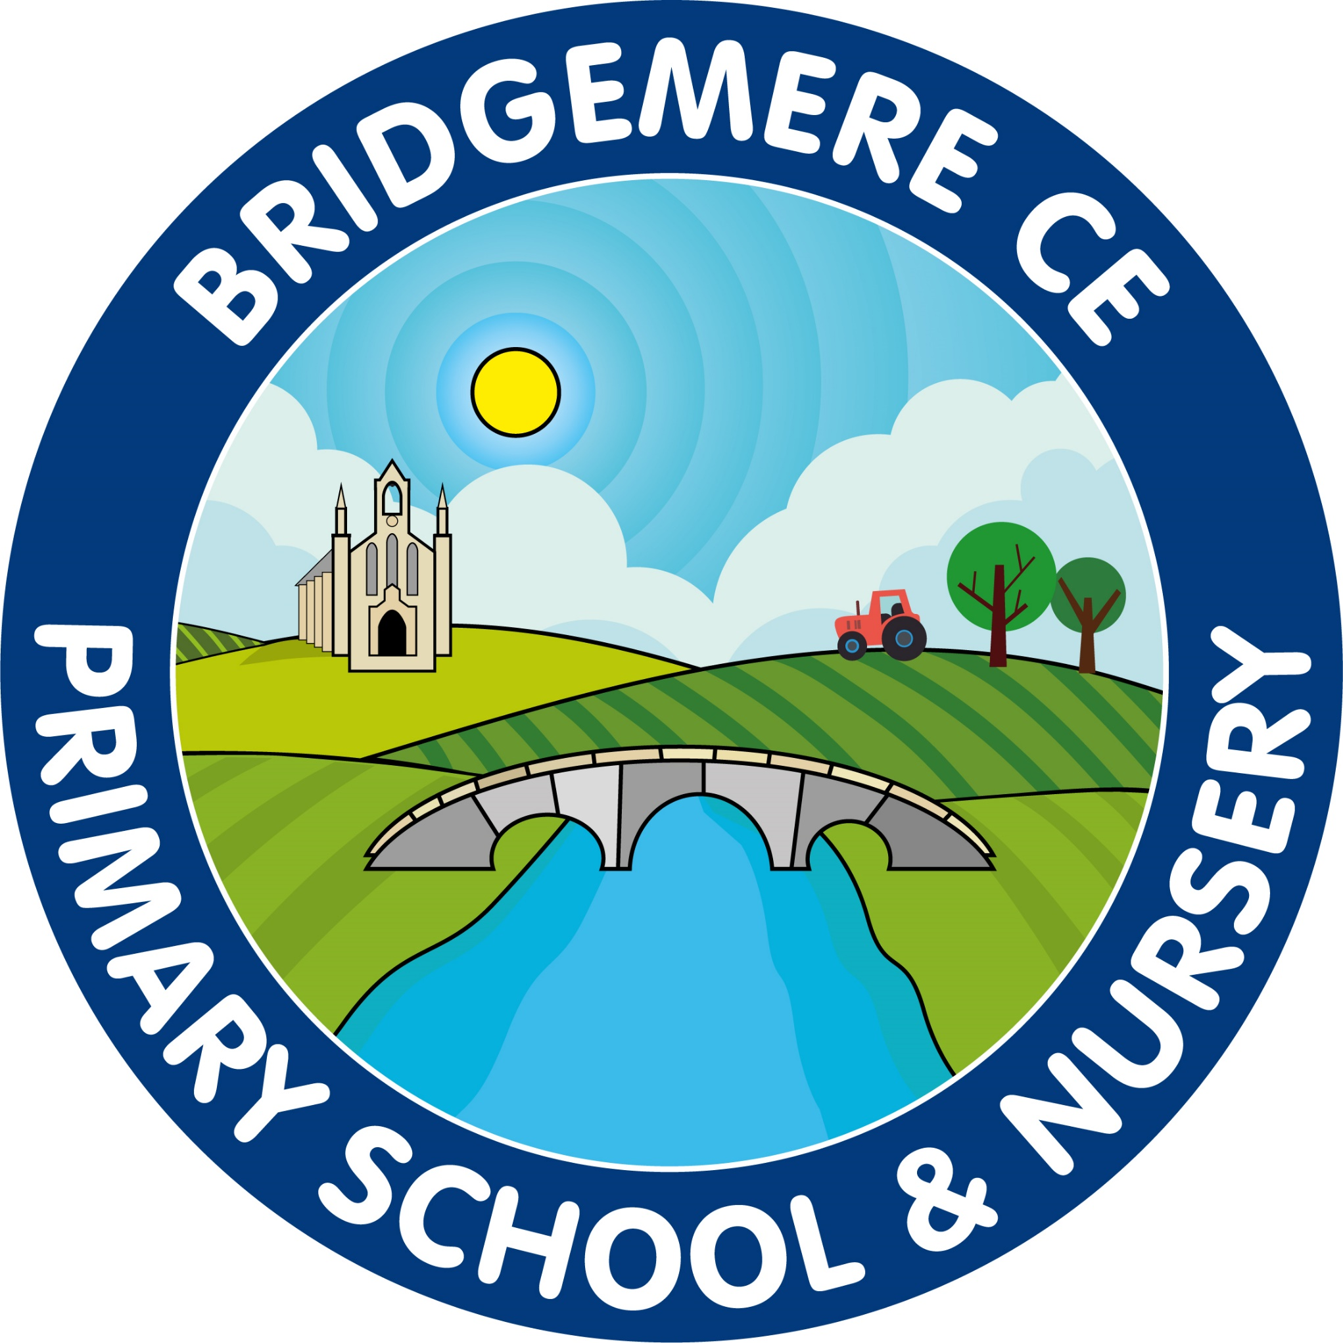  Dates coming up:  Return to school -Monday 17th April  ‘Stay & Play’  Friday 21st April 9.00-10.00am  Early Bank Holiday Monday – 1st May  Milldale Trip – whole school Thursday 4th May  Bank Holiday King Charles III Coronation – Monday 8th May  KS2 SATs – Tuesday 9th – Friday 12th May  KS1 SATs – Monday 15th – Friday 19th May  Class 4 Beeston Trip – TBC – Monday 22nd May  Break up for Whit Holiday – Friday 26th May
  A warm welcome back to the summer term here at Bridgemere CE Primary School. I hope that you all had a restful time over the Easter holiday and were able to spend time with your families.  A new term stretches ahead of us; as usual we will keep you up to date with all the activities and events that will be taking place.  Milldale Field Trip – Thursday 4th May    Once again, the school is being used for Polling Day on Thursday 4th May so will be using the opportunity for the whole school to have an outside learning day at Milldale Scout Camp. Please see the letter that will be sent home for further information and requiring your consent.  If you would like to come and support the learning taking place on this day please let your child’s class teacher know or Mrs Coats in the school office.  Friends of Bridgemere  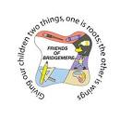  Our Mother's Day Gift sale raised £116! Thank you to Westholme Nurseries for supplying the pretty primroses and to everyone who helped decorate and sell them.  The winners of our 3 lovely Easter hampers were Eddie Forshaw, Vicki Cornes and Christy Woods. A big thank you to those who donated such wonderful goodies and bought raffle tickets. The Easter Raffle raised £143!  Our Easter Bingo was well-attended and raised £137! Thank you to everyone who helped on the day and for all the donations of yummy Easter eggs. | King Charles III Coronation  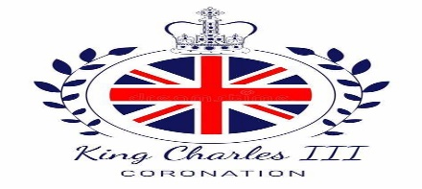  To mark the coronation of King Charles III Bridgemere CE Primary is joining other schools in the NEP (Nantwich, Education Partnership) in the ‘Crown of Crowns’ display in Nantwich Square.  The winner of our competition to design a crown fitting for our school will go to Brine Leas Art Department to create their crown  Which will be hung on the ‘Crown of Crowns’ tree in Nantwich Town Square week beginning May 1st ready for the big event!  In school we will be using the opportunity to teach a unit of history focusing on the chronology of timelines of our British monarchs and celebrating with a ‘Coronation Lunch’ on Friday 5th May.  KS2 SATs –  (Standard Assessment Tests)    The national testing of Year 6 pupils will take place from Tuesday 9th – Friday 12th May.  Tuesday 9th – Grammar, Puncatuation & Spelling  Wednesday 10th – Reading  Thursday 11th – Maths Paper 1 & 2  Friday 12th – Maths Paper 3  There will be a breakfast club for Year 6 pupils on these days from 8.00am to support and nerves and ensure a good start to the day.  KS1 SATs  These will take place the week beginnning Monday 15th May. The children in Year 2 will be tested in reading, maths and spelling, punctuation and grammar.  As always, if you have any concerns or queries regarding your child’s education, please do not hesitate to contact me.  Caroline Middleton  Head Teacher

