Bridgemere CE Primary Newsletter  ‘I can do all things through Christ who strengthens me’  Philippians 4v13 April 2022 |  |  | 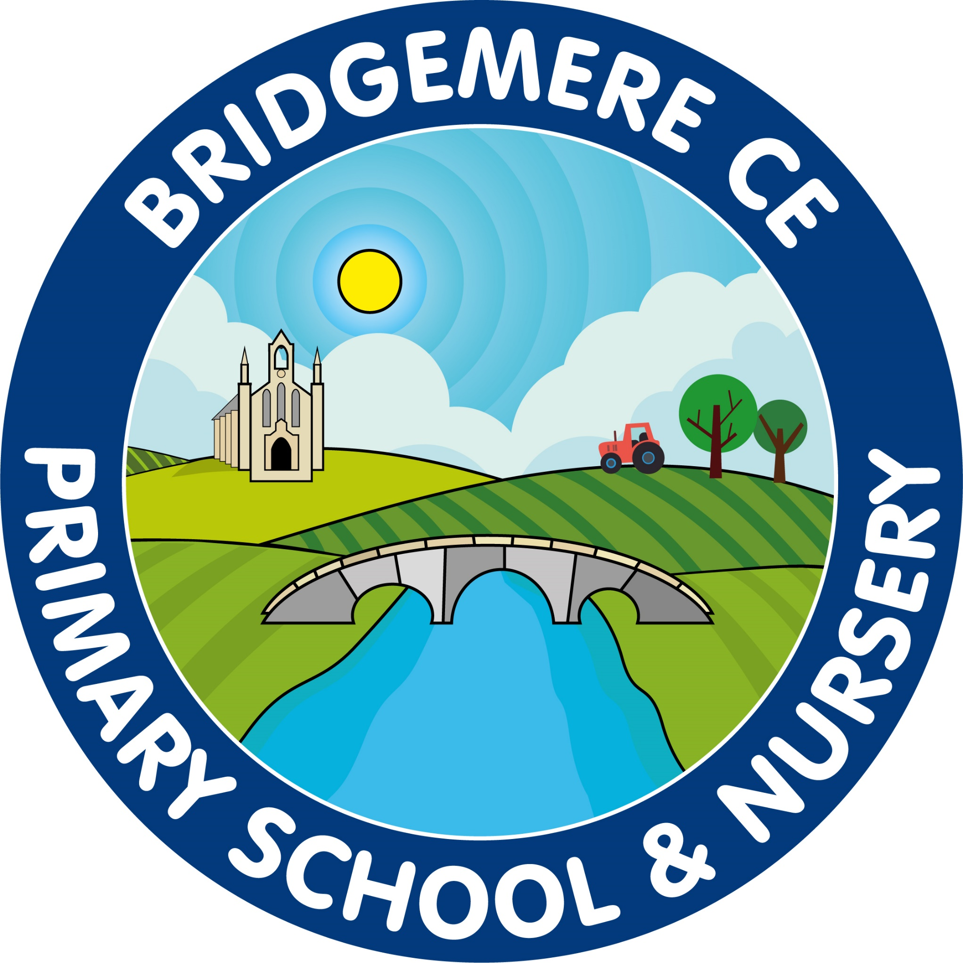  Dates coming up:  Break up for Easter – school closes  Friday 1st April  School opens for summer term  Tuesday 19th April  Class 3 Residential – Bala  Wednesday 20th-Friday 22nd April  Class 2 start Forest School – Wednesday 20th April  Parent Council – Wednesday 27th April 6.30pm  KS1 SATs start – 3rd May  KS2 SATs week –Monday 9th May  Queen’s Platinum Jubilee – 2 week ‘Learning in context’ starts Monday 16th May  Break up for half term – Friday 27th May
Once again we have reached the end of another term! Wishing you all a well deserved break over Easter and looking forward to welcoming everyone back on Tuesday 19th April for the start of the summer term.  Goodbye Mrs Wilcox and Mrs Foyle  At the end of this week we will be saying goodbye to two members of staff that will be greatly missed here at Bridgemere.  We welcome Mrs Chandler who will be replacing Mrs Wilcox in Class 1 on a Wednesday, Thursday and Friday. Mrs Chandler is an experienced teaching assistant who is excited to work with our Nursery and Reception children, I am sure she will settle in quickly.  We are very sad to say goodbye to Mrs Folye, she has been a great member of the Bridgemere team for many years. Mrs Knott has been supporting Mrs Hollowood in morning Boost sessions for a number of weeks, after Easter she will continue this role in our after school sessions also.  We wish both Mrs Wilcox and Mrs Foyle every success for the future.  Friends Of Bridgemere - FOB  We raised a fantastic £120 at Easter Bingo! A big thank you to everyone, who helped out on the day and to you all for donating the delicious Easter eggs. | 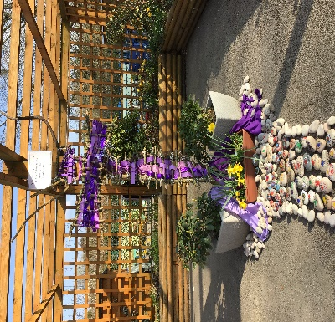  Lent – Outside Reflection Area  Thank you to the Ethos Council who have taken time over the last two weeks to think and put together our new outdoor reflection area. Each child and member of staff have placed a stone on the path leading to the cross with their name and fingerprint to show they are special and unique to God. We would love for parents to also add their own stone, please help yourself to a stone.  Bridgemere School Choir  If there are any children in Class 3 or 4 who would like to join the choir with our already established group please contact the office.  Choir Club takes place on a Monday 3.15-4.00pm.  As always, if you have any concerns or queries regarding your child’s education, please do not hesitate to contact me.  Caroline Middleton  Head Teacher

