Bridgemere CE Primary School and Nursery
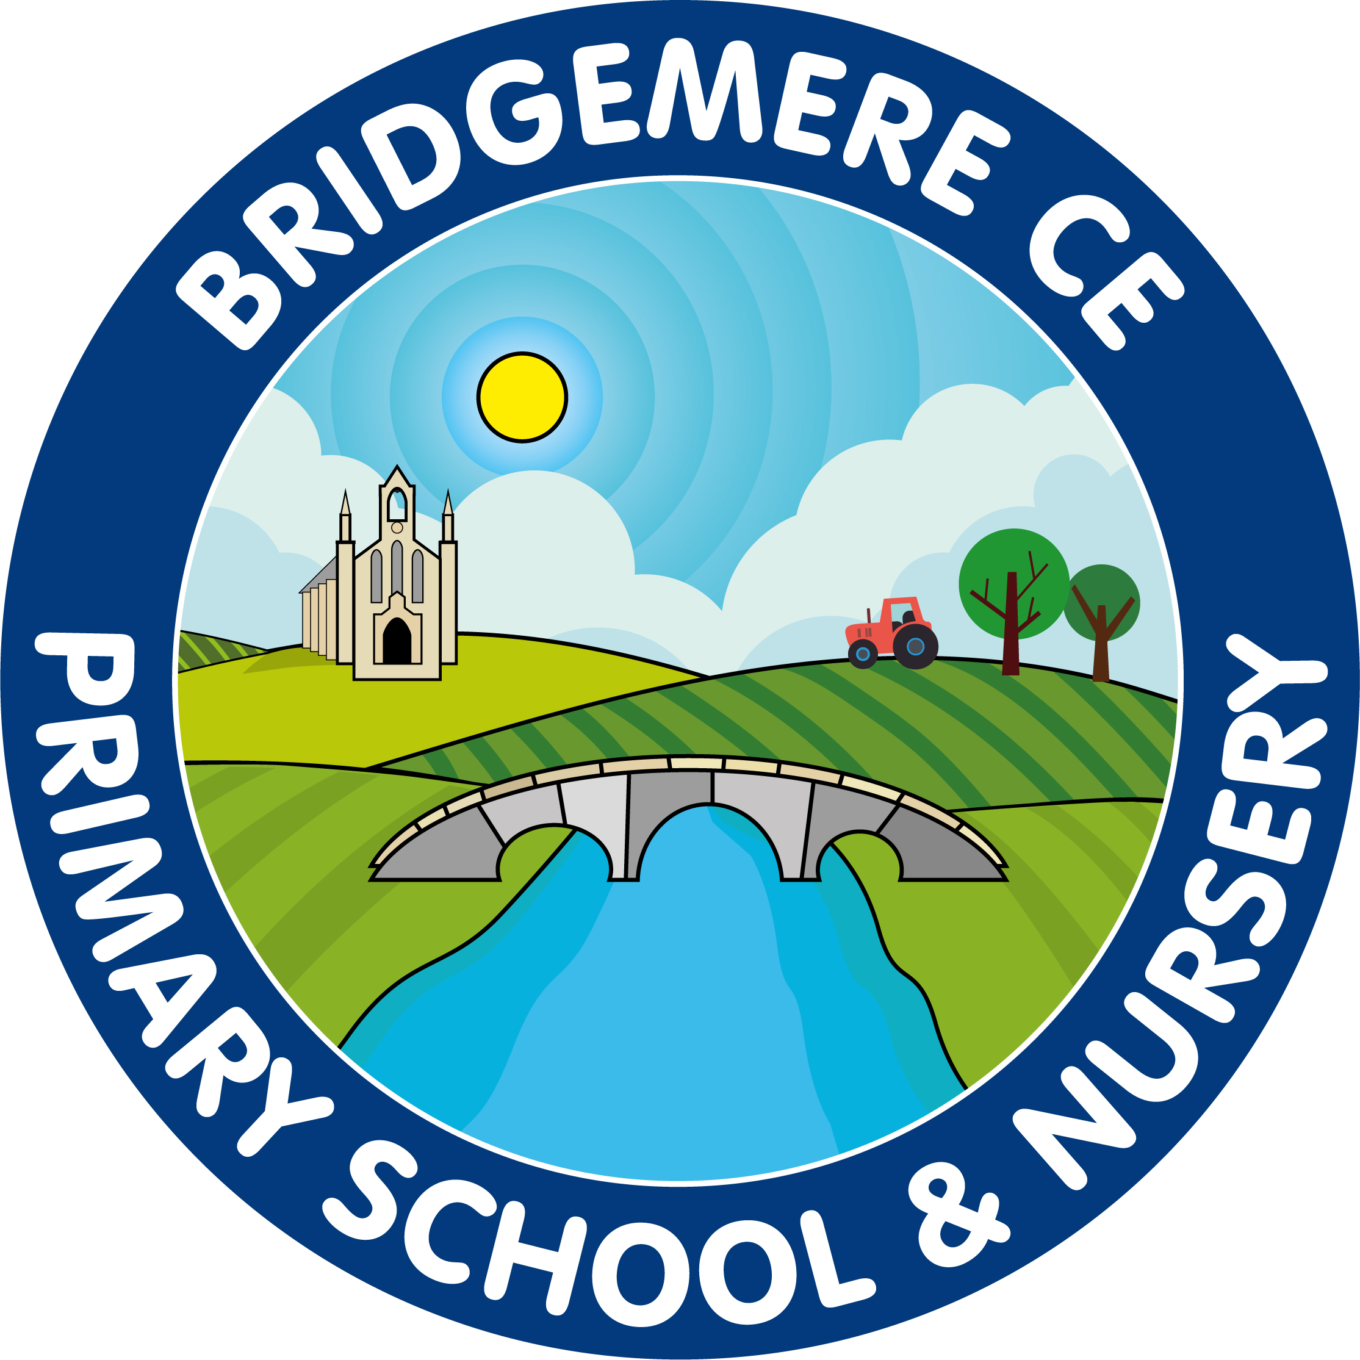
Singapore Maths 2021-22

Introduction:
At Bridgemere CE Primary School, we aim for the children to leave school at the end of Key Stage two with a strong ability to perform a range of mathematical skills and use and apply them across a range of contexts. We achieve this by increasing the children’s number sense, alongside developping their confidence and independence. A consistent and progressive approach to the teaching of mathematics, following the Singapore Maths approach, provides children with the opportutnity to encounter and dsicuss concepts - in depth. Children follow the CPA approach (contrete, pictorial and abstract) – which allows all learners to access mathematics in their own way, developping both accuracy and understanding, leading in turn to high quality reasoning and masters of mathematics.

Aims:
- Ensure all children in Key Stage 1 and 2 follow the Singapore Maths approach every day.
- Provide children with opportunities to apply and use maths across a range of different contexts- both within problem solving and real life.
- Ensure that children have a strong number sense through regular practise and consolidation of both times tables and mental calculation skills.
- Ensure that children read, write and use mathematical language with confidence.
- Provide consistent opportunity for children to reason mathimatically – both verbally and in written form.
- Provide a purpose and real life context for the mathematical skills being taught.
- Develop a love of learning for all learnerswithin each and every maths lesson.

Planning and delivery of maths:
Planning is based on the Singapore maths approach. All teachers have access to the online resources as well as textbooks and workbooks to support this.

The general guide for lessons is:
- Exploration (10 minutes)
- Structure (10 minutes)
- Journaling (10 minutes)
- Guided Practice (15 minutes)
- Independent (10 minutes)

All lessons should begin with an In Focus (anchor) task, a problem that children complete, encouraging high-level thinking and reasoning. Significant time should be spent on this task and effective questioning should develop both reasoning and multiple ways of solving the same problem. Group/pair work should be encouraged at this stage. Children should be supported through the CPA approach. Decisions on differentiation are made by class teachers and teaching assistants – based on the individual needs of the children and concept being delivered.

Teaching should encourage finding multiple ways of finding an answer. Embracing this philosophy will enable children to choose methods that work best for them when solving problems independently. Children should then write their ideas and explanations for the problem within their Journals. Teachers should use the ‘Let’s Learn’ part of the textbook to aid the understanding of children within the lesson and to ensure all methods have been shown.

All children should progress onto Guided Practice, which should be completed with the teacher and class, as a model for the independent work. This does not need to be completed in journals.

Then, children progress onto their independent work in their workbooks. This should then be marked in green pen by the teacher. Teachers should place a tick and green dot by any question that is incorrect, and children given time to correct them. Blue pen can be used in workbooks and journals for corrections and peer marking. Children can complete challenges in blue pen however should complete longer challenges or drawings in pencil to keep journals neat.

Further challenge:
For those children who finish their journaling quickly or are GD children and need stretching, teachers should use the ‘differentiation’ part of the online textbook to help them generate further questions linked to the problem before the lesson. Teachers should also use effective questioning (both verbally and though marking) to enable the children to provide as much in-depth reasoning to the problem they have been given as possible. Eventually, the children will become independent at providing full explanations for themselves.

Example question stems for journaling:
- What do you notice?
- How might you…?
- What is the same and what is different about …?
- What might come next?
- How would you explain/show…?
- What does that tell us about…?
- What is wrong with…?
- Why do you think that…?
- Is there another way/reason/method …?
- What if …? / What if …does not ...?
- Show me, prove to me that....
- Which method do you prefer, why?
- Which is the most efficient method?
- Can you predict what might happen if….
- What is the relationship between...?
- Can you create your own....?

Those children who finish their workbooks quickly or to aid the structure for mixed age classes, teachers can use: Testbase, Mathsframe, NRICH, White Rose Maths hub or NCTEM resources to provide more in depth reasoning practise. These resources can also be used for occasional consolidation lessons, for concepts the children need more practise with before moving onto the next chapter. These can be evidenced in journals also.

All the objectives in the Singapore maths scheme must be taught for that year group- a long term overview with the objectives has been given to staff.

Throughout the year, Year 2 and Year 6 will have additional reasoning evidence in their journals, in preparation for their SATS in May.

There should also be opportunities to use mathematical skills in real life by extending maths across the curriculum – particularly in the area of science.

Presentation:
Teachers should have high expectations of presentation in the journals. They will be ticked to acknowledge they have been read and if there are misconceptions a (VS) verbal support or (T) for support in that session or the next. Teachers can also use an (I) if a child has completed a specific question independently. Children can also be given mountain symbols if the teacher would like to challenge further within a lesson.
Teachers can use their own judgement whether to have the objective already typed for specific children but the ‘In focus’ task needs to be stuck into journals to save time and aid presentation.

4/10/19
Journal 1:4 – Can I multiply correctly?

There should be evidence of Singapore maths every day in Journals, however there may be times where consolidation lessons, practical lessons or active lessons need to take place to help solidify learning.
They should be encouraged to underline with a ruler and write one number into each box. For children who find it difficult to write neatly, scaffolds should be given to aid their presentation e.g strips for bar models, pre-drawn pie charts.
Vocabulary should be updated on the working walls each lesson to encourage children to use good mathematical language within their reasoning and to spell them correctly.
Children will record their methods showing M1, M2, M3…to ensure they are easy to read.

Inclusion:
Use of the CPA approach enables access for all leaners on a daily basis. It is expected that, unless a child is significantly behind his/her peers, he/she will be accessing the same problem each day. Differentiation takes place through the CPA approach and the methods/explanations they discover.

Some children will have TA support during lessons. It is vitally important that they support learning and further question, rather than solve problems for the children. They should feedback assessment information following each lesson.

Assessment:
Following each chapter there is a ‘review’ which needs to be completed independently by the child. This will then inform the teacher whether a child is meeting those objectives and achieving GD, expected or emerging. A greater depth child will be achieving the reviews with no errors and showing confidence with explanations/reasoning in their journals. The reviews will then aid staff to complete their assessment grids for each objective. There are also ‘Revision’ sections after a few chapters, which will also be a further way to assess the children, a few weeks after a section of work and to check their understanding.

