Our Marking Codes March 2018
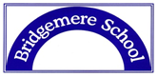

Our children know how well they are doing from the code they receive at the end of their work:
A1 = Outstanding. Well done, you’ve got the majority of your work correct. You will have a challenge to complete during ‘Early Work’.
A2 = Good. Well done, you’ve got most of your work correct. Correct your mistakes during ‘Early Work’.
A3 = Good Try. I will help you before our next lesson. The child will then work directly with an adult (assertive mentoring).

P1 = Perfect Presentation. Well done - Team Point for excellent presentation.
P2 = Good Effort. Improve your presentation slightly and you’ll achieve a P1.
P3 = Please do this work again. Please redo this work again at playtime.

Teachers mark in green pen. We use the following codes to help the children to improve their work:
 | Correct answer, well done
• | Check again
Underlined word | Spelling Mistake
Circle | Punctuation Error
[ ] around a section of the children’s writing | Improve this section

The children are encouraged edit and improve their work before they hand it in for marking. This will be done in pencil or black ink. The marking codes will indicate exactly where a teacher has had direct input into a child’s work. The children respond to the teacher’s marking in blue pen.
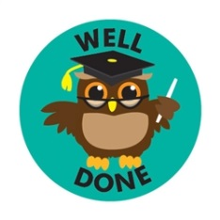
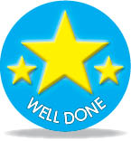

Stickers or Smiley Face = Team Point

