Bridgemere CE Primary School
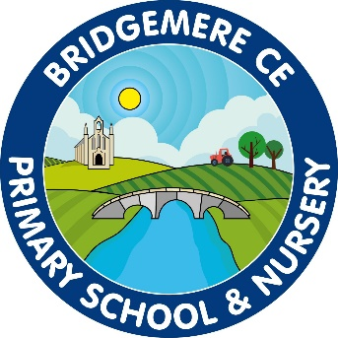

Marking and Presentation Policy

I can do all things through Christ who strengthens me’
Philippians 4 v 13

Confirmation that the Marking and Presentation Policy has been discussed and approved by the Staff
March 2025

To be reviewed
September 2025

Marking and Presentation Policy

Marking:
Introduction
Marking of children’s work is a fundamental part of the process of teaching and learning in school and is an important part of the assessment process. Marking demonstrates a respect for the work produced, gives feedback and indicates the ways in which the individual child can improve. Marking will also encourage the child to look at errors in a positive manner.
Our Aims
- To give credit for achievement.
- To provide guidance on future needs and to help improve work in progress.
- To monitor learning and progress.
- To teach children to develop their own evaluative and assessment skills in responding to their own work and that of others.

Entitlement.
All children will receive verbal and/or written responses to tasks indicating their achievements and identifying strengths and areas for improvement.
Specific comments relating to improving skills and understanding will be made during the process of learning wherever possible. During these discussions, children will be encouraged to evaluate their own work and be given opportunities to assess the work of others.
Here at Bridgemere CE School we believe that ‘live marking’ with the children is the most beneficial.

Implementation
- Work will be marked in green pen and where applicable with the child concerned.
- Teacher’s comments will be written in cursive handwriting.
- Teachers will use their professional judgement as to the amount and type of errors indicated in any single piece of work.

- Incentive stamps, stickers or merits can be used for all children where appropriate.
- Marking will be handed back quickly to encourage discussion of work and focus on targets.
- The teacher’s professional judgement is the key factor in all assessment. Therefore, marking will often be selective and focused on specific areas in order to foster positive attitudes in our children.
- Children will be encouraged at times to mark their own work or group work using peer assessment, if appropriate.
- Peer assessments will be done on post-its and stuck over the piece of work assessed.
- Success ‘Can I….?’ criteria will be used where appropriate for teacher and pupil marking. Criteria will be ticked.
- Children have time to self-assess a piece of work
☺ - Yes I got it!
😐 - I need some more practise
☹ - I haven’t got it yet
- If a session has been entirely practical, either an annotated photo of the session should be in books, or a statement describing the focus of the session.
- Daily targeted marking to take place with a group focus when marking writing to ensure there is not an overload of marking for the teacher and all books are marked weekly with specific detail.
- Supply teachers should mark all set work and return it to the class teacher.
- The audience for children’s work will be widened in order to demonstrate our respect and the value we give it. For example, reading and sharing work in the class group, with other classes, displaying work in all parts of the school, photographic recording, sharing work with other schools and the wider community.
- In these ways, marking will contribute to the raising of self-confidence and self-esteem.

English:
- English marking will include its own set of marking symbols which is in line with Ready Steady Write sentence checkers that are in the back of children’s books.
- All age appropriate high frequency words should be underlined if they are spelt wrong and corrected by the children (unless a child with specific needs in this area).
The teacher or child will write the spelling on the child’s individual spelling word bank that are in the back of the children’s books.
In KS1 the children are expected to practise the writing of the spelling 3x in their book.
- Blue pen is only to be used by children in the editing process of their writing. At all other times they are to use pencil.

Reception, Year 1 &2:
Check finger spaces – picture of a finger
Check capital letters - CL
Check punctuation – P.?! – full stops, question marks exclamation marks

KS2: To be used appropriately for the need of the child. Marking
symbols to be written at the bottom of the page.
Check spelling – wavy line under the word
Check capital letters - CL
Check punctuation – P.?! – full stops, question marks exclamation
marks
Check cohesion – ( ) brackets around specific sentence or
paragraph

Maths:
- Teachers marking will based around four main symbols which will require different pupil responses.
- The dot indicates corrections.
The child writes the correct answer in pencil next to the error, they do not rub out or write over the error.
- The mountain indicates a challenge to follow on or extend learning.
- T/LSA indicates that they have worked with a Teacher or Learning Support Assistant to complete the work
- I indicates that a child who may have previously needed support has completed the work independently

Science / RE / History / Geography:
- The success ‘Can I….?’ criteria will be ticked by the teacher or pupil. This will indicate the work has been checked and the criteria achieved. If the child has not achieved the success criteria the teacher will tick the bottom of the page to indicate the learning has been checked.
- In some cases the children will self-assess a piece of work
☺ - Yes I got it!
😐 - I need some more practise
☹ - I haven’t got it yet
- In some cases the mountain symbol will be used to indicate a challenge to follow on or extend learning.
- Specific language may also be highlighted.

Presentation:
Aims
- To establish high expectations and pride in everything we do – both of ourselves and of the pupils.
- To create a clear and consistent set of guidelines for the presentation of pupils’ learning.

Objectives
• To motivate each individual to present their work in the best possible way.
• To enable pupils to recognise work that is presented to a high standard.
• To ensure each child knows the standard of presentation that is expected of
them.

For Teachers
• To create consistency in standards of presentation across the school.
• To provide a baseline for judging acceptable standards of presentation.

Expectation for layout:

Maths
Reception & Year 1:
2cm squared books – Date (short) and ‘Can I….’ objective to be stuck in by class teacher on the left-hand side of pupil workbook.
7.9.24
Journal 1.1 – Can I?……

Explore

Year 2, 3, 4, 5 & 6:
Year 2 – 1.2cm squared books
Year 3 & 4 – 1 cm squared books
Year 5 & 6 – 0.8 cm squared books

On left hand side of page, written by pupil in pencil
Date 7.9.24
Journal number
‘Can I…’ objective
In Focus task to be stuck in below.
Children are expected to use the symbols below when journaling their methods.
1
M - Year 1 & 2
1
Method - Year 3, 4, 5 & 6

Children are encouraged not to rub out mistakes and to use one square per digit.

Writing:
Reception, Year 1 & 2
Label stuck in the left-hand side of work book. Date (long) and ‘Can I…’ objective.
Monday 3rd September

Can I……

Year 3, 4, 5 & 6:
The long date and ‘Can I…’ objective are written by the pupil and underlined on the left hand side of the page.
A line is left between the date and the ‘Can I…’ objective.

Ready Steady Write statements are used to indicate the process of the writing;
- Immerse/Jump in
- Analyse/ Look
- Plan
- Write
In the planning there is a clear
Purpose:
Outcome:
indicated which can be used to support the ‘Can I…’ statement.

SPAG:
Year 3, 4, 5 & 6:
Left hand side of the page
Week beginning: is written as work is completed throughout the week.
Grammar or spelling focus is put into a ‘Can I…’ objective.

Science:
All children:
Science presentation of the date and ‘Can I…’ statement is the same as writing with the long date and ‘Can I..’ objective on the left-hand side of the page.

Monday 3rd September

Can I……

A coloured dot ● in the margin indicates the scientific process taking place, this is linked to the planning. These are the colours and enquiry needed:
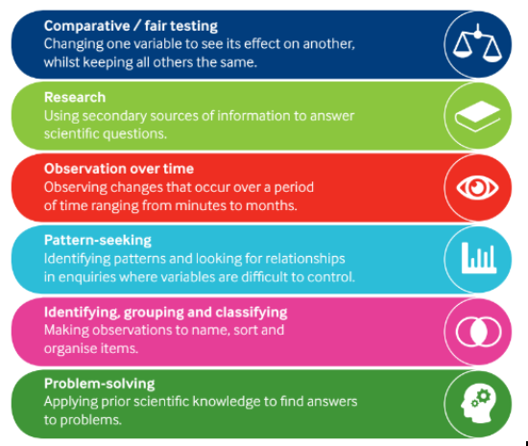

RE:
Work can either be in the Class RE Big Book which is used for discussion and group work or individual pupil workbooks.
The long date and ‘Can I…’ is written on the left-hand side of the page or as a label that can be stuck in the Big Book of pupil workbooks.

Monday 3rd September

Can I……

Questful Learning Maps and God’s Big Story cards (KS2) are kept in the front flap books with assessment sheet on the opposite page.
Each unit of RE Questful learning is indicated in the RE Big Book.
Assessment pieces of work are in individual workbooks.

Music / Art sketchbooks / DT workbooks:
Labels are stuck in on the left-hand side of the page with the date and ‘Can I…’ objective.

Monday 3rd September

Can I……

History:
All children: Labels are stuck into the left-hand side of the page with the long date and the ‘Can I..’ objective.
This is linked to the ‘Enquiry Led Question’ indicated in the planning.
A time-line must be present in the front of all pupils’ workbooks for reference.

Geography:
All children: Labels are stuck into the left-hand side of the page with the long date and the ‘Can I..’ objective.
This is linked to the ‘Enquiry Led Question’ indicated in the planning.
A world map with countries must be present in the front of all pupils’ workbooks for reference.

Computing:
All work is to be saved into Google Drive or individual Purple Mash folders.

Monitoring
At certain times throughout each term, the Headteacher and Subject Leaders will collect together examples of children’s books and ask the children to discuss their learning. The books will be scrutinised to ensure each teacher is adhering to the guidelines set out in this policy.
It is up to every teacher within the school to deliver the contents of this policy.

Review
This policy will be reviewed annually in the Autumn Term.

