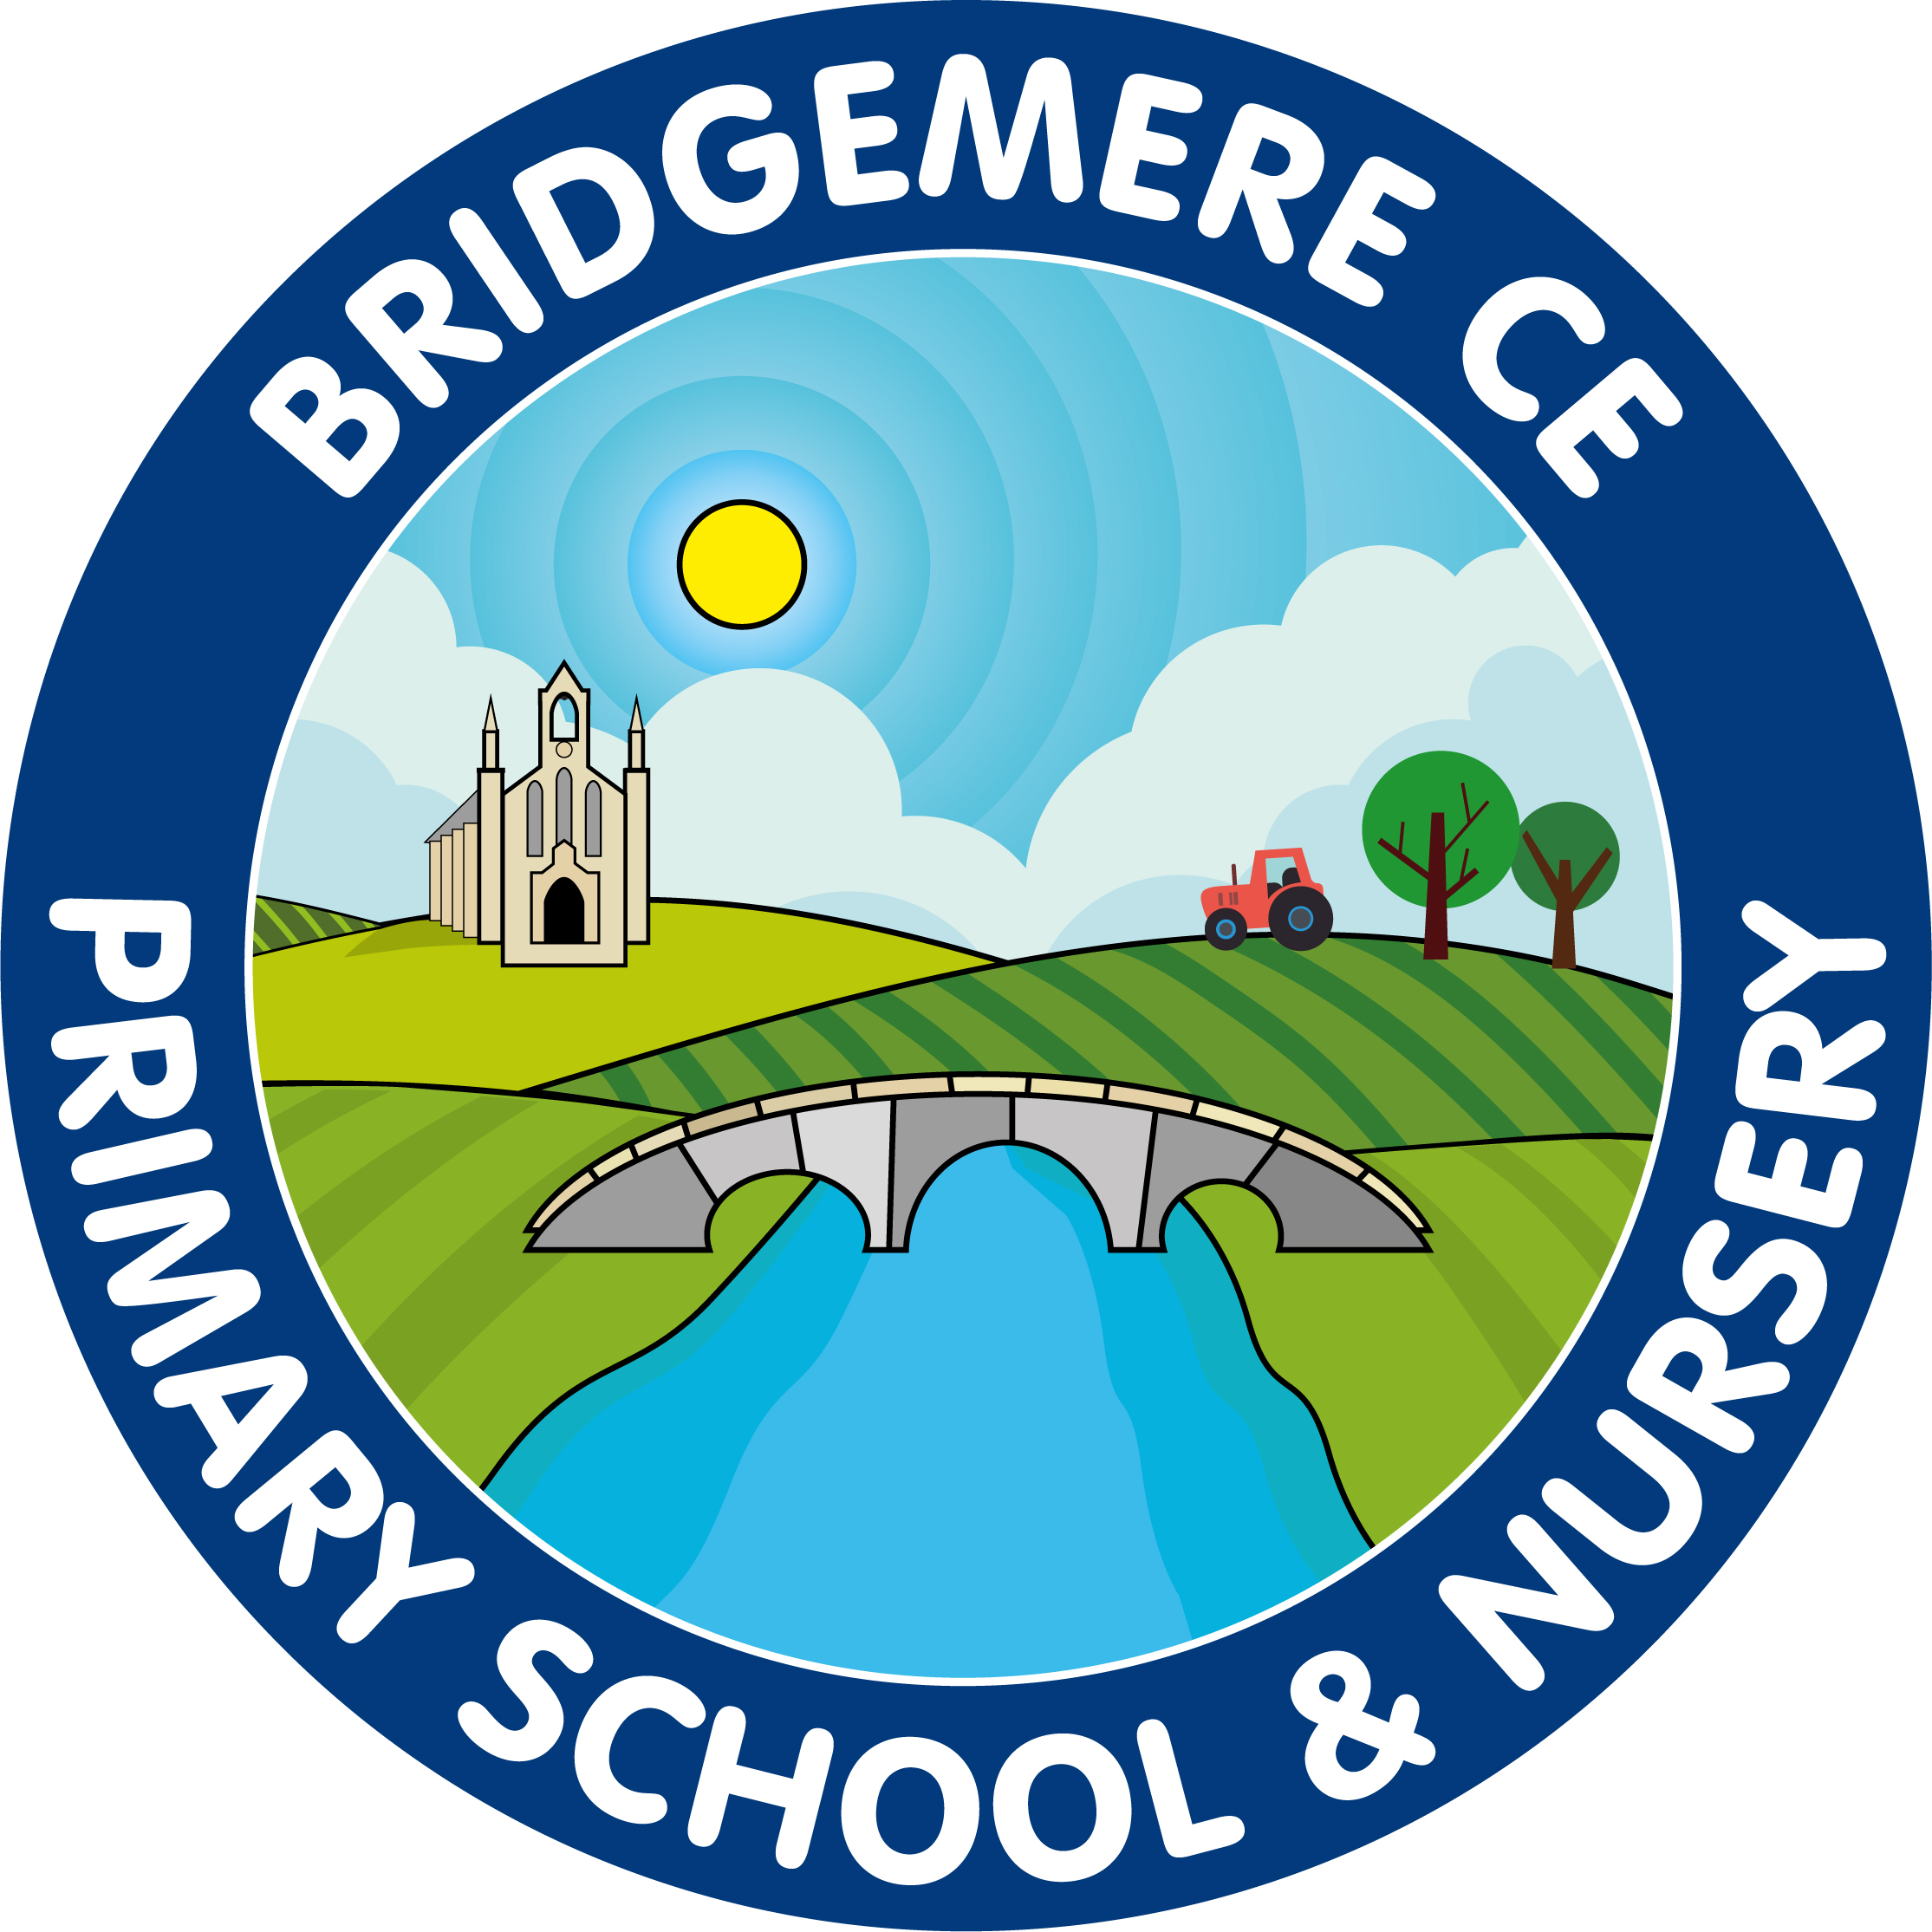
Bridgemere CE (Aided) Primary School
Bridgemere Lane, Bridgemere,
Nantwich, Cheshire, CW5 7PX

Head Teacher – Mrs Caroline Middleton
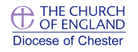 | 01270 520271  admin@bridgemerece.cheshire.sch.uk  www.bridgemereschool.co.uk
30 July 2026

Dear Parent or Carer

Information Regarding Income Related Free School Meals

The Council provides two types of free school meals to children attending a school within the Cheshire East Borough. Income Related School Meals (IRFSM) or Free School Meals for Infants
You can claim free school meals for each child who attends school in Cheshire East if you receive one of these benefits:
- Universal Credit with no earned income or with net monthly earnings less than £616.67
- Income Support
- Income based Jobseeker's Allowance
- Income related Employment Support Allowance
- Support under Part VI of the Immigration and Asylum Act 1999
- The guaranteed element of State Pension Credit
- Child Tax Credit - as long as you have a yearly household income of less than £16,190 (as assessed by HM Revenue and Customs) and do not get Working Tax Credit
- Working Tax Credit run-on (paid for 4 weeks after you stop qualifying for Working Tax Credit)
If your child is in receipt of income related free school meals, they are automatically eligible for the Household Support Fund too.
If you qualify, we suggest you do make a claim for free school meals even if your child is in key stage 1 as the school can claim additional funding (pupil premium) for new equipment and resources.
You can apply for nursery-age children if they attend before and after lunch sessions at a local authority nursery school, nursery class or an Academy nursery if it has the same Ofsted number as the primary school.
Phone 0300 123 5012 for further information and help or copy and paste the link in to your browser
https://www.cheshireeast.gov.uk/schools/school-meals/free_school_meals.aspx
Kind Regards

Caroline Middleton
Head Teacher

