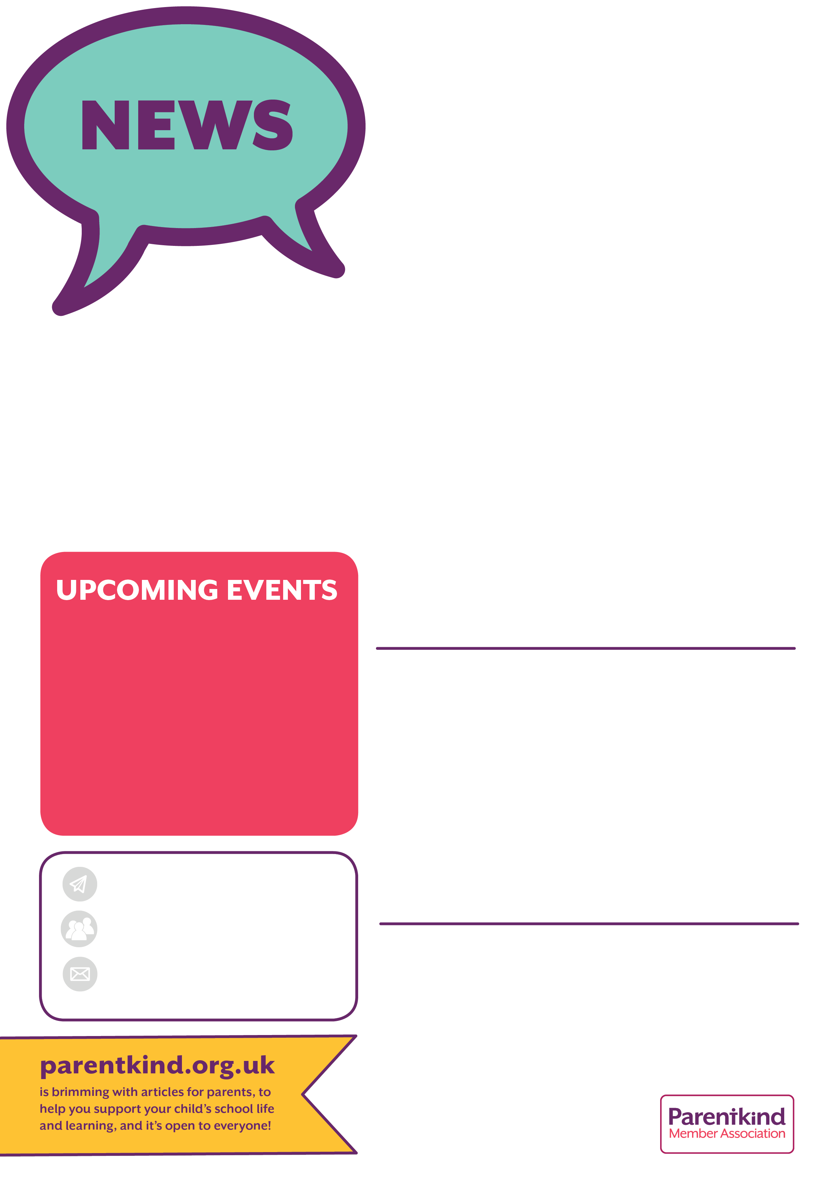

Chair – Emma Minshall

Secretary - Kristen Bahry-Webber

Treasurer – Sarah Furber

We have a NEW Facebook page! Friends of Bridgemere School

**MARCH**

Monday 4th

**Friday 15th**

**Friday 22nd**

**2024**

**School Tea Towels available**

**Non Uniform Day in exchange for chocolate Easter egg to be won at Easter Bunny Drive**

**Easter Bunny Drive &**

**Easter Hamper Raffle draw**



**Easter Hamper Raffle**

**Whole School Tea Towel Fundraiser**

Our schoolchildren have drawn lovely self portraits of themselves, which have been made into a whole school tea towel. A great Mother’s Day gift idea and keepsake!

Tea Towels available to pre-order at £4.50 each or 3 for £12.

Payments by bank transfer to FOBS (account details above). Please also email the School Office to confirm your order.

For the chance to win a hamper filled with exciting Easter goodies, please buy a (virtual) raffle ticket £1 each.

Anyone can enter!

The draw will take place at the Easter

Bunny Drive.

Payments in cash to the School Office

or by bank transfer by 21st March

to the “Friends of Bridgemere School”

Sort code: 54-10-17

Account number: 10724826.

Our Easter Bunny Drive is on Friday 22nd March in School 3:15pm-4:30pm.

It’s £2 per child. Payments in cash to the School Office or by bank transfer to our FOB bank account (details below). Your child will given a card and pencil. And the chance to win some yummy chocolate Easter Eggs!

Parent / carer helpers needed please.

Non-Uniform Day in exchange for

Chocolate Easter Eggs: Friday 24th



**We’re a group of parent and staff volunteers, who give their time to create better learning experiences for our schoolchildren. Anyone can help in any way, big or small.**

**This year’s fundraising will be spent on sports equipment and classroom resources for our school.**

**FOBS recently contributed towards the coach hire cost to the Young Voices Concert at Manchester Arena, which some of the KS2 children took part in. We also paid for the hire of the coaches to take the whole school to the Pantomine Show in December.**

**Friends of Bridgemere School (‘FOBS’)**

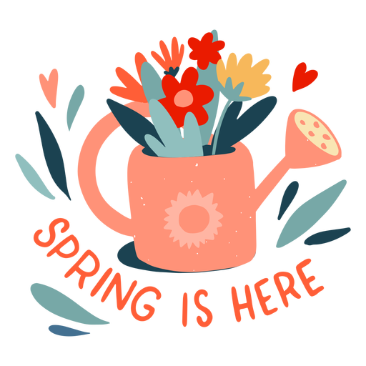

**Easter Bunny Drive**

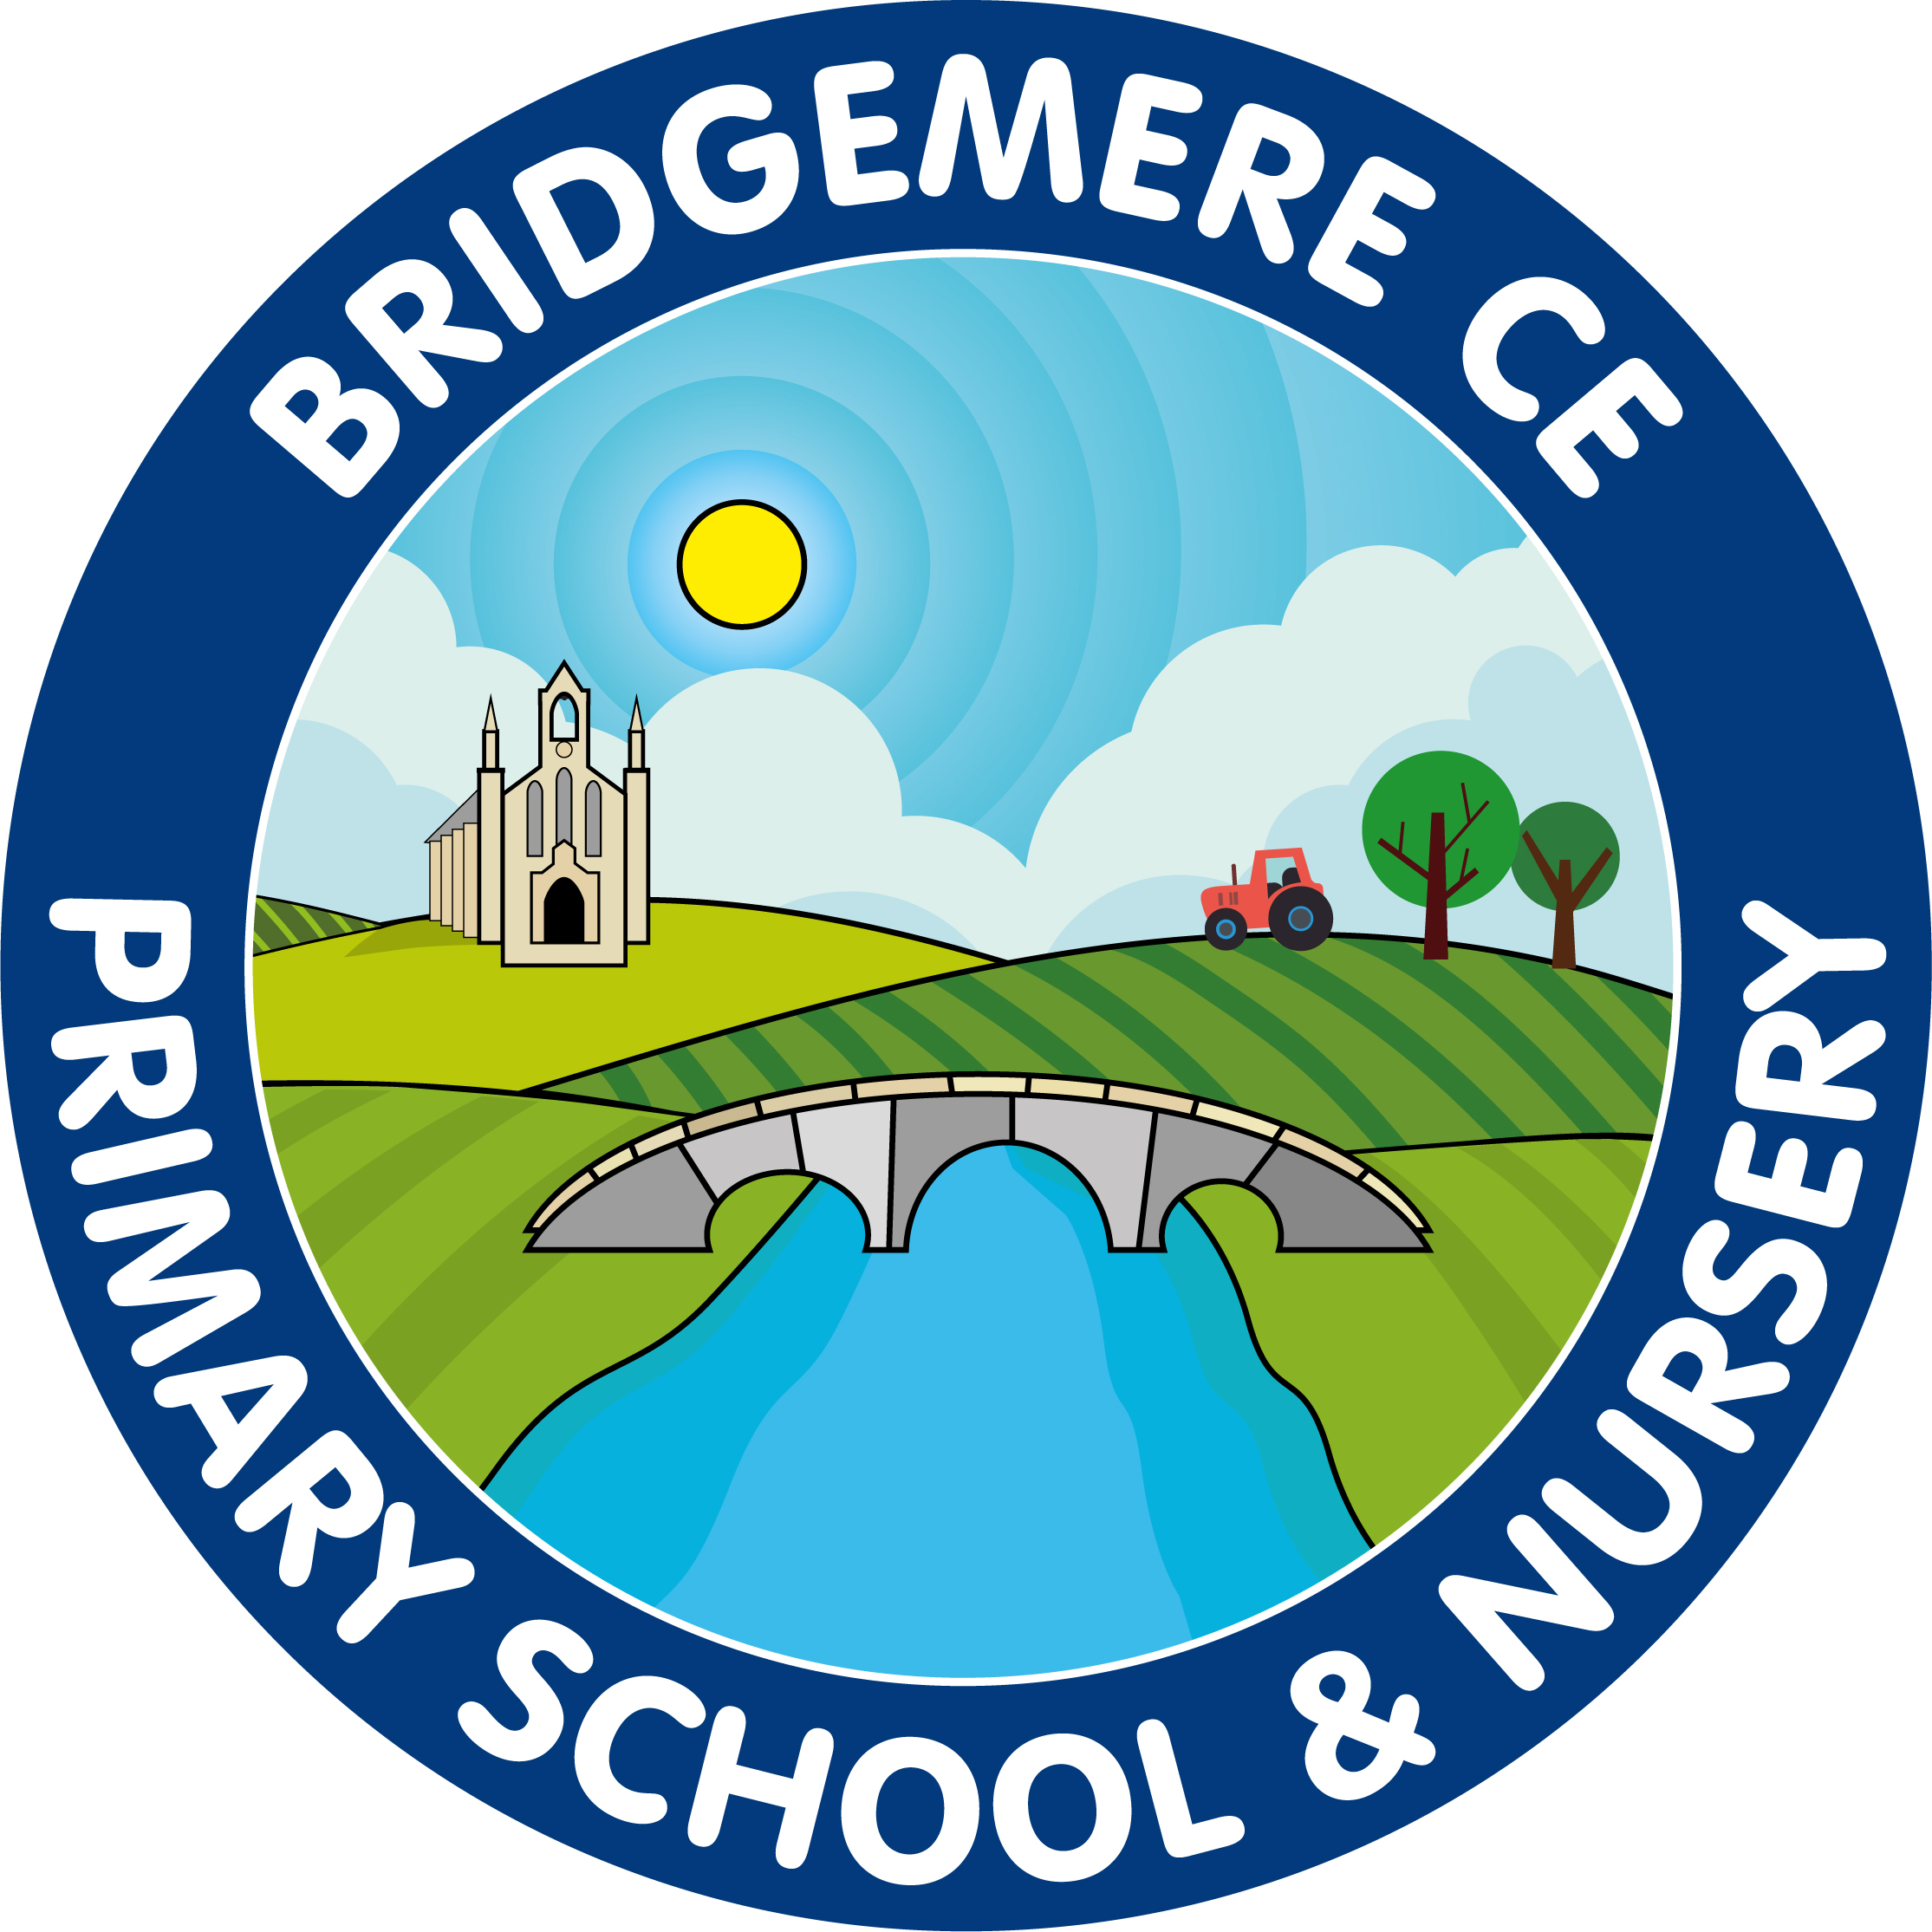

**SPRING ISSUE 2024**