Bridgemere CE Primary  ‘I can do all things through Christ who strengthens me’  Philippians 4v13 Autumn Term 2025 20232023 |  |  | 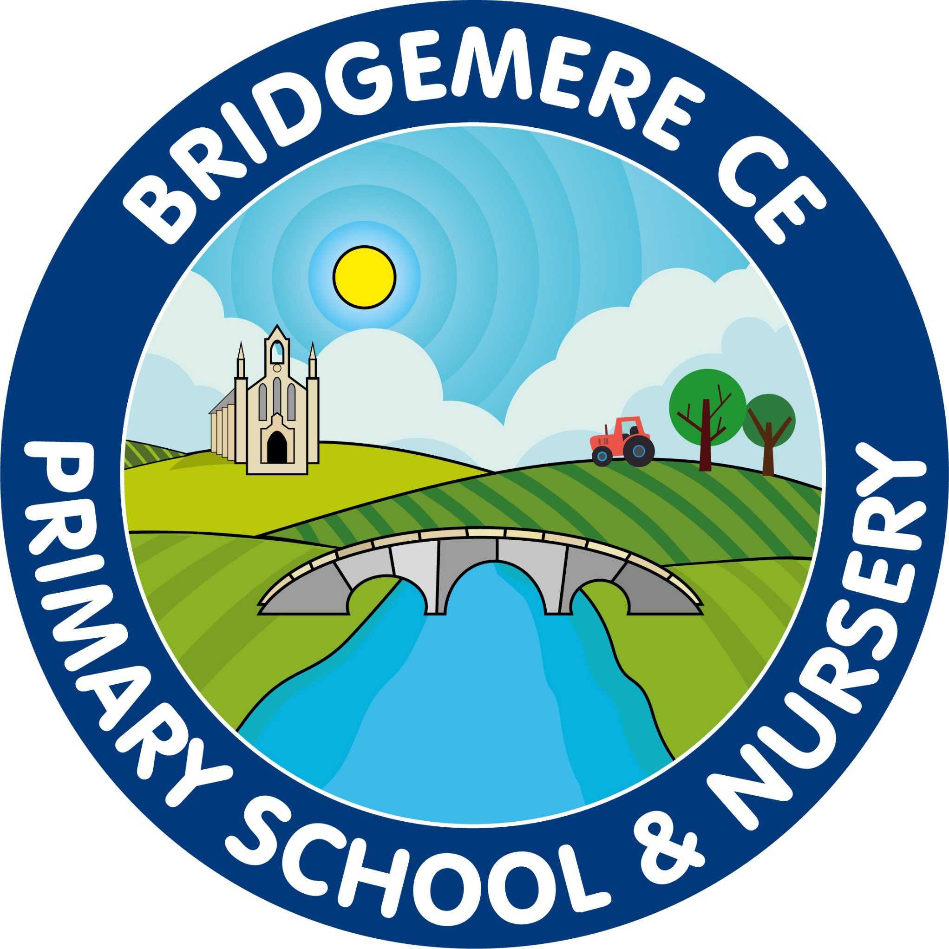
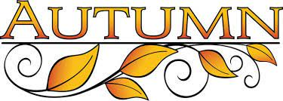  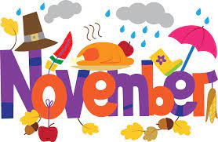  Return to school  Monday 3th November  Bonfire themed school lunch  Wednesday 5th November  Parents’ Meetings  Monday 3rd November – online  Tuesday 4th November – in school  ‘Stay & Play’  Wednesday 12th November 9.00-10.15am  Parent Council Meeting  Wednesday 12th November – 6pm  Non-Uniform Day – for Christmas Fair tombola  Friday 14th November  Scholastic Book Fair  Friday 21st – 26th November |   Friends of Bridgemere – Christmas Fair  Thursday 4th December 3.30-5.00pm  Nativity – Class 1 & 2  Monday 8th December 2pm  Nativity – Class 1 & 2  Tuesday 9th December 5pm  KS2 Carol Service –  Wednesday 10th December at St John’s Doddington 2pm  ‘Stay & Play’  Friday 12th December 9.00-10.15am  Whole school Panto visit – Northwich  Tuesday 16th December  Christmas Dinner Day -  Wednesday 17th December  Bikeability – Class 3&4  Wednesday 17th & Thursday 18th December  Christmas Parties  Break up for Christmas –  Thursday 19th December

