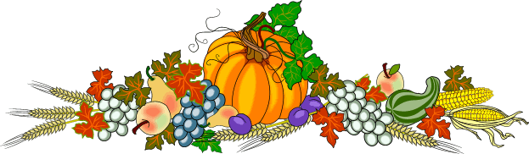
Bridgemere CE Primary
‘Harvest of Hope’
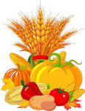
Wednesday 8th October 2025
St John’s Church Doddington - 2pm

Order of Service
Welcome
Harvest of Hope
Song – Cauliflowers Fluffy
Nature Clubs – Sierra Leone – Class 4
Saying Thank You – Class 1
Song – Harvest Hymn
(Congregational song)
Climate Change – Class 4
How can we help others– Class 2
Work of Christian Aid –Class 4
First & Finest– Class 3
Reflection
Song- Wonderful World
Nantwich Foodbank
Song – Harvest Samba
Prayer

Cauliflowers Fluffy
Cauliflowers fluffy and cabbages green
Strawberries are sweeter than any I've seen
Beetroots purple and onions white
All grow steadily day and night

The apples are ripe, the plums are red
The broadbeans are sleepin' in a blankety bed

Blackberries are juicy and rhubards are sour
Marrows are fattening hour by hour
Gooseberries hairy and lettuces fat
Radishes round and runner beans flat

The apples are ripe, the plums are red
The broadbeans are sleepin' in a blankety bed

Orangey carrots and turnips cream
Reddening tomatoes that used to be green
Brown potatoes in little heaps
Down in the darkness where the celery sleeps

The apples are ripe, the plums are red
The broadbeans are sleepin' in a blankety bed
Harvest Samba
Cabbages and greens,
Broccoli and beans,
Cauliflower and roasted potatoes,
Taste so good to me!
Apricots and plums,
Ripened in the sun,
Oranges and yellow bananas,
Good for everyone!
Chorus:
It’s another Harvest Festival
When we bring our fruit and vegetables,
Cause we want to share the best of all
The good things that we’ve been given.
It’s another opportunity
to be grateful for the food we eat
With a Samba celebration
To say thank you to God the Father.

Golden corn and wheat,
Oats and sugar beet,
Fluffy rice and tasty spaghetti,
Wonderful to eat!
Coffee, cocoa, tea,
Growing naturally,
Herbal plants and all kinds of spices
Very nice indeed

Chorus
Thank you for the harvest,
Thank you for your goodness,
For all of the fruit and vegetables
and the wonderful things that grow.!
Thank you for the harvest,
Thank you for your goodness,
For all of the fruit and vegetables
and the wonderful things that grow.!

Choose a part:
Thank you for the harvest,
Cabbages and greens,
Broccoli and beans,
Cauliflower and roasted potatoes,
Taste so good to me!
Apricots and plums,
Ripened in the sun,
Oranges and yellow bananas,
Good for everyone!

Thank you for your goodness,
For all of the fruit and vegetables
and the wonderful things that grow.!
Thank you for the harvest,
Thank you for your goodness,
For all of the fruit and vegetables
and the wonderful things that grow.!

Thank you all for your generous donations, which will go to the Nantwich Foodbank to support those in need in our local community.

What a Wonderful World
Louis Armstrong
I see trees of green, red roses too
I see them bloom for me and you
And I think to myself,
what a wonderful world

I see skies of blue and clouds of white
The bright blessed day, the dark sacred night
And I think to myself,
what a wonderful world

The colours of the rainbow, so pretty in the sky
Are also on the faces of people going by
I see friends shakin' hands, sayin' "How do you do?"
They're really saying "I love you"

I hear babies cryin', I watch them grow
They'll learn much more than I'll ever know
And I think to myself,
what a wonderful world

Yes, I think to myself,
what a wonderful world
Oh yeah

Harvest Hymn
Long before the summer started
Fields were ploughed and sown.
Seeds were scattered, crops were planted,
Now they are full grown.

Give thanks for the harvest,
The sun, the seed, the rain.
Give thanks to God the Father
For Harvest time again.

April showers and sunny weather
Fed the earth again.
Warmth and moisture both together
Helped to grow the grain.

Every field of golden yellow
Standing in the sun.
Tells how God in all His splendour
Cares for everyone.

Come with thankful hearts and voices
Come with joyful song.
For all the good food all around us,
Now the work is done.

