Bridgemere C of E Primary School

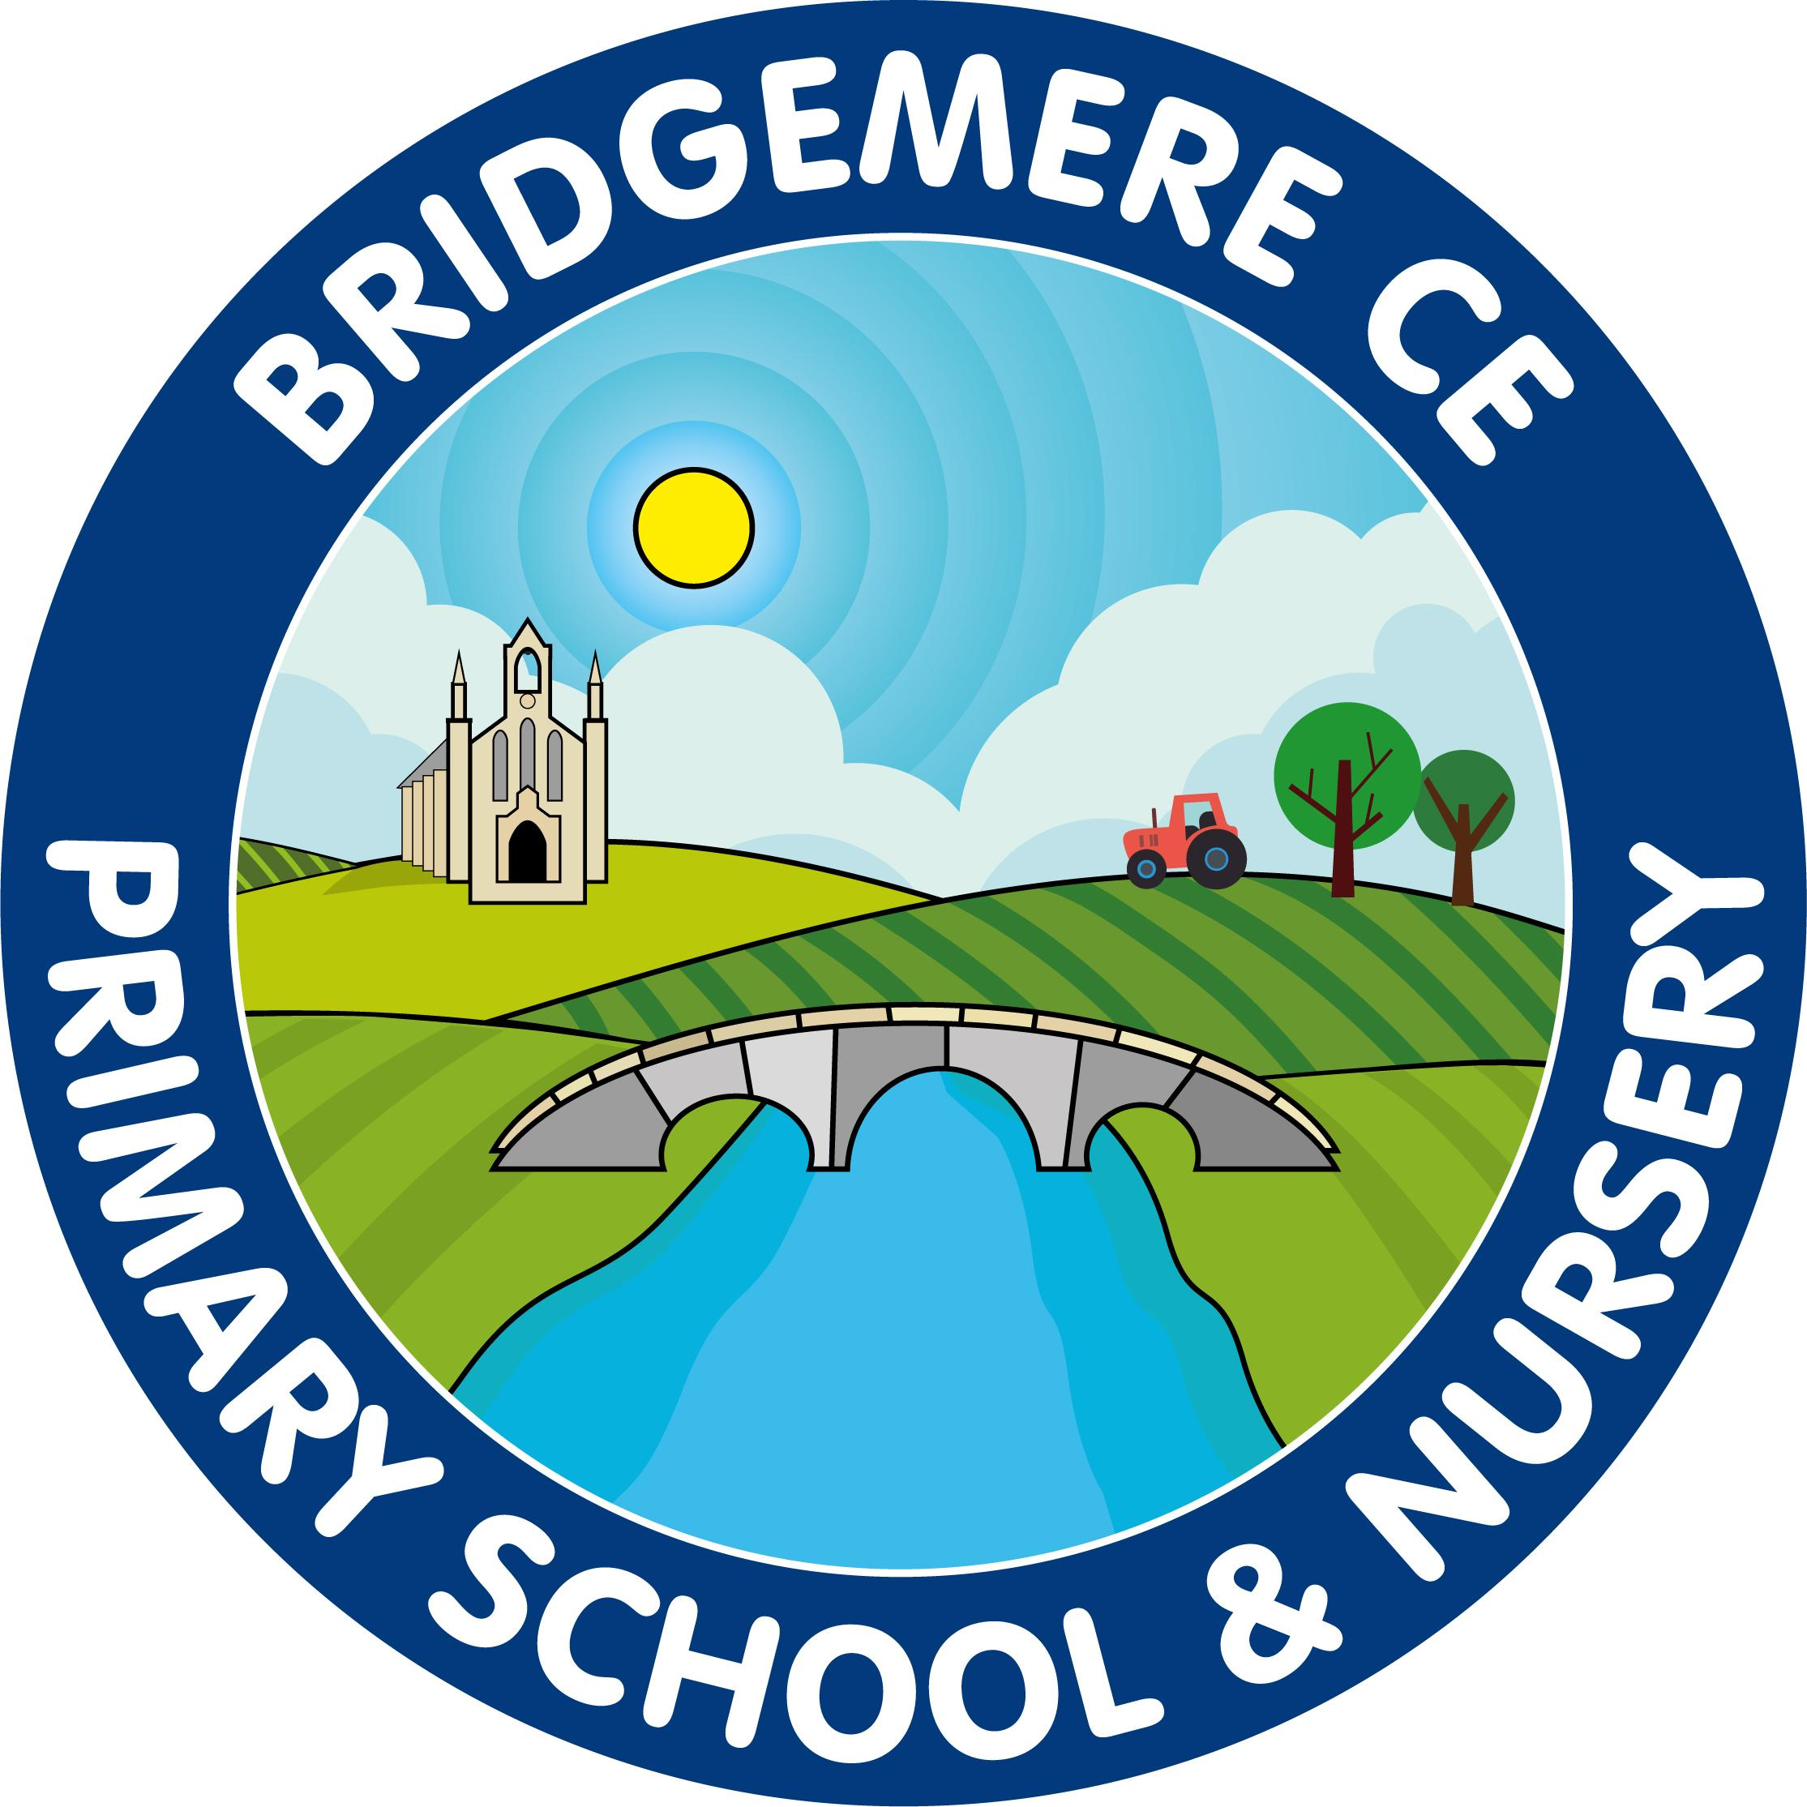

**Read Write Inc**

**Phonics Support Materials**

The following pack of materials is to help you support your child at home with their phonics journey. The first pages can be used as they are or cut up in to individual words to use with your child to help them practice the sound they are learning. Please check the Oxford Owl or You Tube websites for other parent support materials and videos, including how to pronounce the phonemes accurately!

https://home.oxfordowl.co.uk/reading/reading-schemes-oxford-levels/read-write-inc-phonics-guide/ https://www.youtube.com/channel/UCo7fbLgY2oA_cFCIg9GdxtQ

The children learn their sounds in the following order:

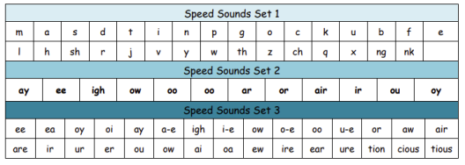As well as these sounds they will also so learn ‘red’ words, which are difficult to sound and blend. However, they must learn these to ensure they can access the texts (eg, said, your, the)

‘Green’ words are printed in the order they are taught. The children work through the set of sounds before moving on to the next set. There are dots and dashes underneath the green words to support children sounding and blending each word.

If there is a **line** under phoneme (sound) this means it has more than one letter but only one sound. (eg, sh, th, tion) 

If there is a dot under the phoneme (sound) this means it only has one letter and

one sound.

How to use the Green and Red words to support your child at home:

**Green Words**:

**Fred talk**- point to each phoneme as you make the sound, the run your finger under the whole word to blend it back together. 

**Fred in your head**- once your child has sounded and blended the words using Fred talk, encouraged them to sound in their head and say the word after a few seconds. **Red Words:**

These words should be told to the children before they are expected to read them by sight. Modelling this by saying ‘My turn said’, ‘Your turn’. You cannot sound and blend these words, they must be learnt regularly to ensure children are embedding their learning.

We have added these to the resource below. Please feel free to use them as you wish to support your child’s reading development.

**Simple Speed Sounds chart (Set 1 and 2 sounds)**

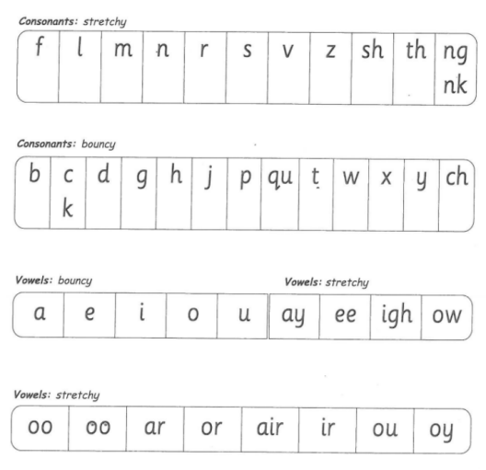

**Complex Speed Sounds chart (Set 3 sounds)**

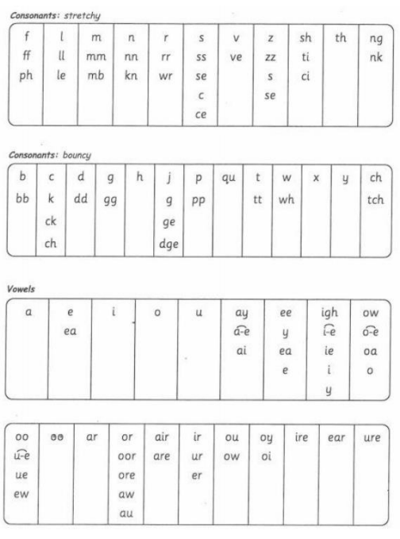

**Red Words (Tricky Words)**

**Red for a while \***

These words are red to begin with but once the phonemes have been taught they are then decodable. Feel free to use them as they are or cut them up to use as flash cards.

**Red Words**

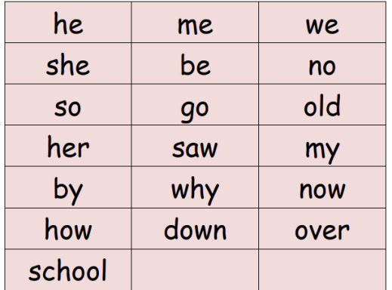

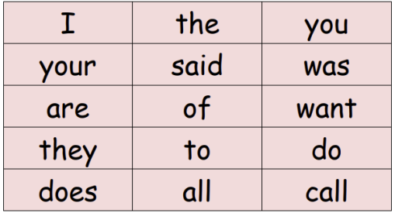

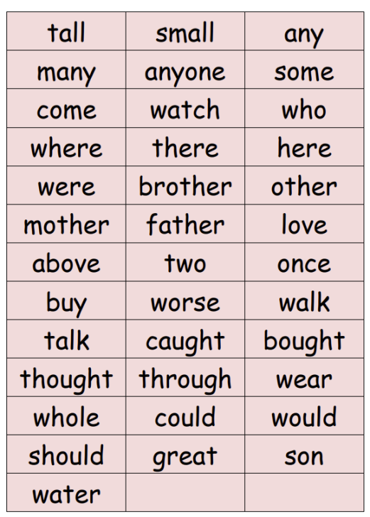

**Set 1 Sounds- Green Words**

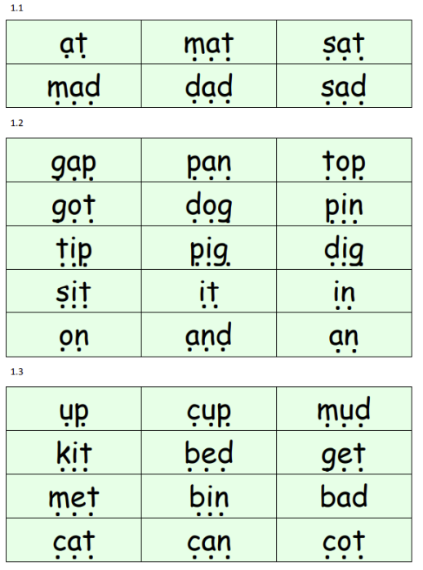

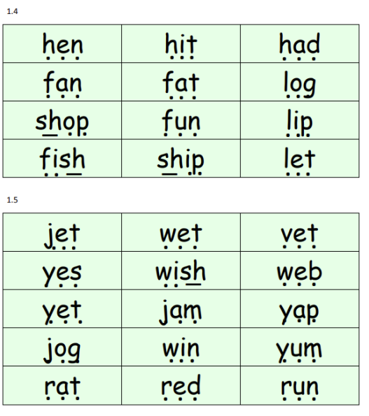

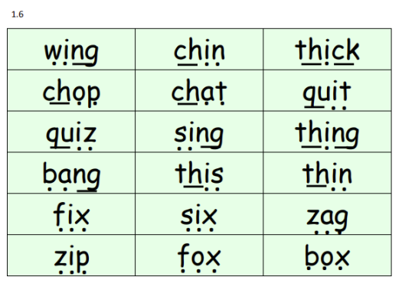

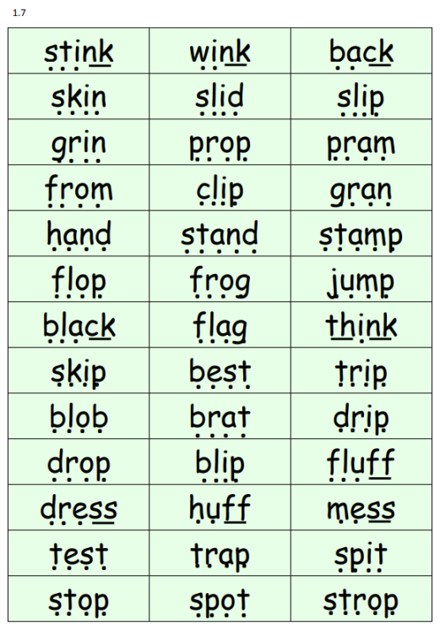

**Set 2 sounds- Green Words**

