Year 5/6 Autumn Term Newsletter
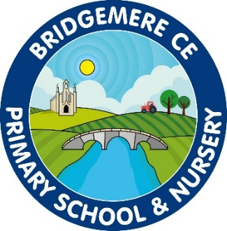
Dear Parents,
I hope that you have all had a lovely summer and are looking forward to the year ahead. I am so excited to be back and the children have already made a great start over the first few days. I am sure it won’t be too long before they settle into/back into the key stage 2 way of life!

Curriculum
This half term we have a history focus, we are looking at The Anglo-Saxons, Vikings and Scots. We will be investigating the power struggle for Britain and discussing whether Alfred deserved his title ‘The Great’.
Our English lessons this year will based on two fantastically immersive books, Rose Blanche by Christophe Gallaz and Roberto Innocenti and When we walked on the moon by David Long. We will be having a go at writing a short narrative and a diary entry based on these stories. Our class novel will be The Nowhere Emporium by Ross McKenzie.
In Science our topic in Autumn 1 is “Materials and their properties”. As part of this topic we will be experimenting with sound proofing, electrical conductivity and recycling. We will also be exploring Earth and Space.
In RE we will be looking at The Kingdom of God, we will be thinking about how the local church community can seek to bring God’s Kingdom of earth.

Times Tables
It is important that children are learning to recall their times tables at speed. They should be able to count up and back in their tables from 2 – 12. It is so important that they are practicing a set of tables every day to ensure that they have been fully embedded in their working memory. I will be testing the children on these once they have settled in over the next few days and times tables tests will be given every week; the challenge is for your child to try and beat their previous score.

Reading
Your child will need their reading diary in school every day. Please ensure that you record any reading that they do at home in their book. In school we shall ensure that they read for 20 minutes each day as well as a class novel and we are also asking for parents to do the same. Reading is key to children’s progress across the curriculum so anything you can do to help will have a great impact. These reading diaries will be used as a communication book between me and you; these books will be checked daily.

P.E
This term we will have P.E on a Wednesday and Friday. The children will be doing lots of different activities in PE. Children may not wear any jewellery for P.E and if they have long hair please make sure it is tied back.

General
Please keep an eye on the class page of the school website for up-to-date information. I will also add any class letters I write onto there in case they get lost on the way home. Please also make sure that your child has a water bottle to bring into school each day.
If you have any concerns or questions about your child’s learning please book an appointment to speak to me through the school office. I am looking forward to the year ahead!

Kind Regards
Mrs McGarrigle

