Bridgemere CE Primary - 2025  ‘I can do all things through Christ who strengthens me’  Philippians 4v13 Summer Term 202 20232023 |  |  | 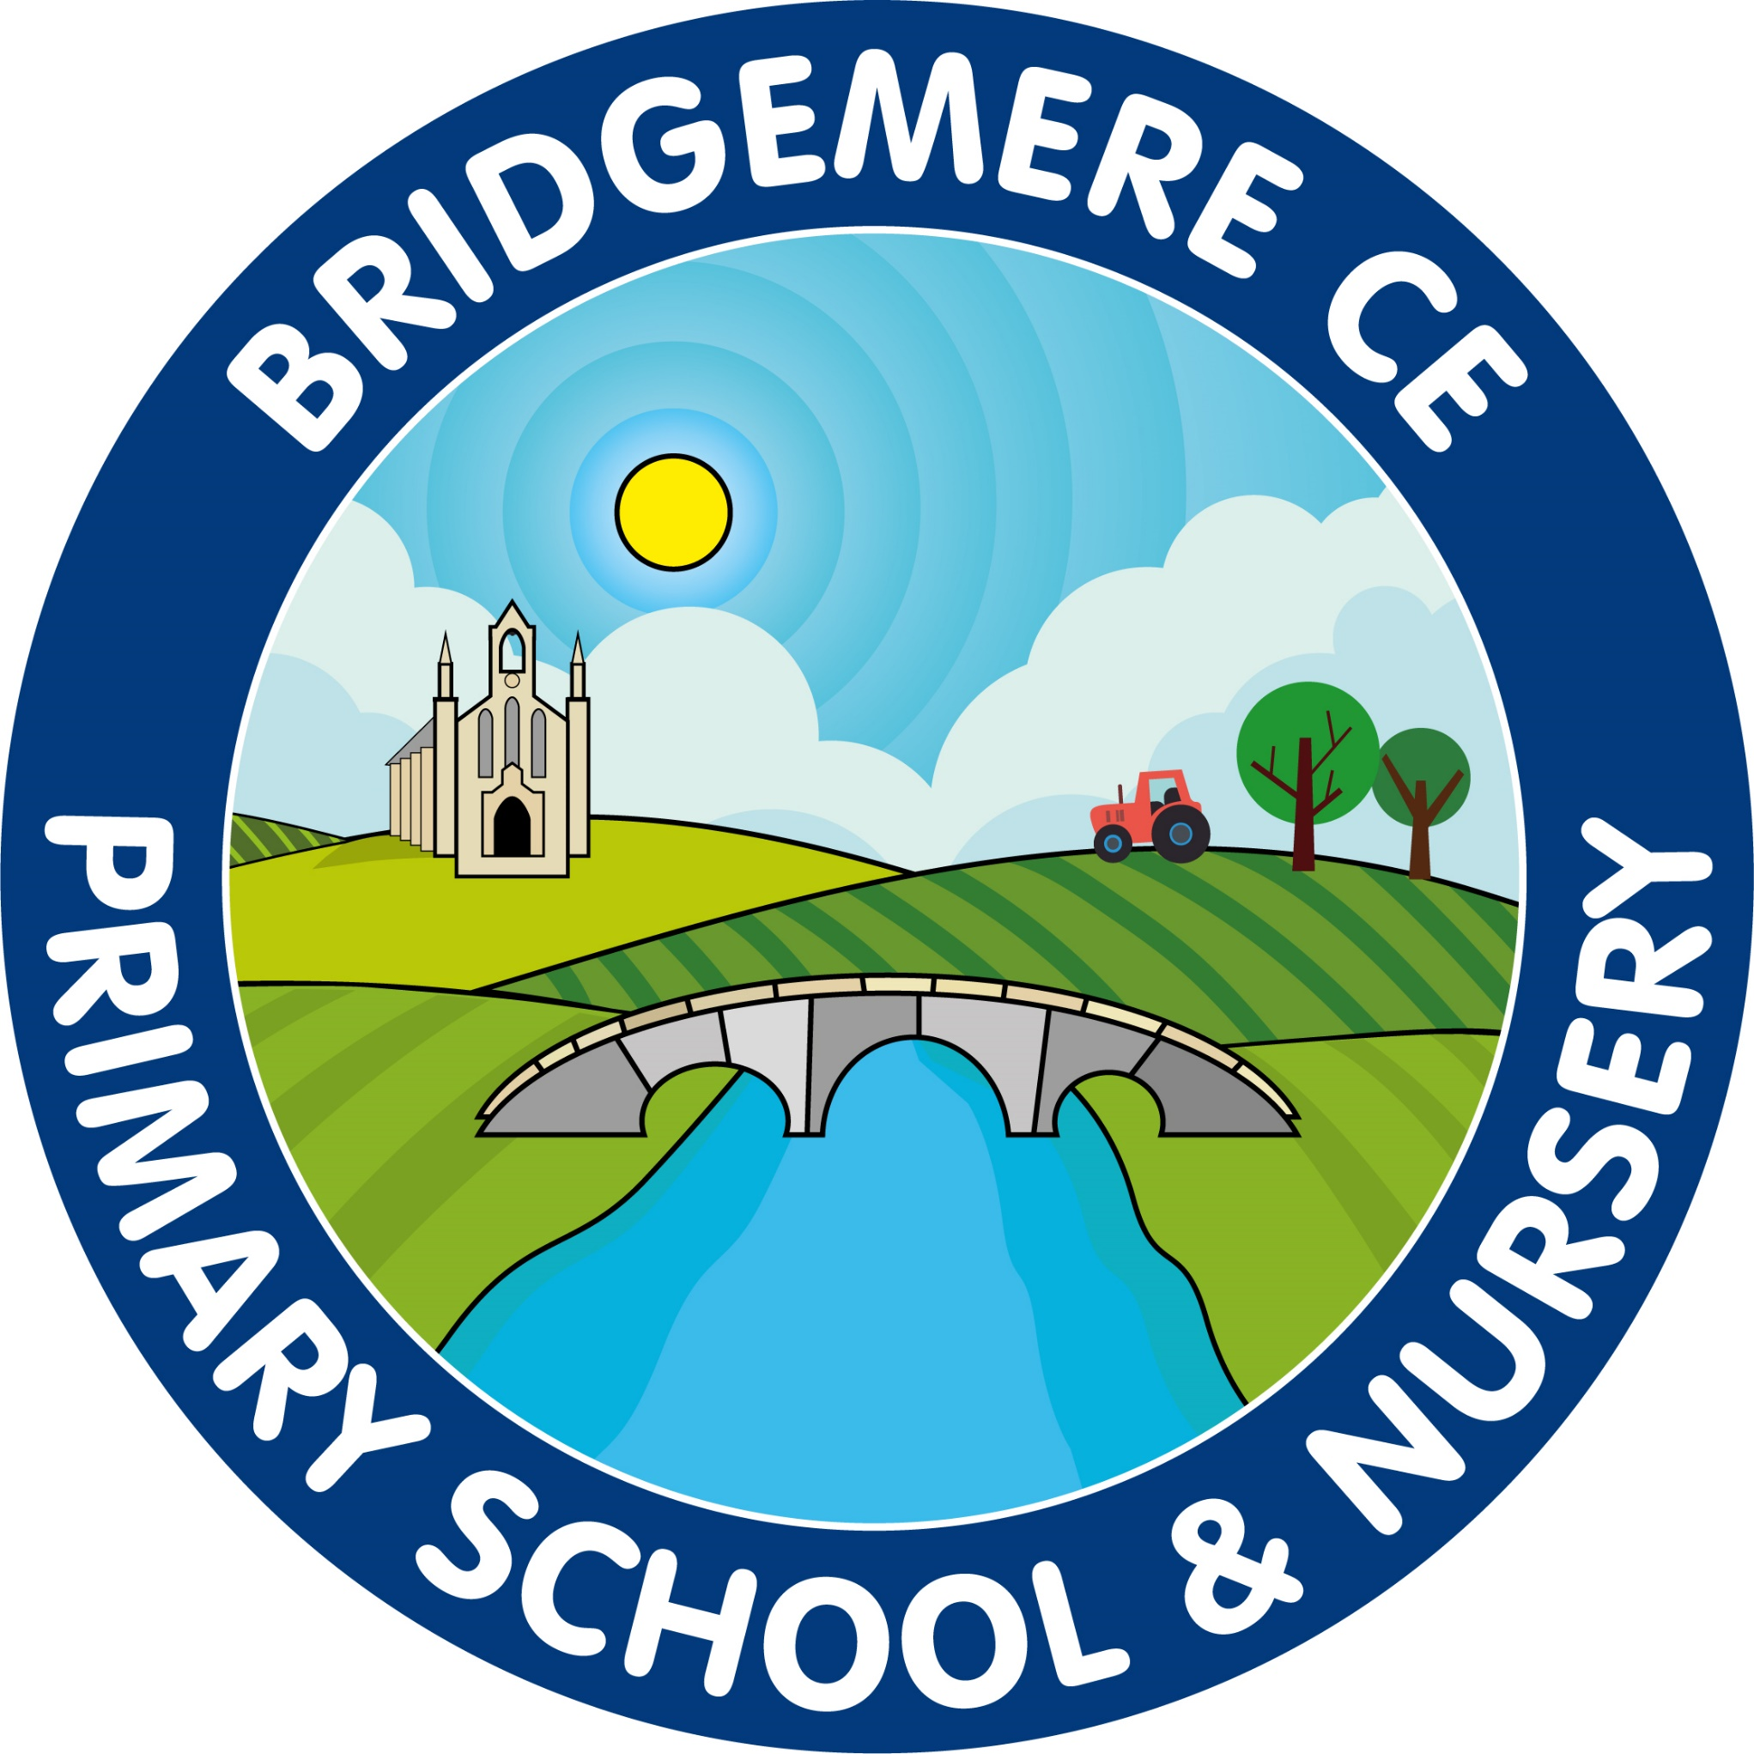
  As the next half term is so busy here is a list of dates for your notice board at home!    Week beginning 9th June  Year 1 Phonic Screening Test  Year 4 Timestable Test  Tuesday 10th June  Year 3 & 4 Mixed Football Competition 12-4pm  Thursday 12th June  FOB Fathers’ Day Stall 3.15-4.15pm  Monday 16th June  Town Sports – Field Events 5-7.30pm  Tuesday 17th June  Class 3 ‘Come and Play with the Halle’ Trip  Bridgewater Hall  Wednesday 19th June  Town Sports – Track Events 5-8pm  Friday 20th June  Stay & Play 9.00-10.15am in Class 1  Monday 24th June  KS2 Cross Country – 3.30-5pm  Malbank School  Wednesday 24th – Wednesday 25th June  Year 6 Shavington Transition Days  Wednesday 25th - Thursday 26th June  Year 6 Brine Leas Transition Days  Thursday 26th June  Year 1 & 2 – Cricket skills 9.30-12pm  Monday 30th June  Year 3 & 4 Diamond Cricket Competition  South Cheshire Collage 9.30-12pm |   Monday 7th –Tuesday 8th July  Year 6 Madeley High Transition Days  Wednesday 9th July  Stay & Play 9.00-10.15am in Class 1  Year 6 Leavers’ Service  Chester Cathedral Service pm  Thursday 10th & Friday 11th July  Class 2 – Residential Fordhall Farm  Tuesday 15th July  Year 6 Surprise Leavers’ Trip  Celebration of Creativity 3.15-5pm  Thursday 17th July  Summer Fair 3.15-6pm  Monday 21st – Wednesday 23rd July  KS2 Residential Ingestre Hall  Friday 25th July  Summer term reports to go out  Monday 28th July  Parents Evening to discuss reports 3.30-5pm  Tuesday 29th July  Leaver’s Service at school – 2pm  Break up for summer holidays  

