Class 3 Autumn Term Newsletter
Mrs Speed

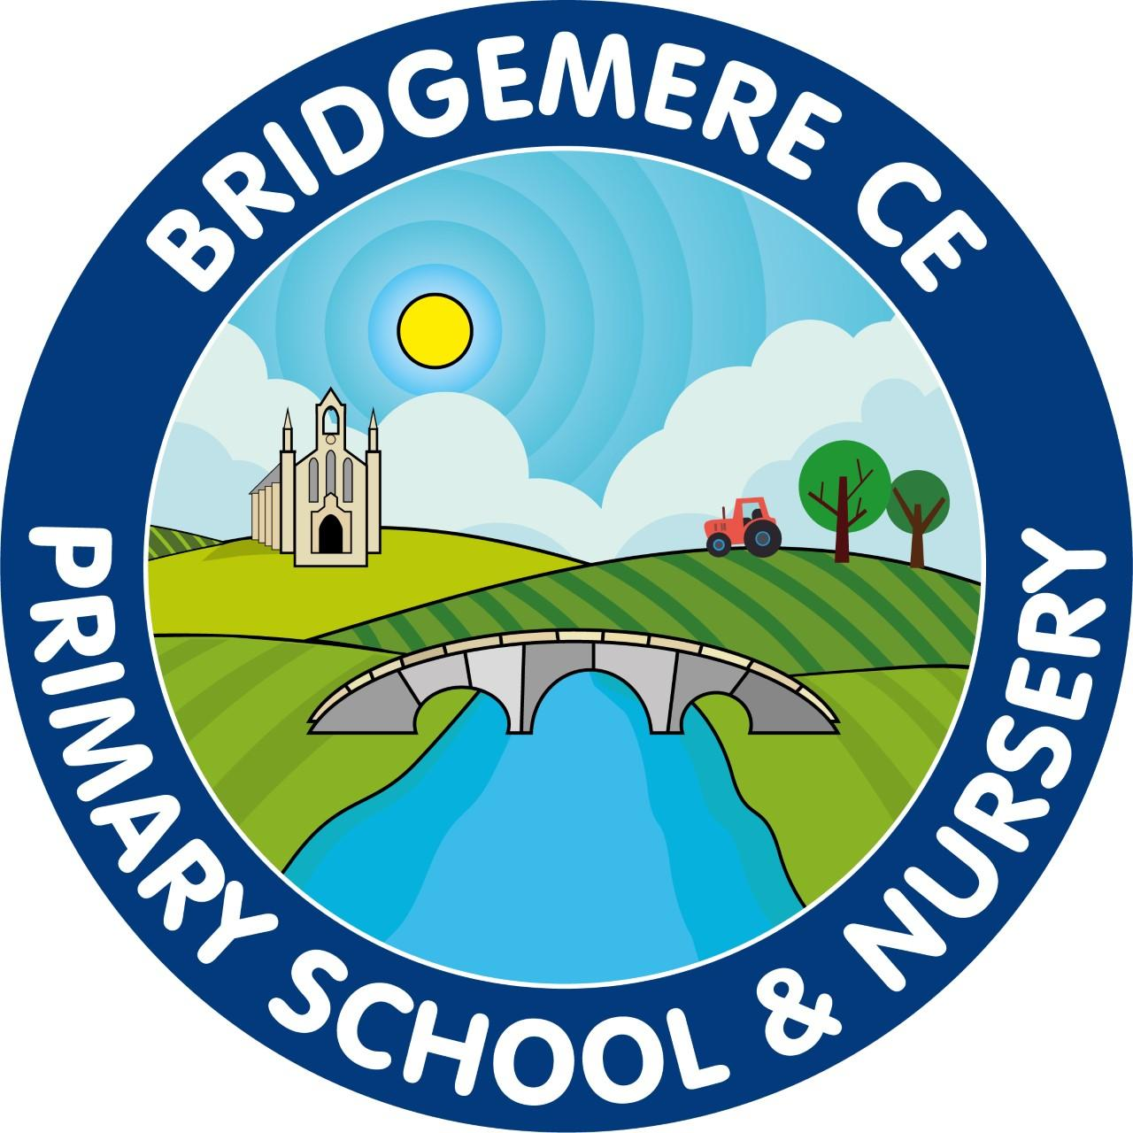

Dear Parents,
Welcome back! I hope you’ve all had a lovely summer holiday and managed to enjoy time together. Hopefully we are all well rested and ready for a new year!

Reading
In Class 3 we use Accelerated Reader to maintain and enthuse our brilliant readers. This will require your child to read every day as compulsory, in and out of school hours for a minimum of 30 minutes aday. When books are read and understood fully, your child will complete an online comprehension quiz. We strive for your children to do their best, however we do have an expectation of understanding a text with a minimum of 80% accuracy. Children will be expected to complete a minimum of 2 quizzes each week, unless reading longer chapter books (blue books) which I understand may take one to two weeks to complete.

English
During our English learning this term we will focus on including our grammatical language and skills when writing narrative and other fictional and non-fictional written pieces. This will include the continuous and known use of Read, Write, Inc for support with spelling and discretely taught grammar and punctuation in SPaG lessons.

P.E
PE lessons will be on Monday and Thursday afternoons. Our focus this term will be on team sports and fitness. We will improve our teamwork and sportsmanship and our knowledge and skills of different sports.
Please make sure your child has appropriate PE clothes as our lessons will be outside as much as possible. Remember on these days your child can come into school wearing their PE kits.
Despite already wearing their PE kits; Please make sure your child’s PE kit and school uniform are clearly labelled.

Other learning
This term our foundation learning will be looking at the first Ancient Civilisations where we will practise our historical and geographical skills. We will look at significant events and timelines to further understand the development of civilisations across the world. We will improve our map skills in Geography focusing on world maps and Link both History and Geography when looking at Naple’s Bay and the role Mount Vesuvius has played in its History. Science we will be focusing on rocks, types and how these are created; followed by the study of light. RE we will look at David and his Psalms; followed by, why Jesus is described as the light of the world.

Homework
Although as a school we don’t set additional homework, it is important to note that we do expect your child to read for 30 minutes a day to support their reading and comprehension skills.
Please note: spellings will be practised and learnt within school, however, you are more than welcome to help your child along by using pages 124-131 in your child’s communication diary. Their communication Diaries are full of useful information and include many pages of ‘need to know’ learning.

Additional to the above, now is the time that Year 3 are to begin knowing their timetables. By June children should know all sets of timetables and recall them within 6 seconds. An easy tool to help this is via TTRockstars which can be used online or within an app. Your child's login for this can be found on page 163 of their communication diary.

As you may appreciate it is not always easy to talk at the end of the day, but I will do my best to accommodate conversations where possible; However, if you have any concerns or questions at all please use communication diaries as these will be checked daily or ring the office to arrange a meeting.

Kind Regards
Mrs Speed

Class 3 Teacher/SENDco

