Class 3 Summer Term Newsletter
Miss Latham

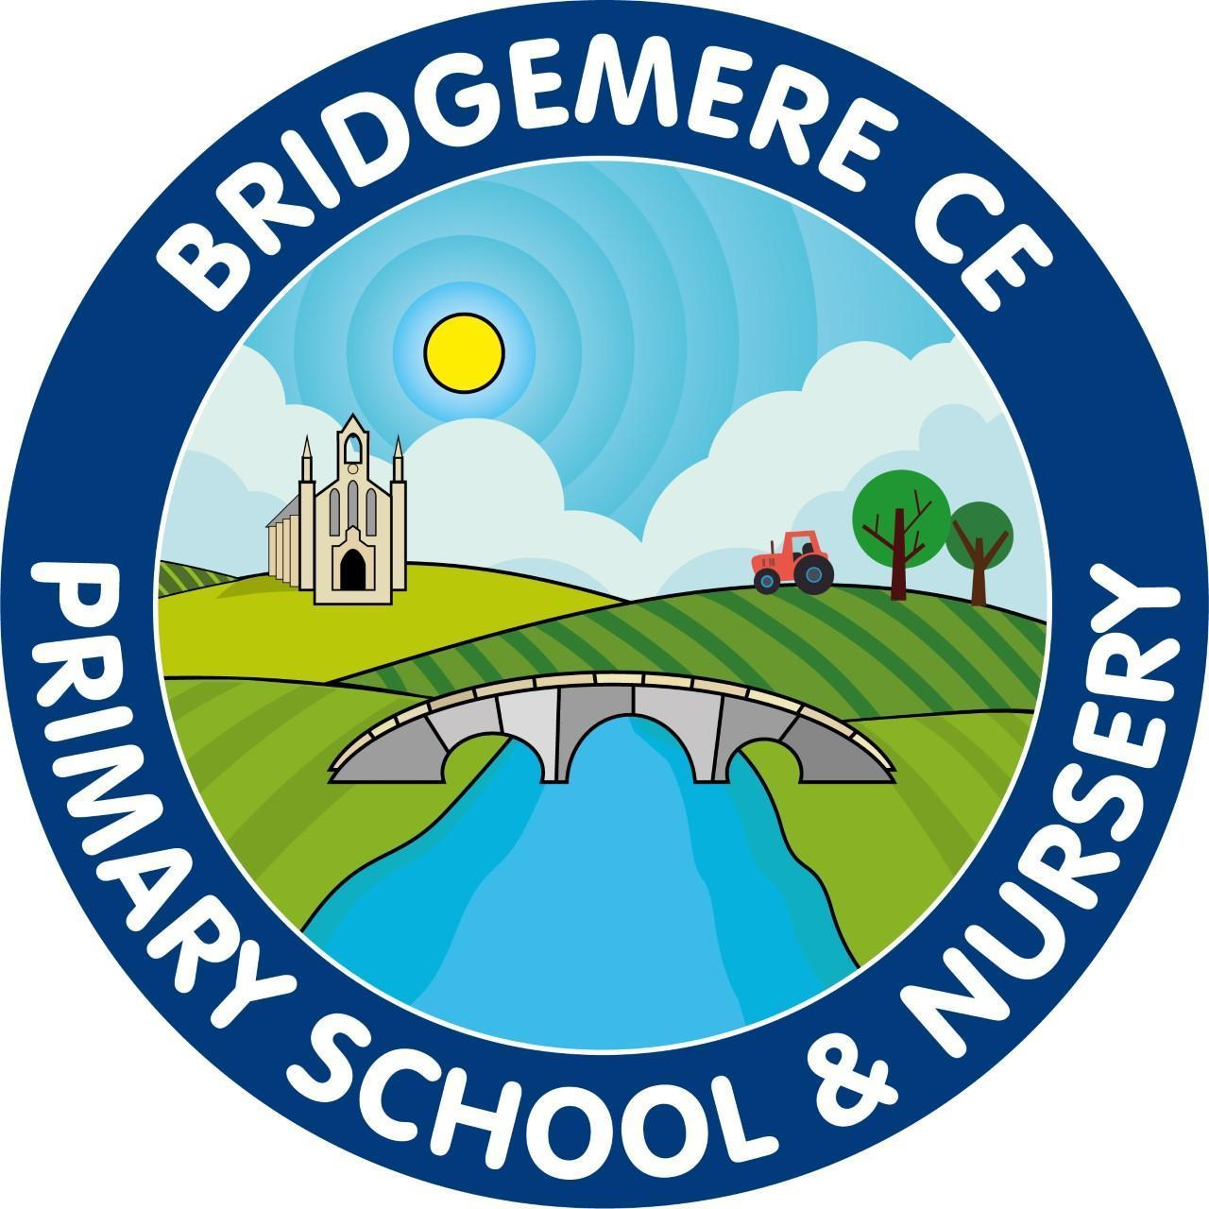

Dear Parents,
How time has flown! We’re already into the Summer term. I hope you’ve all had an enjoyable Easter break and had plenty of opportunities to relax.

Reading
In Class 3 we continue to use Accelerated Reader to maintain and enthuse our brilliant readers. This will require your child to read every day for a minimum of 15 minutes as compulsory. When books are read and understood fully; even if this means reading smaller books twice, your child will complete an online comprehension test. We strive for your children to do their best, however, we do have an expectation of understanding a text with a minimum of 80% accuracy.
In Key Stage Two we love competition, so Class 3 and Class 4 each week will compete to see how many books each class can read with rewards of team points and additional Class choice time on a Friday.
I must note that at the end of Spring term your children all showed improvements in their reading with many achieving improved reading scores. I have expressed to your child how proud I am of them and that their hard work and determination has been shown and noted!

English
During our English learning this term we will focus on consolidating our grammatical language and skills when writing narrative and non-fictional written pieces. As a class, we continue to work on our handwriting and presentation as these can dramatically change our individual outcomes. For this term we will immerse into texts ‘Pip and Egg - By Alex Latimer’, ‘It fell from the sky - By The Fan Brothers’ and ‘Man fish - by Jennifer Berne’

P.E
PE lessons will be on a Monday and Wednesday for this half term. Please make sure your child has the appropriate PE kit when attending school on these days. Please make sure your child’s PE kit and school uniform are clearly labelled.

Other learning
This term our foundation learning will be ‘The Roman Empire and its impact on Britain’ where we will practise our historical and geographical skills linking these to our previous knowledge and understanding of The Stone Age, Bronze Age and Iron Age. We will look at significant events and timelines to further understand these monumental events. We will improve our map skills in Geography focusing on the United Kingdom looking and place knowledge and changes over time linked to Roman invasion. In Science we will be focusing on states of matter, solids, liquids and gases and using this knowledge to learn about evaporation and condensation and their roles within the water cycle. In RE we will look at rules for living - which should we follow and proverbs.
Alongside all this learning, in Summer 1 and part of Summer 2 term, we will have music lessons from Love Music Trust. Your child has been allocated a brass instrument for these lessons which can be brought home once the instrumental loan agreement has been signed and returned. Each week on a Wednesday, your child will need to bring their instrument back in to school. These lessons will allow the children wider opportunities, including using these new skills to play along with the Halle orchestra in Manchester, June 11th.

Dates for your diary for Class 3:
- May 21st - trip to Chester
- May 18th - Sports Day
- Week commencing June 8th - Year 4 times table check
- June 2nd - Summer Fayre
- June 11th – Come and play with the Halle - Manchester
- July 16th - KS2 Camp out (at school)
- July 24th - Last day

If you have any concerns or questions at all please use communication diaries as these will be checked daily or ring the office to arrange a meeting.

Kind Regards
Miss Latham

