Year A
Class One | Elmer – David McKee  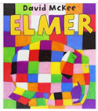  (A fact book) | The River- Tom Percival  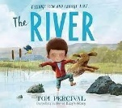  (Narrative Sentences)  How to Hide a Lion  Helen Stephens  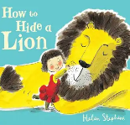  (Instructions) | Mr Gumpy’s Outing- John Burningham  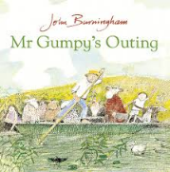  (A Journey Story, an Invitation)
 | Star in a Jar – Sam Hay and Sarah Massini  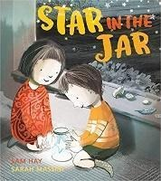  (Messages, information writing, sequencing, poster, recount, information) | Saving Mr Hoot- Helen Stephens  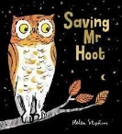  (Narrative sentences) | Stuck  Oliver Jeffers  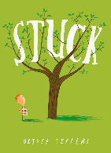
Class Two | Old Bear - Jane Hissey  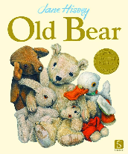  (Narrative – a finding narrative and messages) | Hermelin – Mini Grey  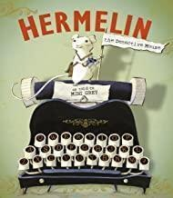  (Detective narrative and letters) | The Secret of Black Rock – Todd Stanton  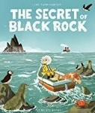  (Descriptive narrative and postcards)
 | The Night Gardener by Eric Fan  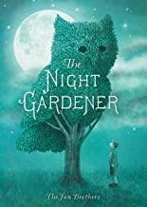  (Narrative, postcard, letter, setting description, poetry, instructions, diary) | Grandad’s Island – Benji Davies  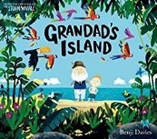  (Return narrative and non-chronological report) | Jack and the Baked Beanstalk- Colin Stimpson  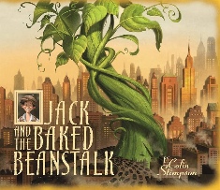  (Persuasive letter and twisted tale)
Class Three | The Ocean Meets the Sky Eric Fan and Terry Fan  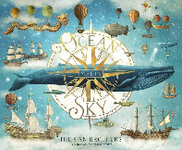  The Search for the Giant Arctic Jellyfish- Chloe Savage  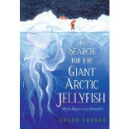 | The Rhythm of the Rain- Graham Baker- Smith  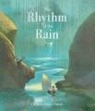  (Setting narrative and information leaflet) | Pip and Egg  Alex Latimer  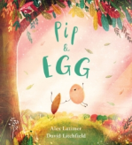  It Fell from the Sky  The Fan Brothers  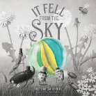
 | Leaf – Sandra Dieckmann  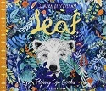  (Outsider narrative, information – Polar Bears) | The Lost Happy Endings – Carol Ann Duffy  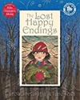  (Twisted narrative and newspaper report) | Man Fish – Jennifer Berne  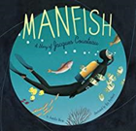  (Invention narrative, biography)
Class 4 | Curosity | The Hound of the Baskervilles – Arthur Conan Doyle  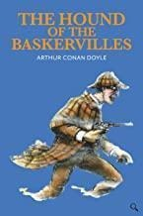  (Cliffhanger Narrative) | Shackleton’s Journey – William Grill  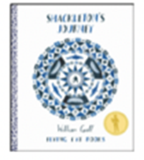  (Endurance narrative, recount – magazine article)
 | Rose Blanche – Christophe Gallaz and Roberto Innocenti  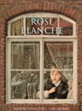  (Recount – diary, bravery speech award) | The Ice Bear  Jackie Morris  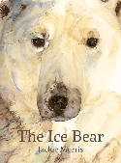 | King Kong – Anthony Browne  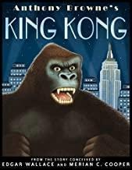  (Dilemma narrative, balanced argument)

Year B
Class One | Super Dooper You –  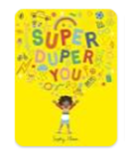 | Little Red – Beth Woolvin  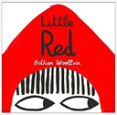  (Labels, captions, invitations, menus, speech, narrative, recount  Traditional tale – narrative writing, instruction writing) | The Extraordinary Gardener – Sam Boughton  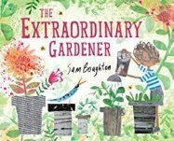  (Narrative, postcards, recount, description, speech, recipes, instructions, information)
 | The Snowman – Raymond Briggs  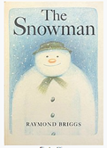  (Labels, recount, instructions) | Juniper Jupiter – Lizzy Stewart  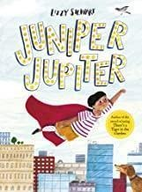  (Traditional tale – narrative writing, instruction writing, letter) | The Storm Whale – Benji Davies  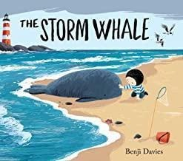  (Postcards, recount, recipes, instructions)
Class Two | Rapunzel – Beth Woolvin  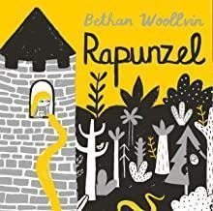  (Traditional tale and instructions)  Daily Phonics | Where the Wild Things Are- Maurice Sendak  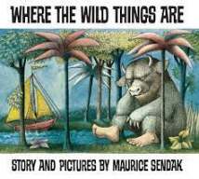  (Portal story and inform) | The Last Wolf  Mini Grey  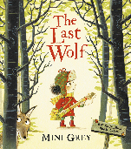  (Hunting story sentences)
 | A River - Marc Martin  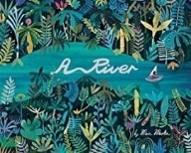  (Circular story and letters) | Bog Baby- Jeanne Willis  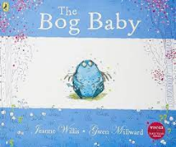  (Finding narrative and instructions) | The King Who Banned the Dark-Emily Haworth-Booth  The King Who Banned the Dark-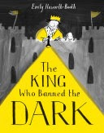  Emily Haworth-Booth  (Persuasive Letter and Banning Narrative)
Class Three | Iron Man – Ted Hughes  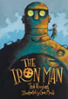  (Approaching threat narrative and explanation) | Marcy and the Riddle of the Sphinx  Joe Todd Stanton  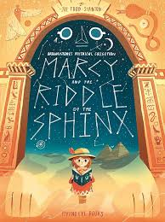 | The Wisp- Zana Fraillon  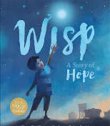  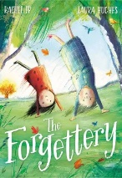  The Forgettery Rachel Ip
 | The Invisible Tom Percival  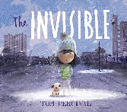  Leon and the Place Between- Angelia McAllister  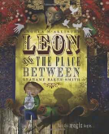 | The Boy that Grew Flowers  Jen Wojtowicz  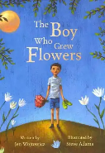 | The Corinthian Girl  Christina Balit  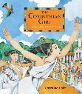  Flotsam David Wiesner  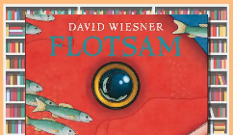
Class 4 | FArTHER – Grahame Baker-Smith  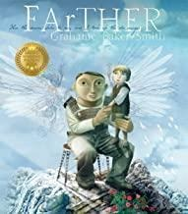  (Setting description and letters) | The Promise – Nicola Davies  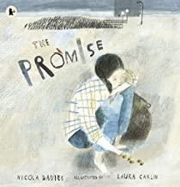  (Character narrative, news report) | Henry’s Freedom Box - Ellen Levine  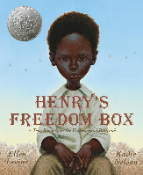  (Diary entry, Biography)
 | One Day  Rescuing Titanic  Flora Delargy  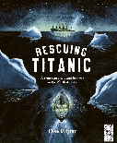 | Ways of the Wolf  Smriti Halls  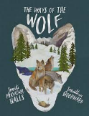  (Documentary Narrative) | Paradise Sands - Levi Pinfold  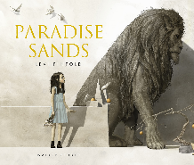  (Dual narrative – persuasion – letter)

