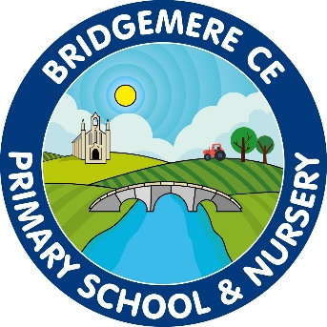

EYFS
Curriculum Policy

Confirmation that the EYFS Curriculum Policy has been approved by the Staff and Governors

June 2021

To be reviewed: June 2023

Caroline Middleton
Sarah Willington

EYFS Curriculum Policy
Curriculum:
What do we mean by curriculum?
At Bridgemere we believe the EYFS curriculum is more than an educational programme or what you want the children to learn. It’s everything the children do and see and hear and feel while they are with us in our setting and includes the unplanned as well as the planned activities.
At Bridgemere we deliver planned activities and experiences that have been thought out for the children but we encourage all learners to develop their own thinking and ideas from their own learnt experiences.
The curriculum is at the heart of our learning journey approach. To ensure children have the quality of education they deserve, we work alongside the principles of:
- Intent: Our EYFS curriculum framework is what we deliver and why
- Implementation: Ensuring practitioners are delivering the curriculum effectively so all learners make progress
- Impact: Evaluating the impact of the curriculum by checking what the children know and can do
At Bridgemere our EYFS curriculum offers all our learners:
- a personalised, innovative and strategically planned curriculum
- development, consolidation and deepening of their knowledge understanding and skills across all areas of learning
- challenging, engaging and real life problems
- a love of learning
- a child centred approach
- a rich learning environment that supports learning at every stage of development and area of the EYFS curriculum
- exploration in all areas of learning are regarded with the same level of importance and are interlinked in learning
- development of skills to build and sustain positive relationships
- skills to develop resilience
The characteristics of effective learning underpin our curriculum.

Our intent:
Vision:
At Bridgemere we aim to provide every child with the skills to become happy, independent and curious lifelong learners. Our priority is that our provision provides a high level of engagement and active learning through a range of skill based activities.

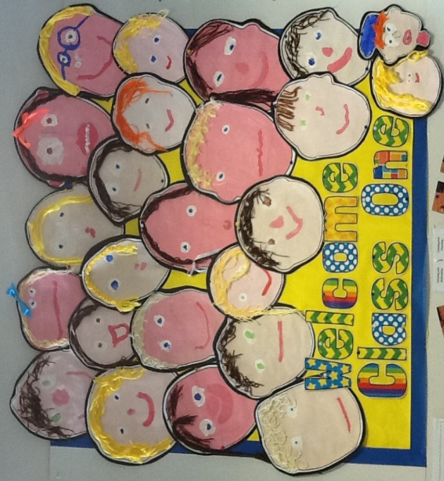

Principles:
At Bridgemere we strive to meet every child’s entitlement to develop a love of learning that will enable them to have the best possible future life chances.
The 2021 Statutory framework for the early year’s foundation stage states four guiding principles which should shape practice in the early years.

These are:
- Every child is a unique child, who is constantly learning and can be resilient, capable, confident and self-assured.
- Children can be strong and independent through positive relationships.
- Children learn and develop well in enabling environments, in which their experiences respond to their individual needs and there is a strong partnership between practitioners and parents and /or carers; and children develop and learn in different ways and at different rates.
- Practitioners teach children by ensuring challenging, playful opportunities across the prime and specific areas of learning and development
Learning and Development:
Our aim is to embed the characteristics of effective learning through our teaching of the areas of learning and development.

The characteristics of effective learning are:
Playing and Exploring:
This is where children’s play reflects their wide range and varied interests. In their play children learn at their highest level. Play with peers is important for children’s development.

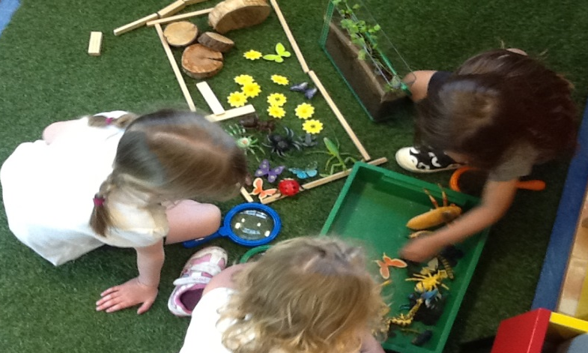

Children learn best through:
- experience
- adult involvement
- context for learning

Active Learning:
This is where the children learn best through physical and mental challenges. Active learning involves other people, objects, ideas and events that engage and involve children for sustained periods.
Children learn best when they have opportunity to engage in:
- mental and physical involvement
- decision making
- personalised learning

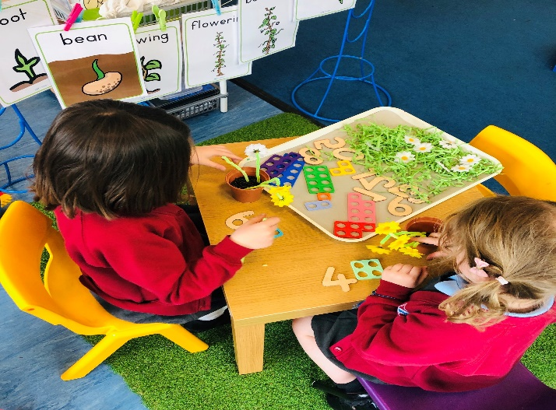

Creativity and Critical Thinking:
When children have opportunities to play with ideas in different situations and with a variety of resources, they discover connections and come to new and better understandings and ways of doing things. Adult support in this process enhances their ability to think critically and ask questions.
Children learn best when they are:
- making connections
- transforming understanding
- sustained shared thinking

There are 7 areas of learning and development.

These are categorised into three prime areas of learning:
• communication and language
• physical development
• personal, social and emotional development

And four specific areas of learning:
• literacy
• mathematics
• understanding the world
- expressive arts and design
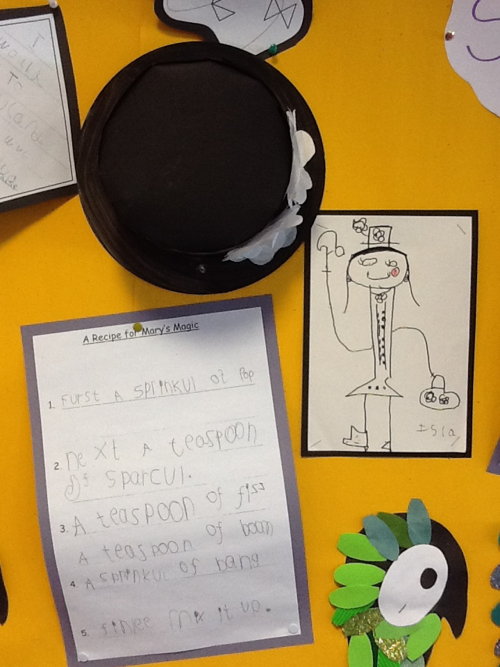
Our Implementation:
Delivery of our EYFS Curriculum:
Communication and Language:
Through our entire curriculum we promote opportunities to talk. Communication and language development however is about more than talking. It means all the different ways a child understands and communicates, only part of which are spoken words.
Communication and language development is important, because speaking is an indicator of fine motor skill development and a reflection of cognitive development.
Physical Development:
We promote the teaching of early skills of fine motor to ensure all of our learners develop a strong manipulation to use and handle tools and equipment effectively, including pencils for writing. We deliver daily sessions of ‘Finger Gym’ and ‘Dough Disco’ alongside continuous provision such as ‘The Cutting Station’.
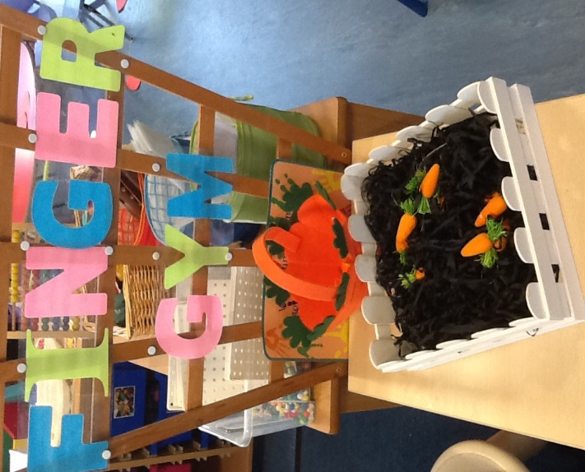

We develop gross motor skills through the use of the outdoor area alongside high quality planned PE sessions. All learners engage in a daily ’Active 15’. This whole school approach teaches the children the importance for good, physical health. Regular visits from the local PCSO ensure that children learn to keep themselves safe.

Personal, Social and Emotional Development:
Personal, Social and Emotional Development is recognised as one of the building blocks to success in life. It supports children’s development by helping them to interact effectively and develop positive attitudes to themselves and others.
At Bridgemere we give children opportunities to build positive relationships; we do this is through Kagan structures, interaction with older children through a buddy system and promoting a positive growth mindset within the EYFS environment.

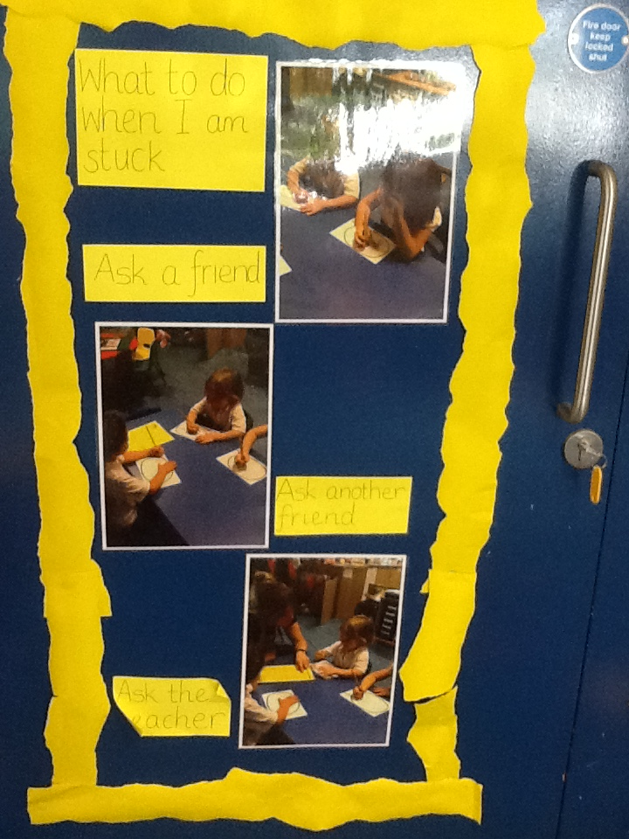

Literacy:
At Bridgemere phonics, reading and writing all go hand in hand.
Phonics:
Phonic knowledge is taught daily in ability groups following the Read Write Inc Programme.
Reading:
We deliver a structured approach to reading where children are given books to read in line with their phonic knowledge.
Other reading opportunities include:
- 1-1 reading
- Guided reading sessions
- Shared reading sessions
- Buddy reading
- Reading with parents
- Reading with others in the reading corner
- Reading in the learning environment
- Planned reading sessions within the curriculum
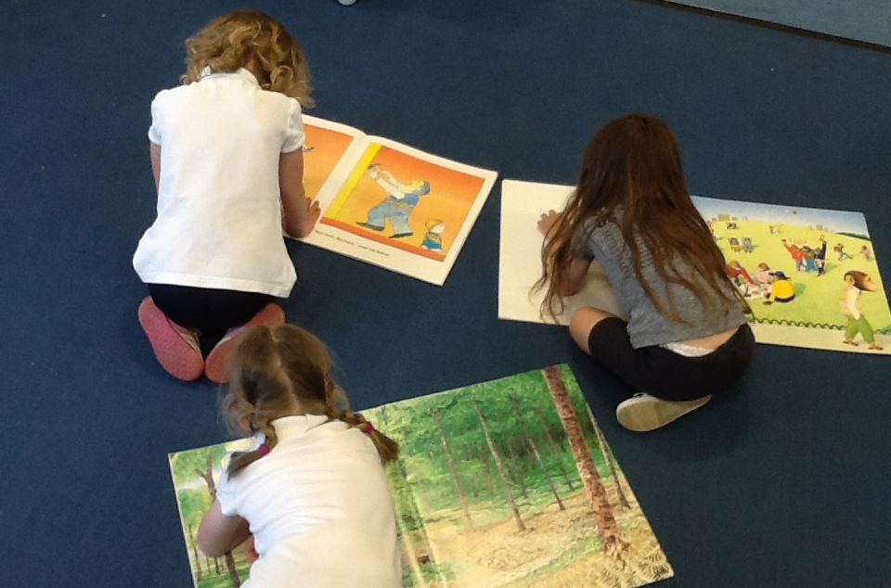

Writing:
At Bridgemere we believe children learn best when they are writing for a purpose. Planned opportunities are given for children to write in the classroom environment, these could include:
- shopping lists in the role play area
- instructions in the mud kitchen
- writing letters and thank you cards

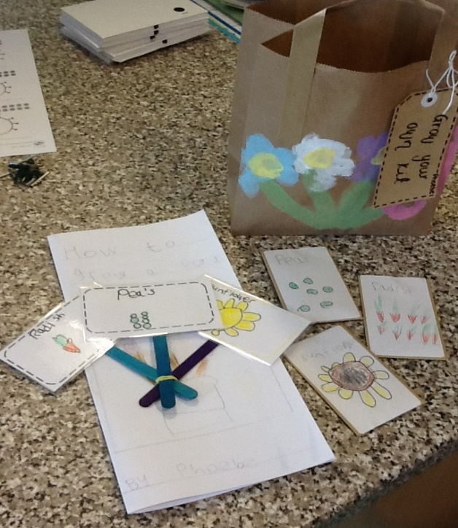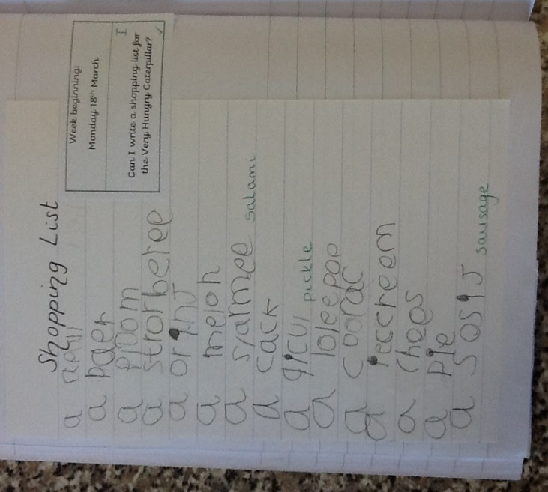
Specific modelling for writing takes place to develop children’s confidence. We encourage children to verbalise their intended sentence first, before writing it. Practitioners encourage all learners to use their phonic and high frequency word knowledge to develop their writing further.
There is a high expectation of correct letter formation and presentation. Children are taught pre cursive handwriting and are encouraged to use it at all times.
Reception follows the Read to Write Programme (Literacy Counts) which provides high quality teaching of writing through children’s high quality books. The teaching sequence follows
- Immerse
- Analyse
- Plan
- Write
This approach to writing is used throughout the school.

Mathematics:
There is more to maths than counting! At Bridgemere we encourage children to use their maths skills in their daily lives and find opportunities for supporting learners with numbers, shapes, space and measures. Maths is taught through real life problems linking to the whole school approach of Singapore Maths.
Daily maths sessions will follow the Reception White Rose Maths planning.

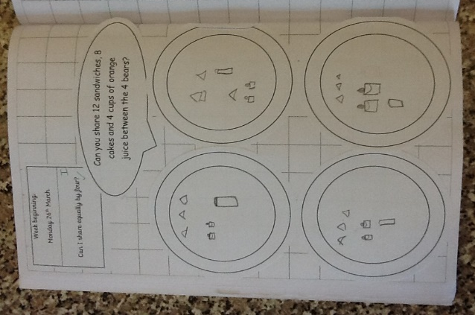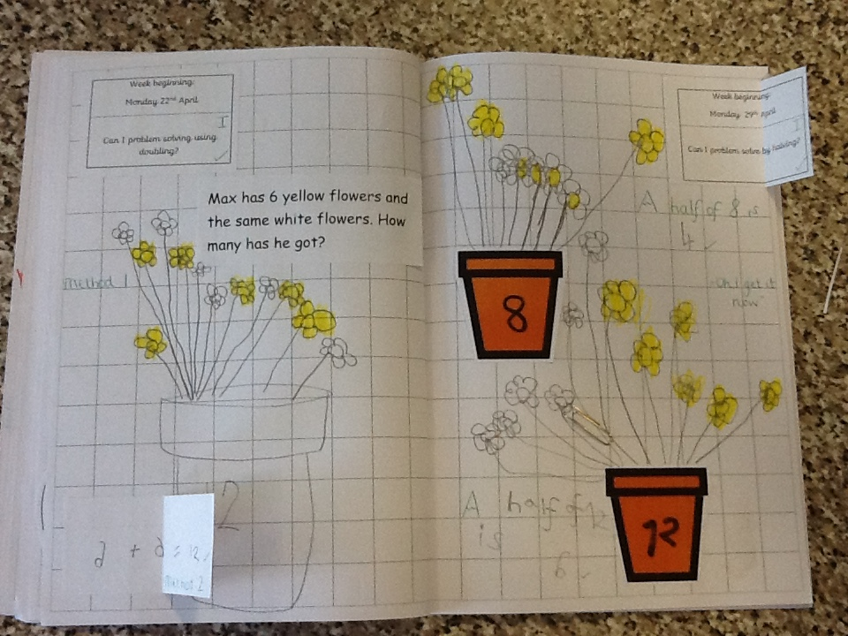

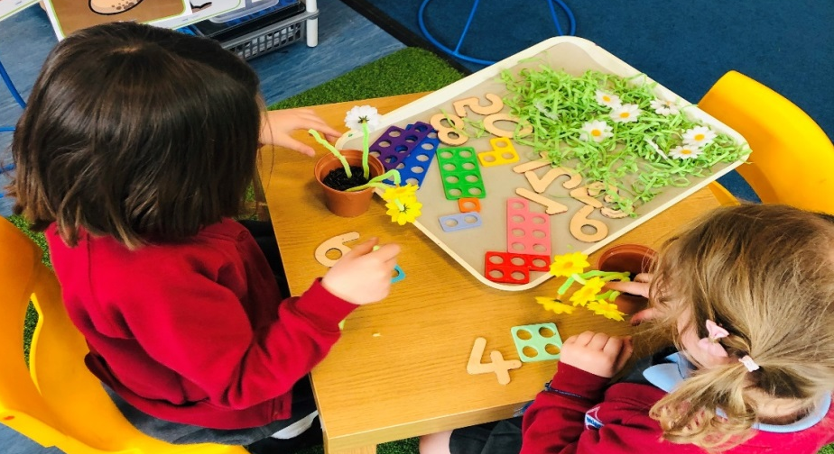

Understanding the World:
Understanding of the World is about how children get to know about other people, the place where they live and about all aspects of the environment. At Bridgemere we use the world around us as a teaching aid. Children are encouraged to use technology to support their learning.

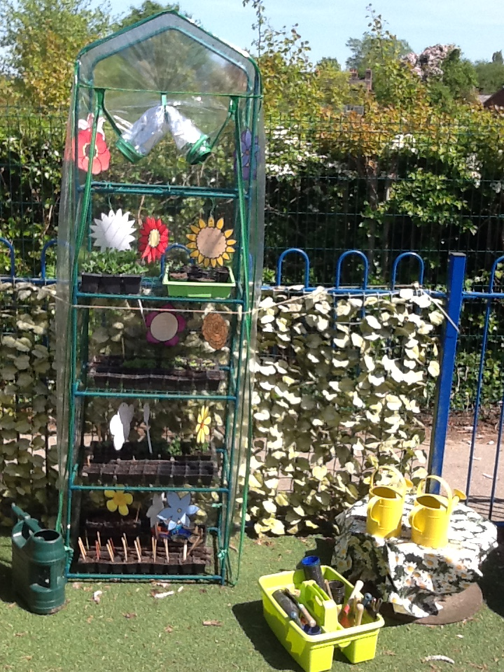

Expressive Arts and Design:
Expressive Arts and Design at Bridgemere involves supporting children to explore and play with a wide range of media and materials. There are also opportunities and encouragement for sharing thoughts, ideas, and feelings through a variety of activities in art, music, movement, dance, role-play, and design and technology.

Planning:
At Bridgemere we use the planning cycle to identify next steps of children’s learning.
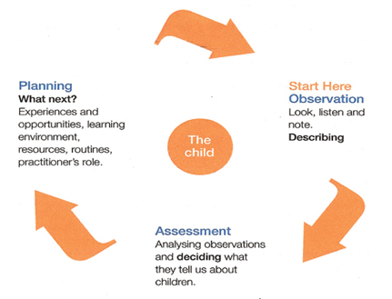
Planning is based on children’s interests. The long term plan states the learning followed throughout the year. These are subject to change according to cohort interests.
Activities based on skills may be led by practitioners in the classrooms. These activities let learning happen through creative opportunities, a supportive environment and a sound, pedagogical understanding.
There is balanced structured between adult led, child led or child initiated learning. Child-initiated activities may be instigated when the child brings something into the setting which might lead to the provision of resources, stories and pictures to support this interest.
A whole class focus is linked to activities within the EYFS setting. These are adapted continuously to meet the needs of the unique child. Attention to children’s adaptation of activities is encouraged and creates extended learning opportunities.
Children are encouraged to challenge themselves through self-selecting tasks and activities. The activities offer opportunities for extended learning and are structured to develop their learning. Planning takes into account children with individual needs.

Learning Environment:
At Bridgemere, our focus is to ensure the learning environment is bright, stimulating and interactive for all learners. We provide clear areas where the children can access continuous provision to consolidate and enhance their learning, as well as enhanced provision which is based upon the main learning intention for that topic.
Within the classroom, all areas of learning should be promoted. There should always be a role play area, writing and maths areas, small world area, construction area, reading area, junk modelling area, creative area, malleable area, along with a well-resourced outdoor area to ensure free flow within the learning environment.

Impact:
Assessment:
On-going formative assessment is at the heart of our effective early years practice.
We make regular assessments of children’s learning and we use this information to ensure that future planning reflects identified needs.
We use the Standards and Testing Agency Reception Baseline Assessments that are carried out in the first three weeks of school. This information will be analysed within our EYFS team. We will plan assessments for each half term in line with the new 2021 EYFS. These will inform the next steps planning. We continue to use Target Tracker throughout the year to monitor progress.
We ensure our end of EYFS assessments are reliable through:-
• our knowledge of the child gained through observation and interaction
• our environment which enables the child to flourish to their full capacity

Parents and carers are given the opportunity to meet with their child’s teacher twice a year in a formal parents’ meeting and receive a written report on their child’s achievements and their Early Learning Goal achievements at the end school year.

Transition:
At Bridgemere we value the importance of a smooth transition into and out of the EYFS. As a mixed nursery and reception provision, transition is a gradual process throughout the summer term.

To ensure the best possible transition into EYFS we:-
- visit as many pre-schools as possible to meet children in a familiar setting
- share important information about our school during our new parents’ meeting (June)
- use written information sent by pre-schools to inform early planning
- hold a series of ‘welcome/taster’ sessions for parents and children in June and July
To ensure the best possible transition out of EYFS we:-
- hold move up sessions with their new teacher, in their new classroom
- have professional teacher discussions regarding individual learning needs of the learners
- hold a ‘meet the teacher’ session for parents to meet the class teacher and discuss and issues or concerns they may have
- use the last half term of Reception to prepare the children for the more formal learning environment in year 1

This policy will be reviewed every 2 years.

