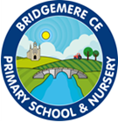

English
Curriculum Map

EYFS Year A

Autumn One  Elmer  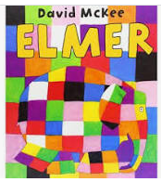 | Autumn Two  Star in a Jar  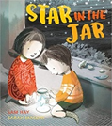 | Spring One  The River  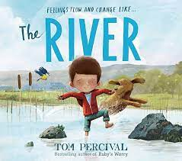 | Spring Two  Saving Mr Hoot  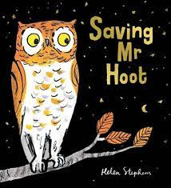 | Summer One  Paper Planes  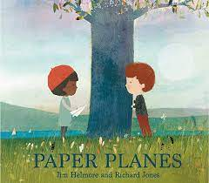 | Summer Two  There’s a Tiger in the Garden  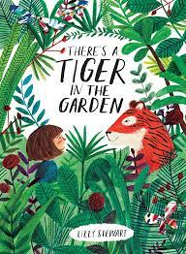
EYFS Year B

Autumn One  Super Duper You  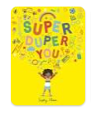 | Autumn Two  The Snowman  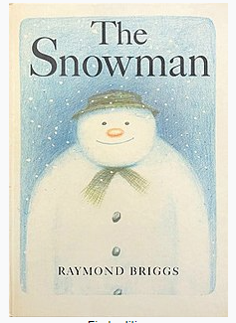 | Spring One  Little Red  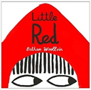 | Spring Two  Juniper Jupiter  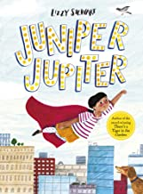 | Summer One  The Extraordinary Gardener  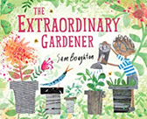 | Summer Two  The Storm Whale  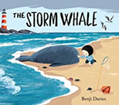
Year 1 and 2 A

Autumn One  Old Bear  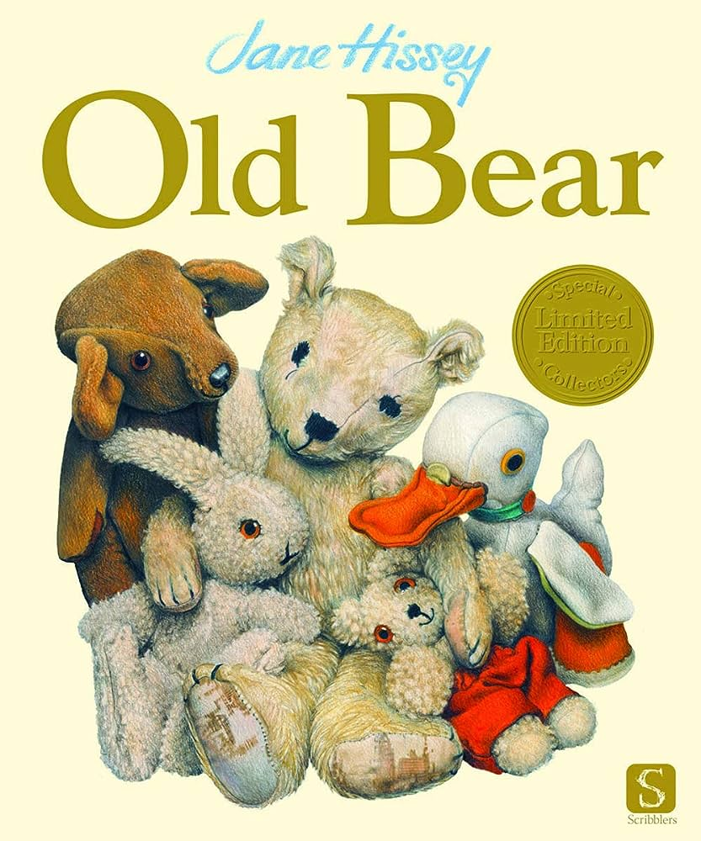 | Autumn Two  Hermelin  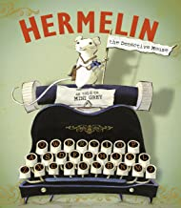 | Spring One  Rosie Revere  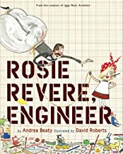 | Spring Two  Grandad’s Island  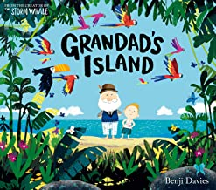 | Summer One  Bog Baby  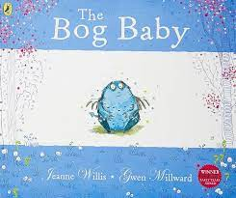 | Summer Two  Where the Wild Things Are  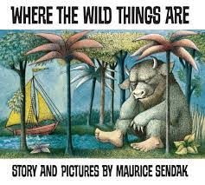
Year 1 and 2 B

Autumn One  The Last Wolf  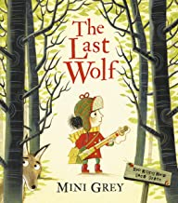 | Autumn Two  Rapunzel  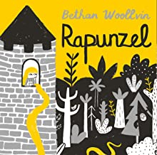 | Spring One  River  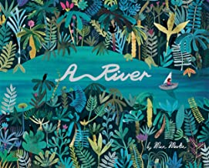 | Spring Two  The Secret of Black Rock  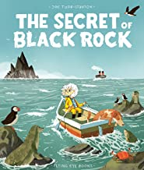 | Summer One  Jack and the Baked Beanstalk  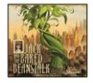 | Summer Two  The Night Gardener  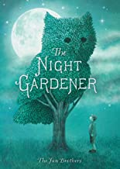
Year 3 and 4 A

Autumn One  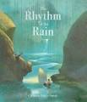  The rhythm of the Rain | Autumn Two  Jemmy Button  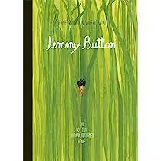 | Spring One  Leaf  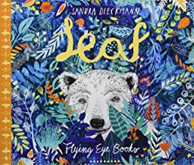 | Spring Two  Man Fish  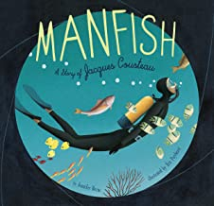 | Summer One  Into the Forest  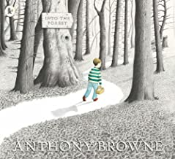 | Summer Two  The Lost and Happy Ending  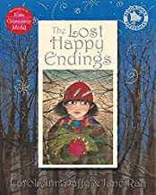
Year 3 and 4 B

Autumn One  The Whale  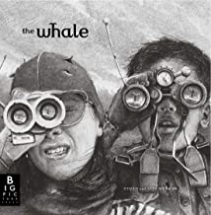 | Autumn Two  Fox  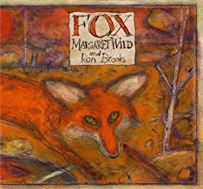 | Spring One  Egyptology  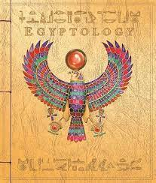 | Spring Two  Arthur and the Golden Rope  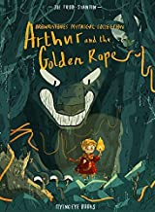 | Summer One  Iron Man  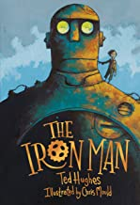 | Summer Two  The Journey  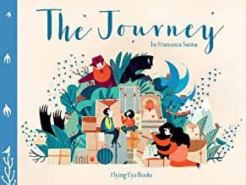
Year 5 and 6 A

Autumn One  The Errand  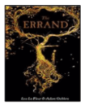 | Autumn Two  Rose Blanche  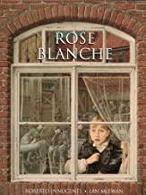 | Spring One  Shackleton’s Journey  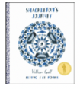 | Spring Two  When we Walked on the Moon  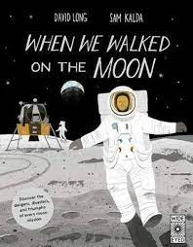 | Summer One  King Kong  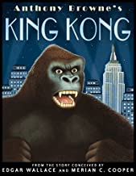 | Summer Two  The Origins of Species  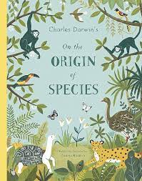
Year 5 and 6 B

Autumn One  Hansel and Gretel  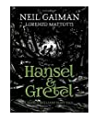 | Autumn Two  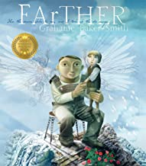  FAtHER | Spring One  The Lost Book of Adventure  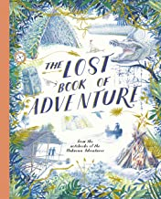 | Spring Two  Wolf  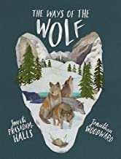 | Summer One  The Promise  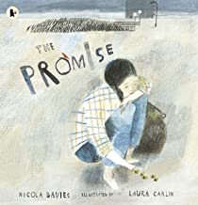 | Summer Two  The Hound of the Baskervilles  