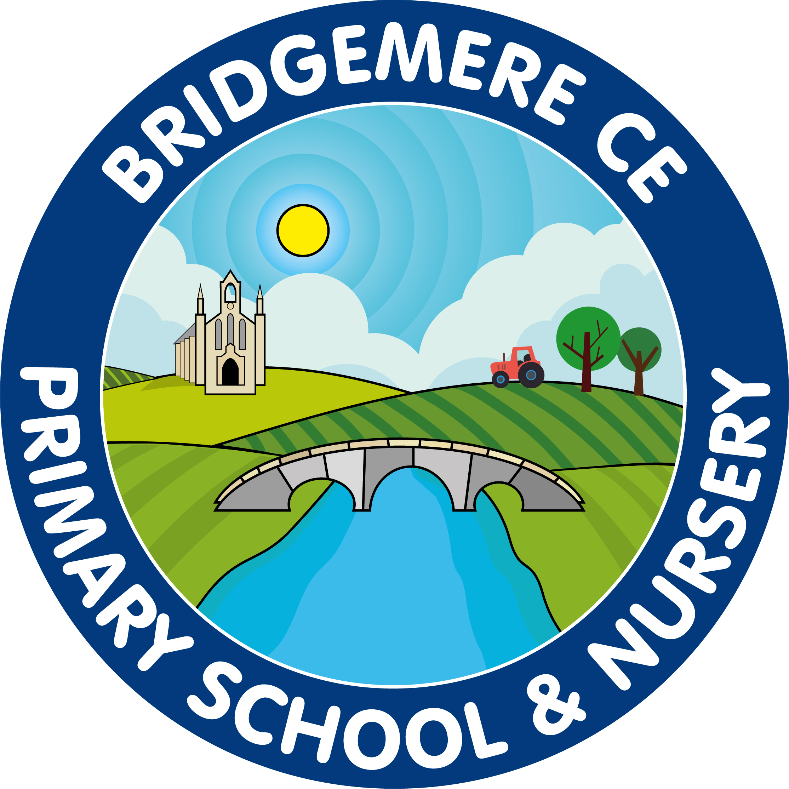
Bridgemere CE (Aided) Primary School
Bridgemere Lane, Bridgemere,
Nantwich, Cheshire, CW5 7PX

Head Teacher – Mrs Caroline Middleton
 | 01270 520271  admin@bridgemerece.cheshire.sch.uk  www.bridgemereschool.co.uk
30 July 2026

Dear Parents/Carers

The COVID Update - locally
As you know numbers of Delta variant case numbers in the area are rising. This variant is far more transmissible so spreads quickly.
Cheshire East has moved into an ‘enhanced support’ category since last Monday and that means there is a travel ban in and out of the area but it also means we can get more help if cases break out with ‘swab squads’ available to undertake mass testing in an area and greater push on vaccinations.

Testing
Thank you to every parent who has checked or asked about testing and that ‘What do I do now?’ question. Your caution helps reduce risk.
The main question school is getting is around testing – this is the advice we follow:

Lateral Flow Tests (LFTs) – freely available from chemists and to order on line;
https://www.gov.uk/order-coronavirus-rapid-lateral-flow-tests

The Lateral Flow Tests are for families to use if they have NO SYMPTOMS. They stop the asymptomatic carriers from wandering around unknowingly spreading COVID. You need to use these twice a week to keep a check on your status – all staff at school test a minimum of twice a week using LFTs.

If you or your child have ANY symptoms that may relate to COVID (see list below), go immediately and book for a PCR test:
https://www.gov.uk/get-coronavirus-test

If you have symptoms a LFT could show as negative and be inaccurate.

The main symptoms of coronavirus (COVID-19) are:
• A high temperature
• A new, continuous cough – this means coughing a lot for more than an hour, or 3 or more
coughing episodes in 24 hours (if you usually have a cough, it may be worse than usual)
• A loss or change to your sense of smell or taste – this means you've noticed you cannot
smell or taste anything, or things smell or taste different to normal
• A runny nose or sore throat are now starting to emerge too as potential Delta variant
symptoms
We know it’s a minefield and we like most of you, are not medically trained but we will always try to help. If in doubt ring or email, we will get back to you as soon as we can.

Vaccines
Finally if you are intending on taking up your vaccine offer the age dropped to 21 last Wednesday morning, click here to book;
https://www.nhs.uk/conditions/coronavirus-covid-19/coronavirus-vaccination/book-coronavirus-vaccination

Many thanks

Caroline Middleton

Headteacher

