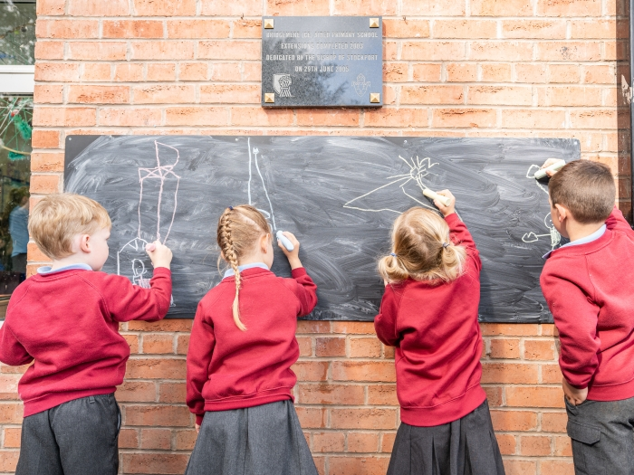

Welcome back to Bridgemere CE Primary
A welcome back guide for our pupils

Beverley Dolman
August 2020

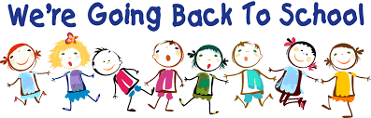

Hello everyone,
I just wanted to take a little bit of time to let you all know how excited we are about you coming back very soon. It has been such a long while since we have seen some of you and we can’t wait to see how much you have grown in that time and find out what you have been up to.
We know for some of you, you will be very excited about coming back and meeting up with the teachers and your friends. We also understand that some of you may be feeling a little worried about coming back. Try not to worry. The teachers and I have been very busy getting the school ready so we can all stay as safe as we possibly can.
Things will need to be a little bit different when we all return so that we can all keep safe. This little booklet will try to explain what school will be like when you return. I have asked your mums and dads to read it through with you and answer any questions you may have. If your mums or dads have any questions they can talk to me.
One thing that has not changed is how much the teachers and myself are looking forward to seeing you and helping you settle back into Acton.
See you all soon, but in the meantime please keep yourselves safe!

Mrs Dolman

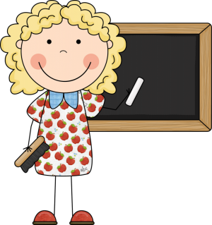

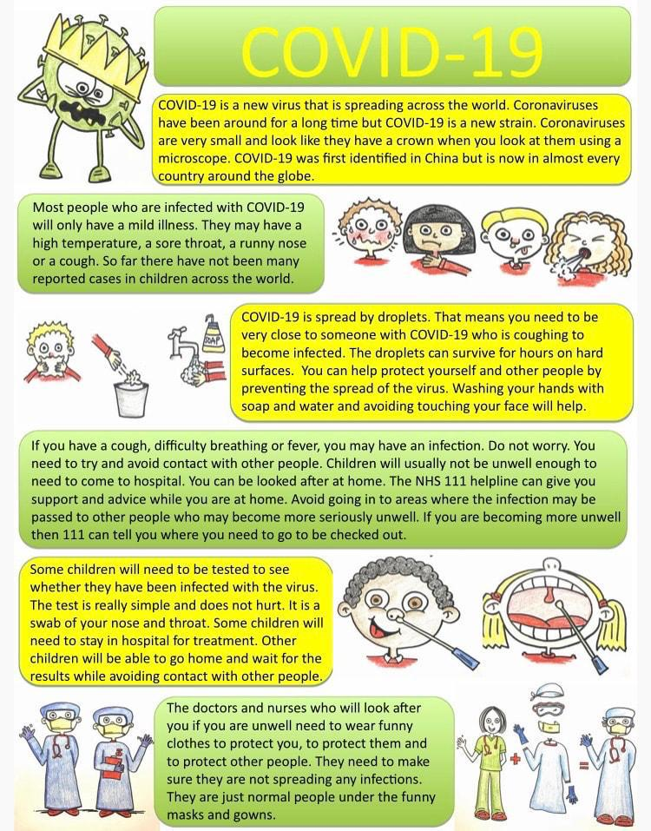
So, what is Coronavirus?
Courtesy of Hartsdown Academy
How will we keep ourselves safe?
Catch it, bin it, kill it!
If you feel the need to sneeze, you must use a tissue to catch it, then put the tissue into the bin. Do not touch the bin. The bin has a sensor, so you put your hand by the sensor and the lid will open automatically. Put in your tissue and walk away. The lid will close automatically.
If you cannot get to a tissue in time, sneeze into your elbow to stop the germs spreading.
Always wash your hands afterwards or use the sanitiser.
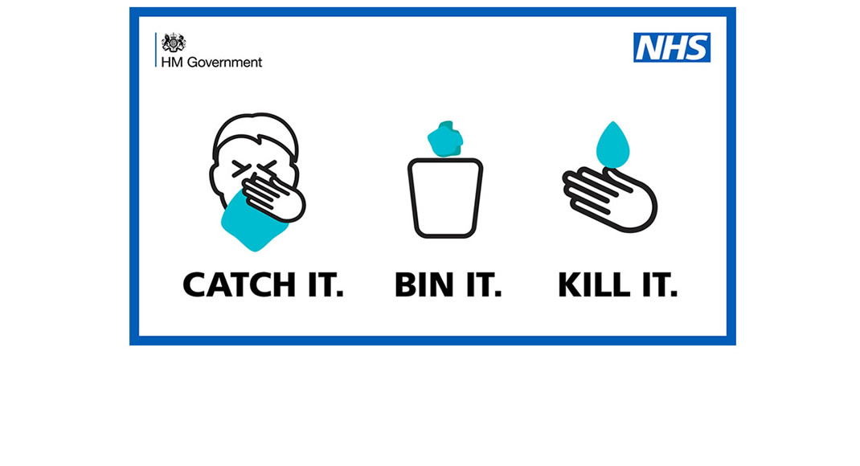
Handwashing
Everyone must wash their hands regularly. Your teachers will make you clean your hands as you come into school, before and after playtime, before and after lunch, before and after PE/Active 30, when toileting and before you go home. There may also be other times.
You may also be asked to use the hand sanitiser. The teachers and adults will always be around to help you if you need help.
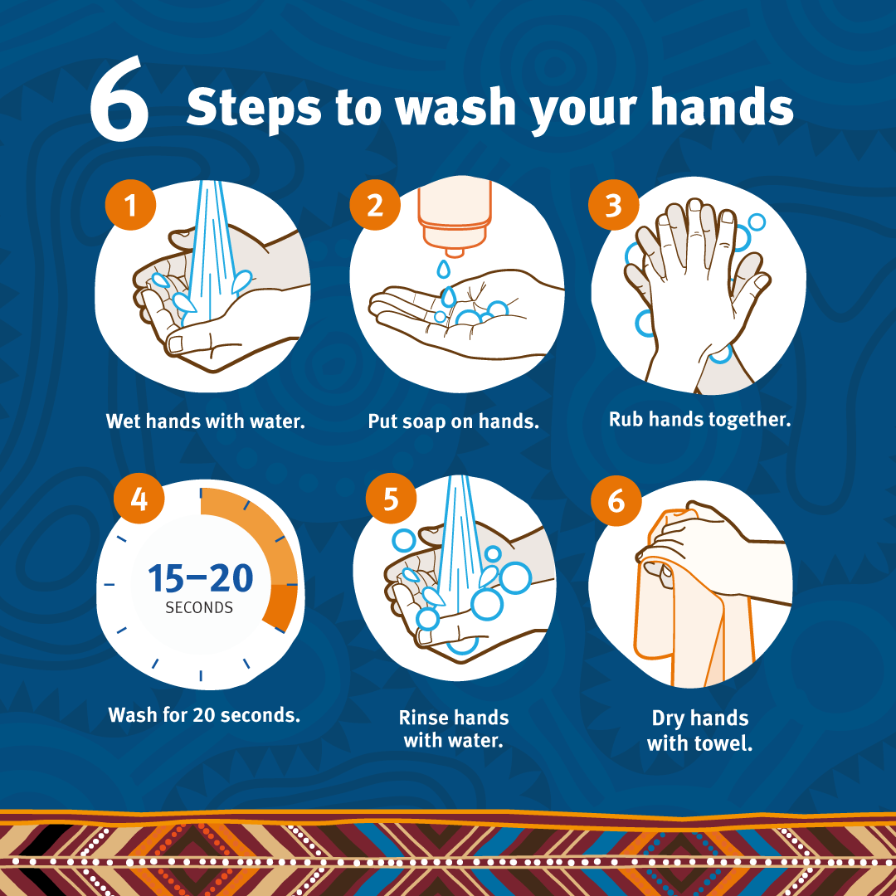

What is social distancing and what does it mean for me? 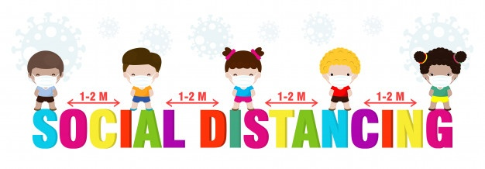
Social distancing means keeping a gap between you and somebody else. When you are in your classroom, you must try your very best to keep a gap between you and your friends.
We have put some markings on the carpet to help you, so you may see some lines, spots or crosses. Your teachers and other adults will help you to do this.
You must try even harder to keep a bigger gap between your teacher and other adults. This is to keep us all safe. Your teacher will have a special space in the classroom by their desk. This space is for them only.
Your classroom desks will be in twos or rows. They will not be in table groups like they used to be. We can still fit everyone in the classroom though so it is fine.
You will not move around the school unless you have an adult with you. This is to avoid unnecessary contact with people and other children who are not in your class.

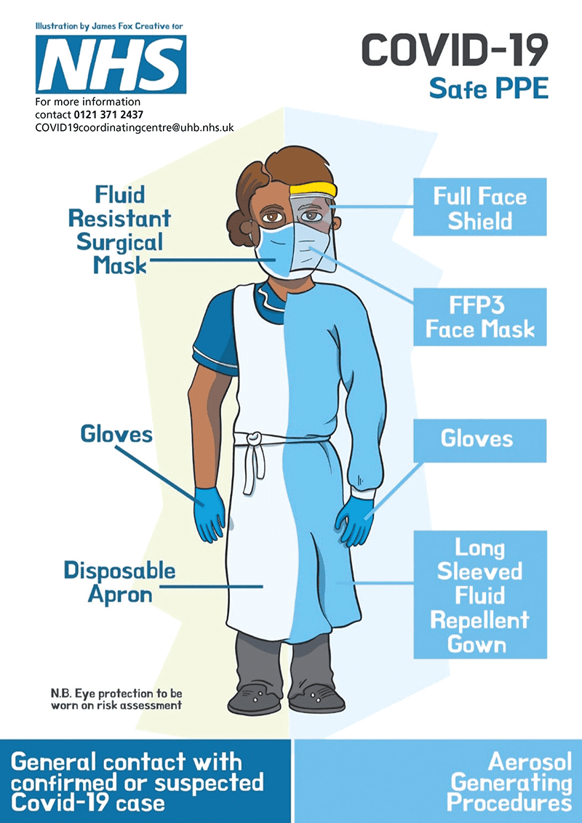
Will we use face masks?
At the moment, we have been told that children do not need to use face masks in primary schools. However, some of the teachers and other adults may use them. This is not to scare you. This is again to keep us all safe. If you have an accident at school, then the member of staff that helps you, may put on some special clothing and masks. This is called personal protective equipment. It will probably be an apron, gloves, face mask and possibly visor or goggles.
Do not be afraid. They will be helping you.
Remember the staff will be there to help you so you do not need to worry about this.

What do I need to bring to school?
You will need to fetch in a water bottle, your coat and if you are having a packed lunch, then you will need your lunchbox. You will also need to fetch in your PE Kit which will stay in school. Your water bottle must go home and be washed each evening. You can fetch in a small schoolbag.

You will be given a communication diary to take home and bring back to school.

You will be given your own zipped wallet with all of the equipment you require. You will not need to share this equipment with anyone else. It is just for you. This will stay on your desk. You must not fetch in pencil cases or anything from home.

You will be given all new exercise books. These books have got special antibacterial covers which means they will stop the spread of germs to keep you a little safer. You may be asked to give these books a wipe sometimes. Wipes will be available for you to do this.

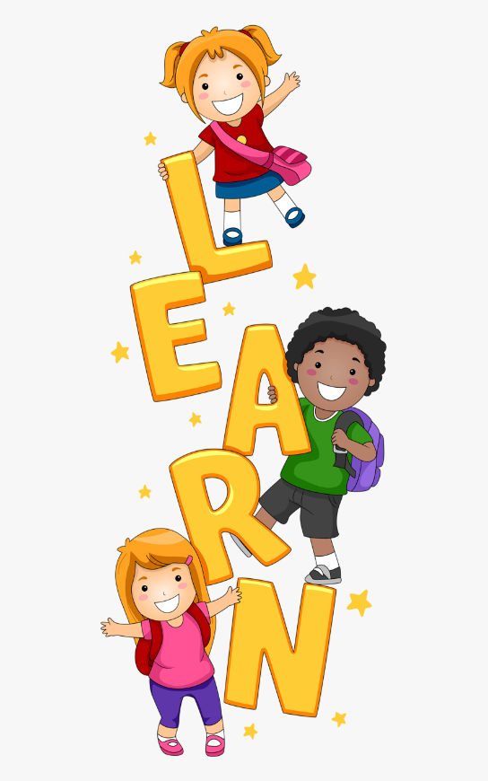
What will I learn?
The teachers have been busy looking at what you will need to learn when you come back.
We have had to make some changes to what we teach to try and make up for the time you have not been in school. This means we will be doing a little bit more Maths and English to start with.
We will also teach Science, PE, RE and Computing. We will be adding some new lessons called “A Time to Talk”. These are lessons to help us talk about any worries we may have. They will also allow us time to talk about lockdown, our families, our friendships and our feelings. We will do lots of different activities in these lessons such as drawing and making things.

What will happen at lunchtime and breaktimes?
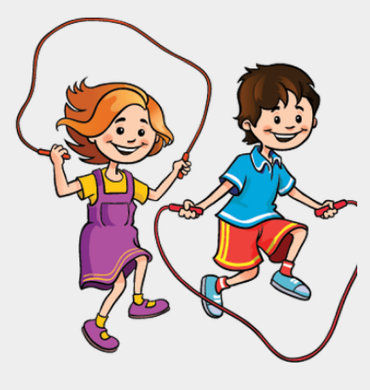
You will still get the opportunity to have a break and lunchtime. There will be less children outside with you however as we have had to stagger the times for each class. You will be allocated a space and that will be where you play each day.
There will not be any snack available at breaktime at the start of the new year due to the staggered timings, so please fetch in a healthy snack if you would like to.
During lunchtime most children will eat in their classrooms and the hot dinners will be brought to you. A few year groups will eat in the hall. Your teachers will explain the routine on your first day back into school. The same routine will apply to anyone having a packed lunch.

What will happen if I am in Breakfast or After School Club?
This may be a little different to normal. You will only be allowed to play with children in your class. You will not be allowed to play with children from other classes. Your class will be given your own space to play in. You will still receive breakfast and a snack as usual.

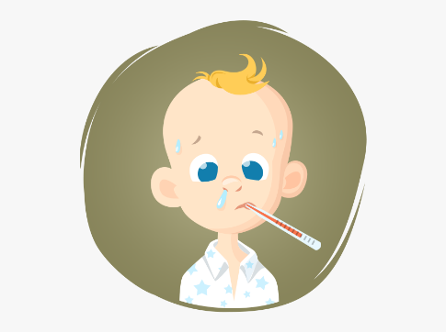
What happens if I feel ill in school?
This used to happen before Covid 19 and like before, an adult will be there to help you. We will also contact your mums or dads to come and collect you so you can go home and recover.
If you are feeling unwell and have a temperature or a cough we may need to ask your mums and dads to take you for a test.

What if I have got a question I want to ask?
If you have a question that you want to ask before you come back to school, you can ask your mum or dad to send me or your teacher an email. We will make sure we answer it before Friday 4th September.

Finally…
Remember, we are very excited to see you all again and we will help you with anything at all, so try and not worry about anything. It is usual for you to feel a little bit nervous when coming back to school, it is the same for the teachers too!
We are all in this together and we will get through this together.
See you all soon.
Mrs Dolman

