Class 2 Spring Term 1 Newsletter

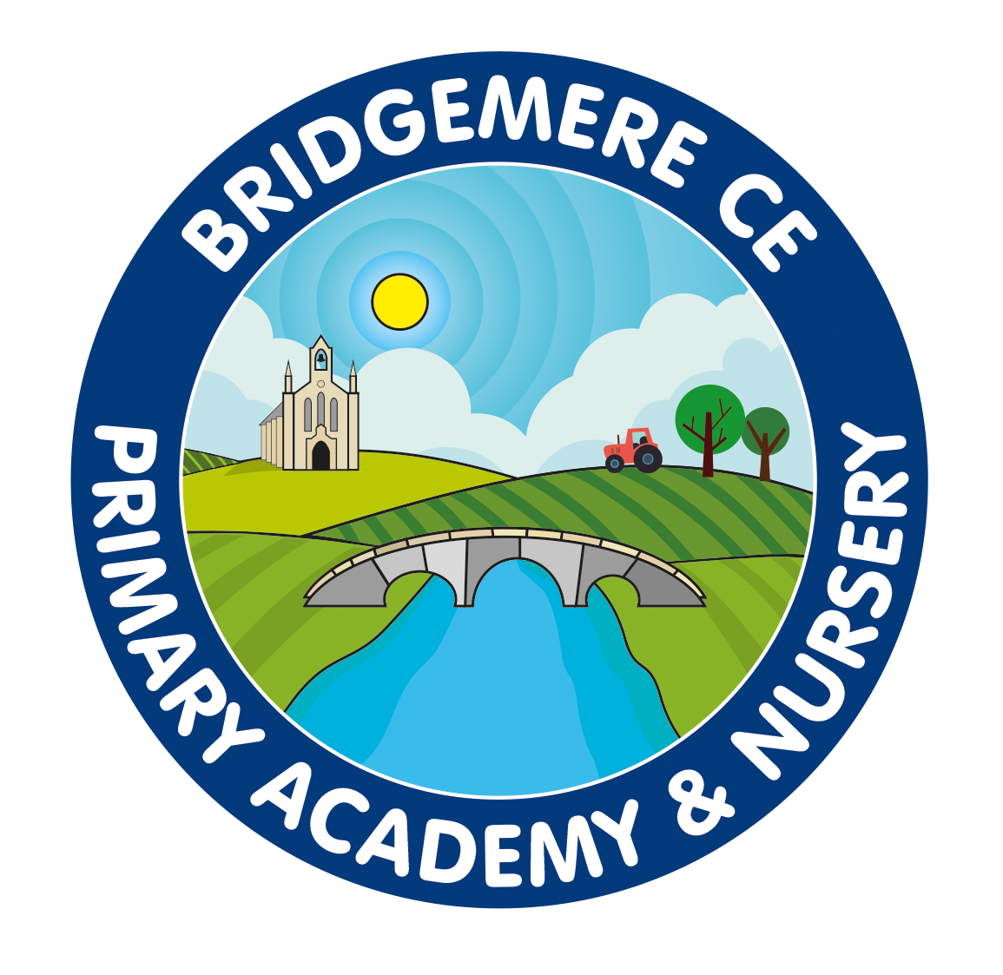

Dear Parents,

I hope that you all had an enjoyable Christmas break, being able to take time to spend with friends and family. The children have told me that Santa visited them all and that they all had a fantastic Christmas, so I hope you all did too.

Curriculum
Our topic this term is all about ‘The Mighty Migration’. This topic will run over the next full term, with the exception of the last weeks of Spring 2 which will be a celebration of Queen Elizabeth II.

During the term the children will learn to identify and name common British birds in our environment. They will also learn about migrating birds and from this we will look at and compare different environments and birds from around the world. As we delve deeper into migration we will link our Science to explore how migration is experienced for other animal groups.
In English the children will be looking at texts such as ‘Grandads Island’ and ‘Grandma Bird’ by Benji Davies. With this we will continue to increase our grammatical language to use within stories and information writing.
In Science our topic is ‘Animals, including Humans’ where the children will learn many aspects of our animal kingdom.
Within art the children will be looking at artist Lyn Norton using techniques similar to hers, to be able to create their own masterpieces using similar techniques. They will also begin to look at designing and making their own bird feeders in DT using ideas from Architect Frank Lloyd Wright.
We have been very lucky with PE this term as we are supported by Crewe Alexander on Fridays to conduct a range of skills lessons. Along side this children will build on fundamental skills needed for athletics on Wednesdays with myself.

Reading
The children are doing well in their reading and will continue to be assessed through Read, Write, Inc. Children will read every morning. It is still expected that children are to read their Read, Write, Inc books at home every day. This is to improve sounding out on Day 1 of reading, fluency on Day 2 and finally comprehension on Day 3. We will change these books every Tuesday and Friday to allow for these three days of reading.
To encourage an enjoyment of reading please enjoy as many other books throughout the week and at bed time as possible. Reading is the key to all learning and enables great writing and imagination throughout the curriculum.

Homework
Children are expected to read daily for 15 minutes.
Maths or English may be sent out if the children require additional practise at home or at the request of parents. This is optional but will build on previous or new learning the children have gained within school.

General
I endeavour to try to organise a visit or trip this half term as the children have missed many opportunities over the last two years to be able to do this. Hopefully we will be able to do so and allow the children these experiences.
Please feel free to come and chat about anything you or your child may have a concern about by booking an appointment through the school office via email or phone.

Thank-you for your continued support, it is very much appreciated.

Kind Regards

Miss Latham

