Class 2 Autumn Term Newsletter
Miss Latham

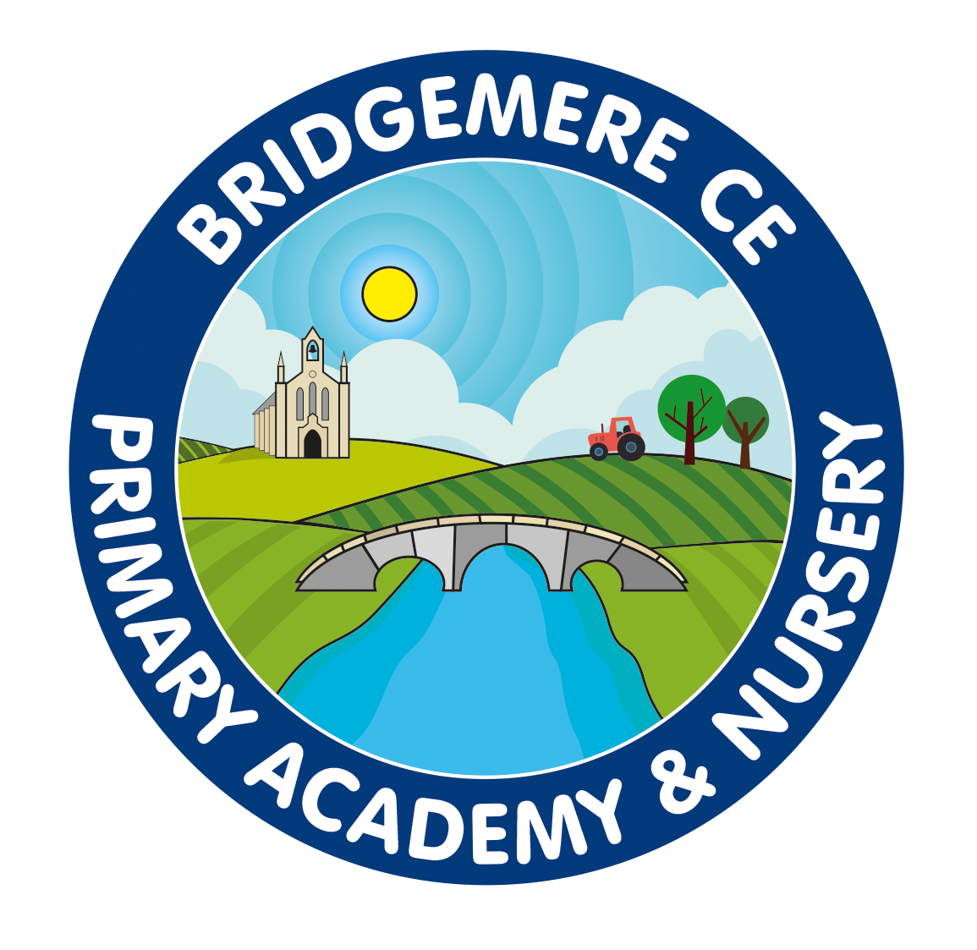

Dear Parents,

Welcome to Class Two. We have had a great start to the year so far. The children have all been excited to come in and meet their new teacher, and I have loved getting to know them too. They’ve been brilliant so far especially as we now have such a big class.

Topic
Our topic for this term is ‘Where in the world is Bridgemere?’ We will be learning our compass points and using our directions to navigate around places we know and put them into perspective of the world around us.

Reading
The children will get a reading book which should be kept in their book bags. Please ensure you are reading with your child every night, either their reading book or a bedtime story of your choice and remember to sign their dairies so they can change their books the following day.

Please use these diaries to also communicate any messages to me which are of importance. I will also be available to talk before school.

P.E
PE lessons will be on a Friday and will be lead by Mr Gibbons. In addition to this the children will also have performing arts on a Monday afternoon. Please ensure your child has their PE kit in everyday (white t-shirt and navy shorts and pumps)
Active 30 is now run from 11.30-12. As the weather gets colder, you may prefer to provide navy jogging bottoms and a jumper. Please make sure everything is named.

Snack
Snacks are available to buy from the kitchen at playtime. Children can bring a wallet or purse into school with their own money to purchase a snack, should they desire. On Thursday we also have bacon rolls for sale for £1.

Website
The class page will be updated regularly, so please take a look at all the exciting things we have been learning in class. I will also post any upcoming events to the page so you have advance notice of anything coming up. You will also find any letters I send on there too.

If you have any concerns at all you can write me a note or make an appointment to come and see me, I’m always happy to discuss any concerns or issues. Similarly if I have concerns or worries about your child, I will let you know. I feel it is important that your child is happy in the classroom so that they achieve their full potential.

Already I feel that Bridgemere Primary is such a lovely school. You have made me feel very welcome in this short space of time. I look forward to teaching your child and fostering a love of learning throughout the year.

Kind Regards

Miss Latham

