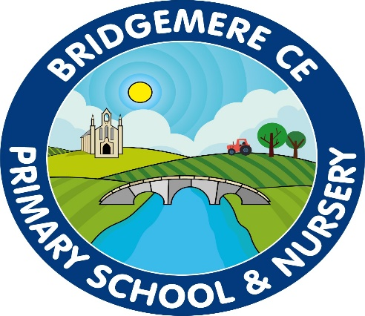
Autumn 1 | Autumn 2 | Spring |  | Summer 1 | Summer 2
Class 2 -Year 1/2: 2019-2020
Where in the world is Bridgemere? |  | Our Feathered Friends |  | Afternoon Tea with the Royals | Commotion in the Ocean
Class 2 -Year 1/2: 2020-20121
The British Isles | Behind enemy lines  (George VI 1936-1952) | Fun at the Fair | Gardener’s World |  | Water Matters
Class 3 -Year 3/4: 2019-2020
A Passport to Europe | Penny Black (Queen Victoria – 1837-1901) | Reduce, Reuse, Recycle |  | Ready, Steady, Cook
Class 3 - Year 3/4: 2020-2021
The Forgotten, flamboyant King (James I 1567-1625) | Gift of Giving | War, fire and pestilence  (Charles I-II  1625-1649,  1649-1651) | Around the World in 80 Days | Lights, Camera, Fashion
Class 4 - Year 5/6: 2019-2020
Sails, seas and scurvy  (Queen Elizabeth I/Tudor Exploration 1558-1603) | Wonders of the World | Ecotricity |  | What’s on the Menu? |  | The Empire strikes back  (27BC-476AD)
Class 4 - Year 5/6: 2020-2021
Law and Disorder  (Vikings 790-1066) | The Apprentice | GlobalCitizen@work |  | Pharaohs, Pyramids and Prehistoric periods  (30,000 - 327BC) |  | Wacky Races

