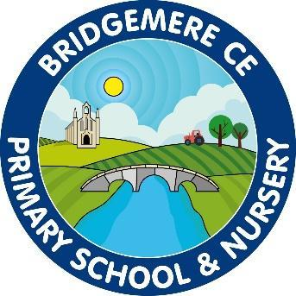

Bridgemere CE Primary School Curriculum
“I can do all things through Christ who strengthens me”
-Philippians 4 v 13
●Perseverance ●Courage ●Trust● Compassion● Community
●Responsibility ●Respect● Creativity ●Friendship ●Thankfulness

EYFS Bridgemere CE Primary School
EYFS– Curriculum overview
Year A – See detailed yearly overview on EYFS & Class 1 Webpage
Year B – See detailed yearly overview on EYFS & Class 1 Webpage
Subject | Autumn  A: It’s Good to be Me  A: A Starry Night  B: Just Like Me  B:Winter Wonderland | Spring  A: Passport to Bridgemere  A: Walking with Dinosaurs  B: Bream Big  B: To the Rescue | Summer  A: Are we nearly there yet?  A: Farm to Fork  B: In the Garden  B: Splish Splash
Literacy- Ready Steady Write  Read Write Inc | Daily Phonics – Read Write Inc  Elmer – David McKee  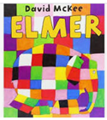  (A fact book)  Star in a Jar – Sam Hay and Sarah Massini  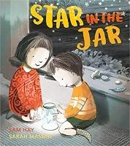  (Messages, information writing, sequencing, poster, recount, information)  Super Dooper You –  The Snowman – Raymond Briggs  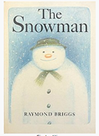  (Labels, recount, instructions) | Daily Phonics – Read Write Inc  The River- Tom Percival  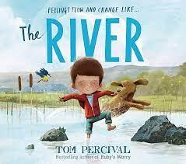  (Narrative Sentences)  Saving Mr Hoot- Helen Stephens  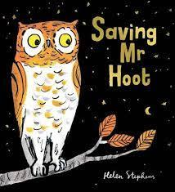  (Narrative sentences)  Little Red – Beth Woolvin  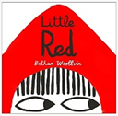  (Labels, captions, invitations, menus, speech, narrative, recount  Traditional tale – narrative writing, instruction writing)  Juniper Jupiter – Lizzy Stewart  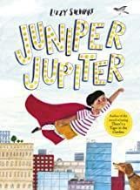  (Traditional tale – narrative writing, instruction writing, letter) | Daily Phonics – Read Write Inc  Paper Planes- Jim Helmore  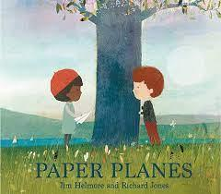  (Friendship story and recount messages)  There’s a Tiger in the Garden-Lizzy Stewart  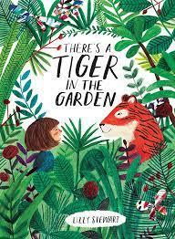  (Search and return native and invitations)  The Extraordinary Gardener – Sam Boughton  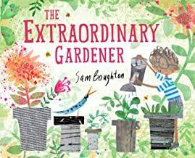  (Narrative, postcards, recount, description, speech, recipes, instructions, information)  The Storm Whale – Benji Davies  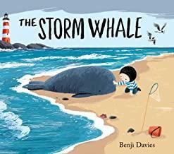  (Postcards, recount, recipes, instructions)
Maths – White Rose Maths | Matching and sorting  Making comparisons  Making simple patterns  Representing 123  Comparing 123  Composition of 123  Circles and triangles  Spatial awareness  4 and 5  One more one less  Shapes with 4 sides  Time | Introducing 0  Comparing numbers to 5  Composition of 4 and 5  Comparing mass, capacity  6,7 and 8  Making pairs  Combining 2 groups  Length and height  Time  9 and 10  Comparing numbers to 10  Bonds to 10  3D shape  Pattern | Building numbers beyond 10  Counting patterns beyond 10  Spatial reasoning  Adding more  Taking away  Doubling  Sharing and grouping  Even and odd  Spatial reasoning  Deepening understanding  Patterns and relationships
Understanding of the World:  Science History Geography: | Sense of Self  Families  Specials Day  Geography:  Where do we live?  Locational Knowledge  Place Knowledge  Science:  Seasonal changes  Observing weather changes  Materials  Sense of Self  Families  Special days  Geography:  Where do we live?  Locational Knowledge  Place Knowledge  History:  Family trees  Past & Present: How I have changed from a baby?  My Family  My 5 senses  Science:  Materials  Seasonal changes  Observing weather changes  Changing state – freezing & melting | Forest Schools-  Learning outdoors  Geography:  Locational knowledge: Bridgemere  Map work  Following a route  Researching local attractions  Comparing Bridgemere to other environments  Respecting the environment  History:  How has Bridgemere changed over time?  Researching dinosaurs- what Were they like?  Where did they live?  What happened to them?  Forest Schools-  Learning outdoors  Geography:  Can you help Little Red through the woods?  Map work  Following a route  History:  How have fairy tales changed over time?  Roles in society | Geography:  Can you help Mr Gumpy plan his journey?  Map work  Following a route  History:  How has transport changed over time?  Science:  Life on the farm  Lifecycles  Jobs  Animals  Geography:  Where have you been on holiday?  History: How have holidays changed over time?  How have I changed since beginning Reception?  Science:  Growing  Our environment  Minibeasts/ habitats  ‘Bug Hotel’  Planting seeds  Observe growth & change  Life cycle of a butterfly  Science:  Floating & sinking – waterproof
RE | Kingdom of God  God/incarnation  Good News  Incarnation | Christian Community  Resurrection  Creation  Salvation | Multi-Faith  Discipleship  World Religions  Holy Spirit
Expressive arts:  Art DT Music | What we can see?  How can we explore colour?  How can we build worlds?  What we can see?  How can we explore colour?  How can we build worlds?  Hinges & catches  Fantastic Fruit  Five little monkeys  Hello!  Sing the register  Teddy bear  Songs to develop a singing voice  Exploring sounds  I have sounds | How can we explore materials and marks?  How can we explore 3D materials?  How can we explore materials and marks?  How can we explore 3D materials?  Let’s look at products  Chairs for 3 bears  Numbers  Some sounds are short  Graphic score  Whispers  Beat and rhythm games  Copycat  Giraffe and worm | How can we use our bodies to make art?  How can we use our imaginations?  How can we use our bodies to make art?  How can we use our imaginations?  Let’s look at vehicles  Let’s look at hats  Waves on the Sea  Round and round the garden  Story time  Graphic Score  Voice game  How am I played?  Hop little bunny
Physical Development:  PE | Unit 1: Manipulation & Coordination  Unit 1: Body Management  Unit 1: Cooperate & Solve Problems  Unit 1: Gymnastics  Unit 1: Manipulation & Coordination  Unit 1: Body Management  Unit 1: Cooperate & Solve Problems  Unit 1: Gymnastics | Unit 2: Gymnastics  Unit 1: Dance  Unit 2: Manipulation & Coordination  Unit 1: Speed, Agility & Travel  Unit 2: Gymnastics  Unit 1: Dance  Unit 2: Manipulation & Coordination  Unit 1: Speed, Agility & Travel | Unit 2: Cooperate & Solve Problems  Unit 2: Body Management  Unit 2: Speed, Agility & Travel  Sports day practise  Unit 2: Cooperate & Solve Problems  Unit 2: Body Management  Unit 2: Speed, Agility & Travel  Sports day practise
Music | Five little monkeys  Hello!  Sing the register  Teddy bear  Songs to develop a singing voice  Exploring sounds  I have sounds | Numbers  Some sounds are short  Graphic score  Whispers  Beat and rhythm games  Copycat  Giraffe and worm | Waves on the Sea  Round and round the garden  Story time  Graphic Score  Voice game  How am I played?  Hop little bunny
Computing | Coding  Using technology  Using Software  Online Safety | Online Safety  Using technology responsibly  Using the internet safely  Using Equipment | Technology out of school  Using the internet safely  Using Equipment  Taking Photos and Videos
PHSE | Family and Friendships  Caring Friendships  My Happy Mind | Family and Friendships  Being Kind  My Happy Mind | Family and Friendships  Families  My Happy Mind

Bridgemere C E Primary School
Year 1 and 2 – Overview of two-year rolling programme
Year A
Year B
Topics are always linked to children’s interests so curriculum objectives may be taught in a different order to fit with topics and interests.
Subject | Autumn | Spring | Summer
Literacy – Ready Steady Write  Read Write Inc | Daily Phonics – Read Write Inc  Old Bear - Jane Hissey  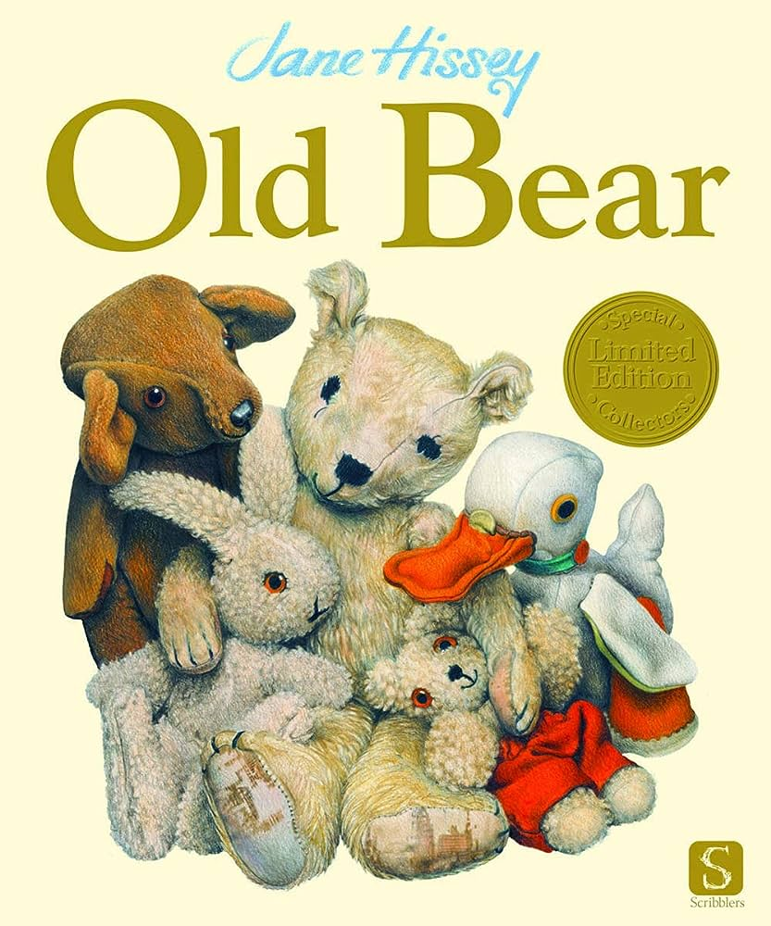  (Narrative – a finding narrative and messages)  Daily phonics  Hermelin – Mini Grey  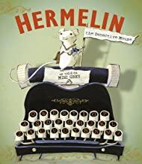  (Detective narrative and letters)  Daily Phonics  The Last Wolf – Mini Grey  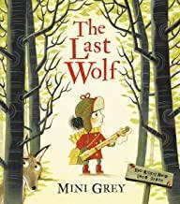  (Hunting narrative and recipes)  Daily phonics  Rapunzel – Beth Woolvin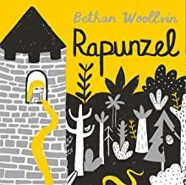  (Traditional tale and instructions)  Daily Phonics | Daily Phonics – Read Write Inc  Rosie Revere Engineer – Andrea Beaty  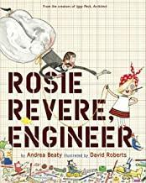  (Invention narrative and explanation)  Daily Phonics  Grandad’s Island – Benji Davies  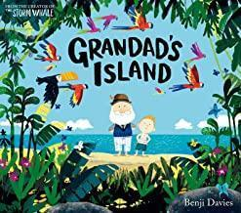  (Return narrative and non-chronological report)  Daily Phonics  A River – Marc Martin  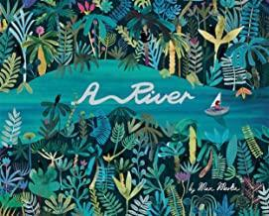  (Circular story and letters)  Daily Phonics  The Secret of Black Rock – Todd Stanton  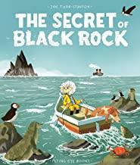  (Descriptive narrative and postcards)  Daily Phonics | Daily Phonics – Read Write Inc  Bog Baby- Jeanne Willis  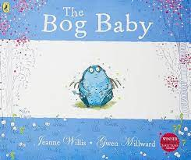  (Finding narrative and instructions)  Daily Phonics  Where the Wild Things Are- Maurice Sendak  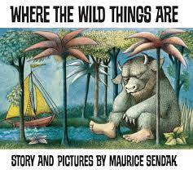  (Portal story and inform)  Daily Phonics  Jack and the Baked Beanstalk –  Colin Stimpson  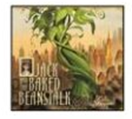  (Twisted narrative, persuasion- letters)  Daily Phonics  The Night Gardener by Eric Fan  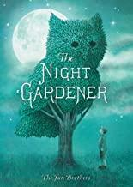  (Narrative, postcard, letter, setting description, poetry, instructions, diary)  Daily phonics
Maths – Maths No Problem | Year 1:  Number and Place Value: Numbers to 10  Calculations: Addition and subtraction  Geometry: Positions  Number and Place Value: Numbers to 20  Calculations: addition and subtraction within 20  Year 2:  Number and place value: Numbers to 100  Calculation: addition and subtraction  Calculations: Multiplication of 2,5 and 10  Calculations: Multiplication and Division of 2,5 and 10  Measurement: Length  Measurement: Mass  Measurement: Temperature | Year 1:  Calculations: addition and subtraction within 20  Geometry: Properties of shapes  Measurement: Length and Height  Number and Place value: Numbers to 40.  Calculations: addition and subtraction  Calculations: Multiplication  Year 2:  Statistics: Picture Graphs  Calculations: More word problems  Measurement: Money  Geometry: 2D shapes  Geometry: 3D Shapes  Fractions | Year 1:  Calculations: Multiplication  Calculations: Division  Fractions  Number and Place Value to 100  Measurement: Time  Measurement: Money  Measurement: Volume and Capacity  Measurement: Mass  Geometry: Space  Year 2:  Measurement: Time  Measurement: Volume  Revision – catch up / consolidation
Science | Animals including humans-Amazing Me  Seasonal Change-  Wild Weather  Animals including humans –  People and Pets  Seasonal changes –  Weather Art | Everyday Materials-  Brilliant Builders  Plants –  Growing things  Everyday materials –  Brilliant Builders 2  Plants –  Art and Nature | Animals including humans –  Wonderful Creatures  Living Things and their habitats-  Food Chains  Exploring uses of everyday materials  Living things and their habitats-  Habitats and homes
Geography | Our school, our school grounds  Our churches – Our local area | Geography of the local area – Nantwich  Is the UK the same all over? | Geography around the World  Coming to England
History | Our school, our school grounds-Changes within living memory  Our churches  London’s Burning… So is Nantwich!  More events beyond living memory - Gunpowder Plot, Remembrance Day | How has shopping changed in the last 100 years?  -Changes within living memory | Famous Explorers –  Ibn Battuta, Columbus, Shackleton, Johnson, Bird, Armstrong & Williams  2 Queens and a King  Elizabeth I, Victoria, King Charles III  Coming to England
RE | Kingdom of God  God/incarnation  Good News  Incarnation | Christian Community  Resurrection  Creation  Salvation | Multi-Faith  Discipleship  World Religions  Holy Spirit
Art | Spirals  Using drawing, collage and mark-making to explore spirals. Introducing sketchbooks  Explore & Draw  Introducing the idea that artists can be collectors & explorers as they develop drawing and composition skills | Making Birds  Sculptural project beginning with making drawings from observation, exploring media, and transforming the drawings from 2d to 3d to make a bird  Be An Architect  Exploring architecture and creating architectural models | Simple Printmaking  Explore simple ways to make a print. Use line, shape, colour and texture to explore pattern, sequencing and symmetry  Expressive Painting  Explore how painters sometimes use paint in an expressive and gestural way. Explore colour mixing and experimental mark making to create abstract still lifes
DT | Mechanisms  Sliders and levers  Mechanisms  Wheels and axles | Textiles  Templates & joining techniques  Structures  Free standing structures | Food  Preparing fruit & vegetables  Food  Preparing fruit & vegetables
Music | Tell me a story  Around the world  Fireworks and Fantasy  Fire Fire | Get on board  Down in the woods  Under the sea  Down in the Jungle | Blast off  Sun, moon and stars  Changes  Whatever the weather
Computing | Online Safety  Effective searching  Lego Builders  Online Safety  Maze Explorer  Questioning | Technology outside school  Grouping & Sorting  Creating Pictures  Online Safety  Animated Story Books  Making Music | Spreadsheets  Coding  Spreadsheets  Pictogram  Presenting Ideas
PE | Unit 1: Gymnastics (1)  Unit 1: Distanced PE Fitness  Unit 1: Send & Return (1)  Unit 1: Run, Jump & Throw (1)  Unit 1: Attack, Defend & Shoot (1)  Unit 2: Distanced PE Fitness  Unit 2: Attack, Defend & Shoot (1)  Foundations | Unit 1: Dance (1)  Unit 1: Gymnastics (2)  Unit 2: Send & Return (1)  Unit 2: Run, Jump & Throw (1)  Unit 2: Gymnastics (1)  Unit 1: Dance (2)  Unit 2: Hit, Catch & Run (2)  Beginner Swimming | Unit 1: Send & Return (2)  Unit 1: Hit, Catch & Run (1)  Unit 2: Hit, Catch & Run (1)  Unit 2: Run, Jump & Throw (2)  Unit 1: Attack, Defend & Shoot (2)  Unit 2: Gymnastics (2)  Unit 2: Attack, Defend, Shoot (2)  Unit 1: Hit, Catch & Run (2)
PHSE | Growing and caring for ourselves-  Different friends  Families and friendships  Safe relationships  Respecting ourselves and others  My Happy Mind  Differences  Families and friendships  Safe relationships  Respecting ourselves and others  My Happy Mind | Growing and caring for ourselves-  Growing and changing  Belonging to a community  Media literacy and Digital resilience  Money and Work Strengths and interests  My Happy Mind  Differences  Belonging to a community  Media literacy and Digital resilience  Money and Work  My Happy Mind | Growing and caring for ourselves-  Families and care  Keeping healthy  Growing and changing  Keeping safe  My Happy Mind  Differences  Physical health and Mental wellbeing  Growing and changing Growing older  Keeping safe Safety in different environments  My Happy Mind

Bridgemere C E Primary School
Years 3 and 4– Overview of two year rolling programme
Year A
Year B
Subject | Autumn | Spring | Summer
Literacy – Ready Steady Write | The Rhythm of the Rain- Graham Baker- Smith  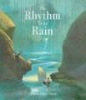  (Setting narrative and information leaflet)  Jemmy Button-Alix Barzelay  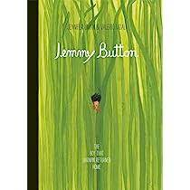  (Return narrative and letters)  The Whale – Vita Murrow  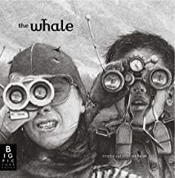  (Setting narrative, newspaper report  Fox - Margaret Wild  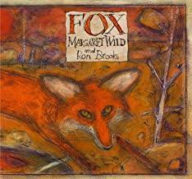  (Fable narrative and persuasion) | Leaf – Sandra Dieckmann  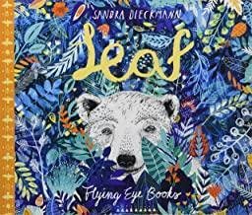  (Outsider narrative, information – Polar Bears)  Man Fish – Jennifer Berne  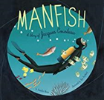  (Invention narrative, biography)  Egyptology- Dugald Steer  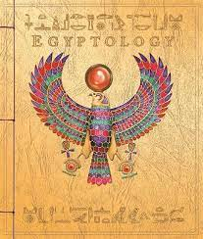  (Egyptian Mystery Narrative and secret diary)  Arthur and the Golden Rope -  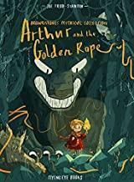  (Myth narrative, information – Defeating a Viking monster) | Into the Forest – Anthony Browne  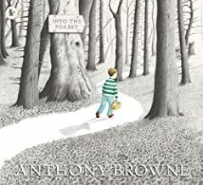  (Lost narrative and newspaper report)  The Lost Happy Endings – Carol Ann Duffy  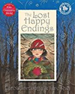  (Twisted narrative and newspaper report)  Iron Man – Ted Hughes  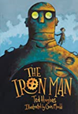  (Approaching threat narrative and explanation)  The Journey – Francesca Senna  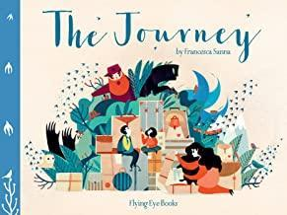  (Refugee narrative, diary recount)
Maths – Maths No Problem | Year 3:  Number and Place Value: Numbers to 1000  Calculations: Addition and Subtraction  Calculations: Multiplication and Division  Calculations: Further Multiplication and Division  Year 4:  Place Value - Numbers to 10,000  Calculations - Addition and Subtraction within 10,000  Calculations - Multiplication and Division  Calculations - Further Multiplication and Division | Year 3:  Measurement: Length  Measurement: Mass  Measurement: Volume  Measurement: Money  Measurement: Time  Year 4:  Statistics – Graphs  Calculations – Fractions  Measurement – time  Calculations - Decimals | Year 3:  Statistics: Picture and Bar Graphs  Fractions, decimals and percentages  Geometry: Angles  Geometry: Lines and Shapes  Measurement: Perimeter of figures.  Year 4:  Calculations – Money  Measurement – Mass, volume and length  Measurement - Area of figures  Geometry – angles, triangles, quadrilaterals, symmetry  Geometry – Position and Movement  Calculations – Roman Numerals
Science | Forces and magnets  Animals including humans – food,  nutrition, skeleton  Rocks  Light | Living things and their habitats  Plants: focus on life cycles.  Living things in their habitats- Habitats help  Plants | States of matter  Sound  Animals including humans  Electricity
Geography | Locational Knowledge of the UK  Geography of the first civilizations | Locational Knowledge of the UK  Geography of Egypt  How is the North West similar or different to the Naples Bay Region in Italy? | Locational Knowledge of the UK  Place Knowledge  Geography of Greece  Europe
History | Stone Age  Old & New Stone Age  Overview of early civilizations – Sumer, Indus, Egypt, China | Bronze Age to Iron Age  Egyptians | The Roman Empire & its Impact on Britain  Achievements of the Ancient Greeks
RE | Kingdom of God  God/incarnation  Good News  Incarnation | Christian Community  Resurrection  Creation  Salvation | Multi-Faith  Discipleship  World Religions  Holy Spirit
Art | Gestural Drawing with Charcoal  Making loose, gestural drawings with charcoal, and exploring drama and performance  Storytelling Through Drawing  Explore how artists create sequenced drawings to share and tell stories. Create accordian books or comic strips to retell poetry or prose through drawing | Cloth, Thread, Paint  Explore how artists combine media to create work in response to landscape. Use acrylic and thread to make a painted and stitched piece  Exploring Still Life  Explore artists working with the genre of still life, contemporary and more traditional. Create your own still life inspired art work | Festival Feasts  How might we use food and art to bring us together?  Making Animated Drawings  Explore how to create simple moving drawings by making paper “puppets” and animate them using tablets
D&T | Structures  Shell structures  Mechanical systems  Levers & linkages | Textiles  2D shape to 3D product  Food  Healthy & varied diet | Food  Healthy & varied diet  Electrical systems  Simple circuits & switches
Music | Stone Age  Countdown to Christmas  Peter and the wolf  Christmas singing | Planet Exploration  Painting a picture  Folk Music  Musical Recycling | Food fabulous food  Tasty Tunes  Meet and Greet  Say hello, wave goodbye
MFL | Greetings - Bonjour,  Monsieur, Madame, Au  revoir  Classroom commands x 8  Colours x 5  Christmas nouns x 6  Voici/Et | Name -Je m’appelle,  Comment t’appelles-tu?,  Comment tu t’appelles?  Colours x 6  Numbers – 0- 6  Pencil case items x 4  S’il vous plait, Merci  Oui, Non  Voici/Et | Numbers 7 - 12 Masculine animal x 5 Qu’est-ce que c’est? C’est Ce n’est pas Voyelle/Consonne
Computing | Online Safety  Coding  Spreadsheets  Coding  Online Safety  Spreadsheets | Touch Typing  Email  Branching Database  Writing for different audiences  Logo  Animation | Simulations  Graphing  Presenting (Google slides)  Effective Search  Hardware Investigation
P.E. | Tag Rugby (3)  Foundations  Indoor Athletics  Football (3)  Tag Rugby (4)  Unit 1: Distanced PE Fitness  Indoor Athletics  Hockey (3) | Unit 1: Dance (4)  Unit 1: Gymnastics (3)  Unit 2: Gymnastics (3)  Football (4)  Unit 1: Gymnastics (4)  Unit 1: Dance (3)  Unit 2: Gymnastics (4)  Intermediate Swimming | Athletics (4)  Handball (4)  Rounders (4)  Cricket (4)  Hockey (4)  Athletics (3)  Netball (4)  Tennis (4)
PHSE | Valuing Difference and Keeping Safe-  Body Differences  Families and friendships  Safe relationships  Respecting ourselves and others  My Happy Mind  Growing Up -Changes  Families and friendships  Safe relationships  Respecting ourselves and others  My Happy Mind | Valuing Difference and Keeping Safe-  Personal Space  Belonging to a community  Media literacy and Digital resilience  Money and Work Different jobs and skills  My Happy Mind  Growing Up -What is Puberty?  Belonging to a community  Media literacy and Digital resilience  Money and Work  My Happy Mind | Valuing Difference and Keeping Safe-  Help and Support  Physical health and Mental wellbeing  Growing and changing  Keeping safe  My Happy Mind  Growing Up -Healthy Relationships  Physical health and Mental wellbeing  Growing and changing  Keeping safe  My Happy Mind

Bridgemere C E Primary School
Years 5 and 6– Overview of two year rolling programme
Year A
Year B

Subject | Autumn | Spring | Summer
Literacy – Ready Steady Write | The Errand- Leo LaFleur  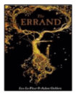  (Cliff hanger narrative, instruction – instruction manual)  Rose Blanche – Christophe Gallaz and Roberto Innocenti  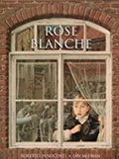  (Recount – diary, bravery speech award)  Hansel and Gretel – Neil Gaiman  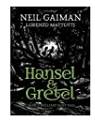  (Dual narrative – persuasion – letter)  FArTHER – Grahame Baker-Smith  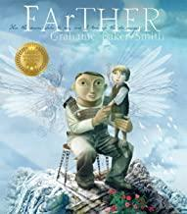  (Setting description and letters) | Shackleton’s Journey – William Grill  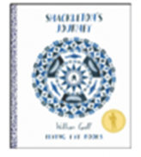  (Endurance narrative, recount – magazine article)  When we walked on the Moon- David Long  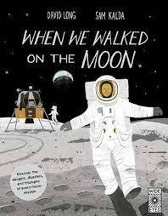  (Exploration narrative and formal mission log, to recount)  The Lost Book of Adventure – Teddy Keen  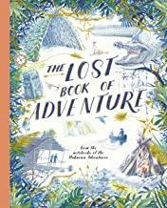  (Survival narrative, explanation – survival guide)  Wolf - Smriti Prasadam  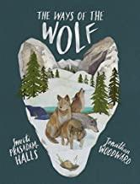  (First person narrative, balanced argument, information text – wolves) | King Kong – Anthony Browne  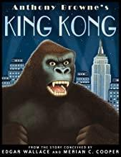  (Dilemma narrative, balanced argument)  The Origin of Species- Sabina Radeva  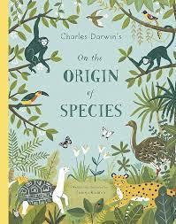  (Discovery narrative and adaptation, to explain)  The Promise – Nicola Davies  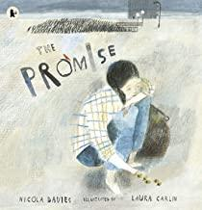  (Character narrative, news report)  The Hound of the Baskervilles – Arthur Conan Doyle  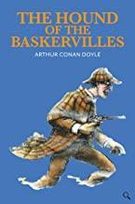  (Outsider narrative, information text, cliff-hangar narrative, formal event report)
Maths – Maths No Problem | Year 5:  Place Value - Numbers to 1,000,000  Calculations - Addition and Subtraction within 1,000,000  Calculations – Whole numbers - Multiplication and Division including squared and cubed numbers  Calculations – Multiplication and Division word problems  Statistics – Graphs  Year 6:  Place Value - Numbers to 10,000,000  Calculations - Addition and Subtraction within 10,000,000  Calculations – Whole numbers - Multiplication and Division including squared and cubed numbers  Measurement – Converting units of length, mass, volume and time  Calculations – Word problems | Year 5:  Calculations – Fractions  Calculations – Decimals  Calculations – Percentages  Statistics – Graphs  Geometry – Position and Movement  Year 6:  Calculations – Fractions, Decimals and Percentages  Calculations – Ratio and algebra  Geometry – Area and Perimeter  Geometry – Positon and  Movement  Revision for SAT’s | Year 5:  Geometry - Area and Perimeter  Measurement – Converting units of length, mass and time  Measurement - Volume  Geometry – Position and Movement  Calculations – Roman Numerals  Year 6:  Calculations - Negative  Numbers  Calculations – Word Problems
Science | Properties and changes of matter  Earth and Space  Living things and their habitats  Properties and changes of  materials | Forces  Living things and their habitats  Animals including humans  Light | Evolution and inheritance  Properties and changes of materials  – Sensational science.  Electricity  Animals including humans –  Medical manoeuvres
Geography | Anglo-Saxons, Scots and Vikings  Locational Knowledge  Geography of Shrewsbury | North & Central America  South America | Why are water and rivers so important?  Water cycle  Beeston Castle Stone Age to Modern Day
History | Anglo-Saxons, Scots and Vikings  Crime and Punishment Throughout time | Mayans | The impact of wars on the local area:  Civil War,  WW1 and WW2  Early Islamic civilization – contrast with British history  (2022-23 only)  Beeston Castle Stone Age to Modern Day – local history study  The King’s Coronation
RE | Kingdom of God  God/incarnation  Good News  Incarnation | Christian Community  Resurrection  Creation  Salvation | Multi-Faith  Discipleship  World Religions  Holy Spirit
Art | Typography & Maps  Exploring how we can create typography through drawing and design, and use our skills to create personal and highly visual maps  2D Drawing to 3D Making  Explore how 2D drawings can be transformed to 3D objects. Work towards a sculptural outcome or a graphic design outcome | Mixed Media Land & City Scapes  Explore how artists use a variety of media to capture spirit of the place  Activism  Explore how artists use their skills to speak on behalf of communities. Make art about things you care about | Architecture: Dream Big or Small?  Explore the responsibilities architects have to design us a better world. Make your own architectural model.  Brave Colour  Exploring how artists use light, form and colour to create immersive environments
D&T | Structures  Frame structures  Mechanical systems  Pulleys or gears | Food  Celebrating culture & seasonality  Textiles  Combining different fabric shapes | Electrical systems  More complex circuits & switches  Food  Celebrating culture & seasonality
MFL (French) | Shapes x 4  Colours x 11  Petit/grand  C’est  Ce n’est pas  Un/une | Colours x 14  Le, la, l’, les  Comme | Colour adjectives x 11  Adjectives of size x 4  Parts of the body x 15
Computing | Coding  Online Safety  Spreadsheets  Coding  Online Safety | Databases  Game Creator  Blogging  Text Adventures  Understanding Binary | 3D Modelling  Concept Maps  Word processing (google docs)  Network  Quizzing
Music | Improving colours  Stage and screen  Getting Loopy  Codebreakers | Vikings  Performance Poetry  Samba  Music from around the world | Your song  Newsbeat  Lights, camera, action  Sounds of the future
P.E. | Unit 2: Distanced PE Fitness  Tag Rugby (5)  Indoor Athletics  Football (5)  Hockey (5)  Tag Rugby (6)  Indoor Athletics  Basketball (5) | Unit 1: Gymnastics (5)  Unit 1: Dance (5)  Unit 2: Gymnastics (5)  Football (6)  Unit 1 Gymnastics (6)  Unit 1: Dance (6)  Unit 2: Gymnastics (6)  Advanced Swimming | Athletics (6)  Handball (6)  Rounders (6)  Cricket (6)  Hockey (6)  Athletics (5)  Netball (6)  Tennis (6)
PHSE | Puberty- Talking about Puberty  Families and friendships  Safe relationships  Respecting ourselves and others  Puberty, Relationships & Reproduction -Puberty & Reproduction  Families and friendships  Safe relationships  Respecting ourselves and others  My Happy Mind | Puberty- The Reproductive System  Belonging to a community  Media literacy and Digital  Money and Work  Puberty, Relationships & Reproduction-Communication in Relationships  Belonging to a community  Media literacy and Digital resilience  Money and Work  My Happy Mind | Puberty- Help and Support  Physical health and Mental wellbeing  Growing and changing Personal identity  Keeping safe  Puberty, Relationships & Reproduction-  Families, Conception & Pregnancy  Online Relationships  Physical health and Mental wellbeing  Growing and changing  Keeping safe  My Happy Mind

