Bridgemere CE (Aided) Primary School
Bridgemere Lane, Bridgemere, Nantwich, Cheshire, CW5 7PX

Executive Head Teacher – Mrs Beverley Dolman
Head of School – Mrs Caroline Middleton

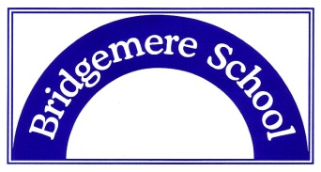 |  01270 520271   admin@bridgemerece.cheshire.sch.uk   www.bridgemereschool.co.uk   @BridgemereCE

31 July 2026

Dear Parents/carers

We have ordered some CGP Maths and English curriculum books which are year group specific to support your child’s learning at home. This is because a number of parents have informed us their children are spending too much time on screens or that they do not have a printer at home and their children enjoyed the packs we first sent home in March.
If your child is accessing school provision at Bridgemere the children’s books will remain in school as we will be working on these each day. If your child is only accessing part time provision in school we will still send the books home as we have spare resources we can use in school.

We have prepared a schedule of work for the next 5 weeks which you will find with the books. This schedule will be used both at school and at home so there is a consistency of what children are accessing across every year group.

We are therefore inviting you to collect your child’s books from school at the following time:

Day: Thursday 18th June

Please see times below:
Reception, Year 1, Year 2: 9.30-10.00am
Year 3, Year 4, Year 5, Year 6: 10.00-10.30am

Please drive into the parent car park. You will see myself and Mrs Rowley by the small gate with packs ready for collection. If you have children in more than one year group, we will have these ready together for you to collect.

If you are unable to attend on the day above, there will be one final opportunity to collect the books on Friday at: 9.15am- 9.45am

If you are unable to collect the books at all, please can you contact the school office directly.

Many thanks

Caroline Middleton
Head of School

