Bridgemere CE Primary  ‘I can do all things through Christ who strengthens me’  Philippians 4v13 Autumn Term 2023 20232023 |  |  | 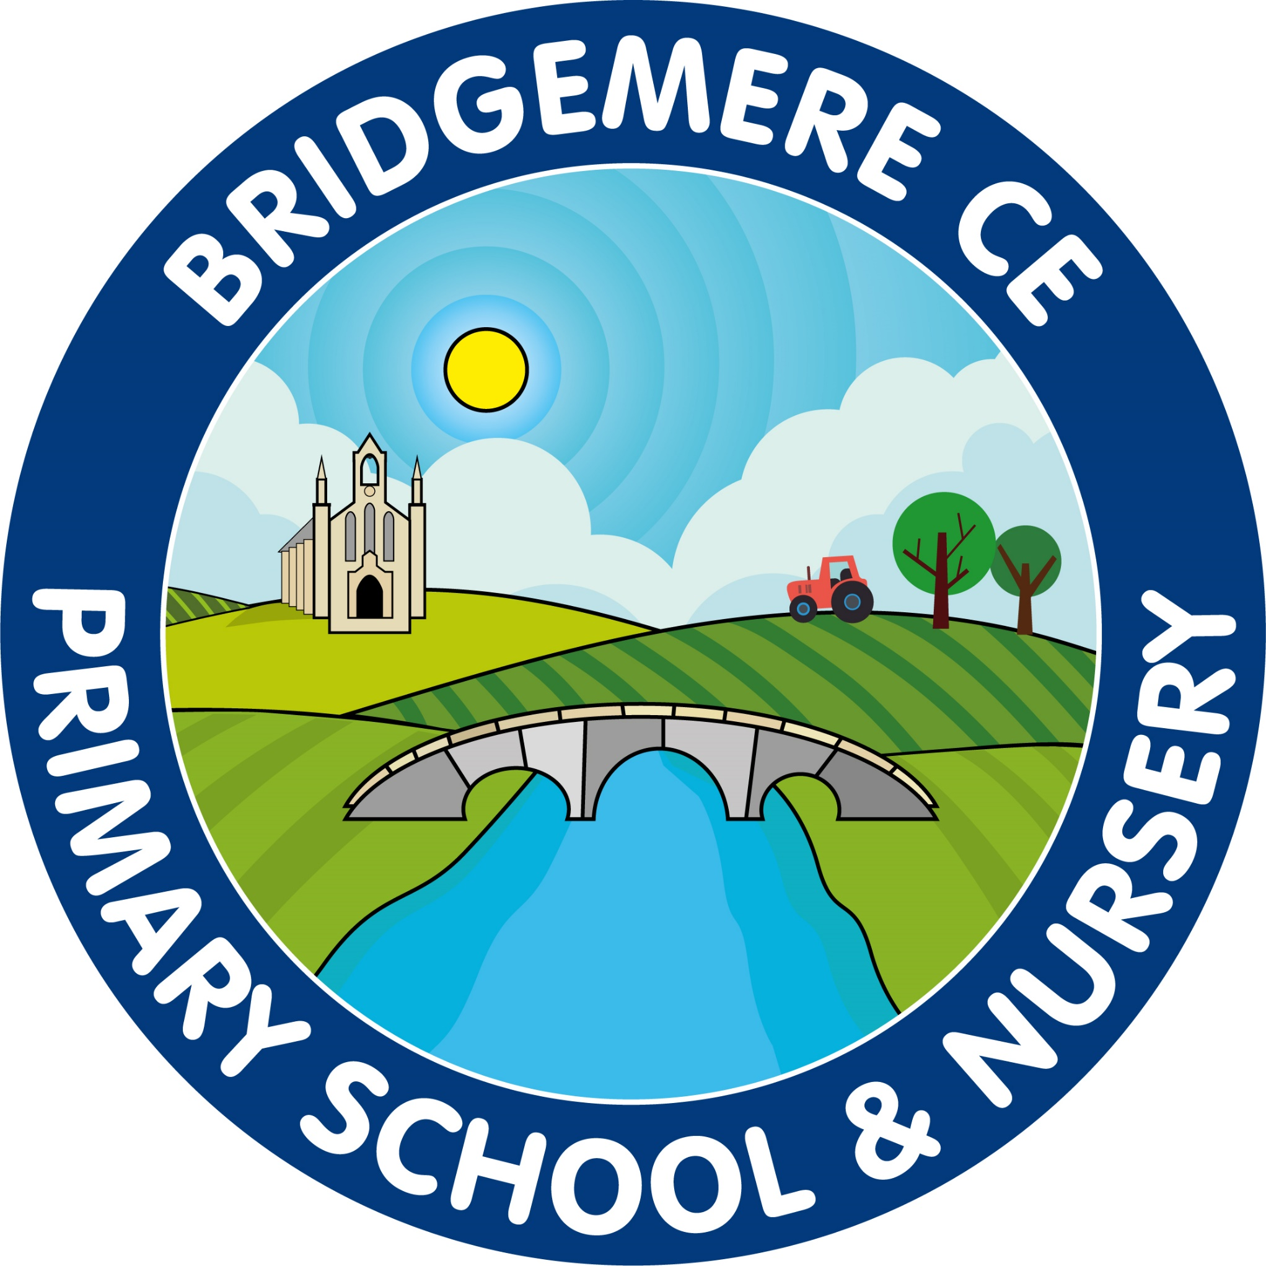
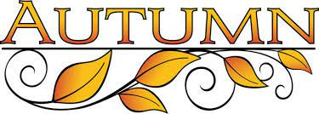  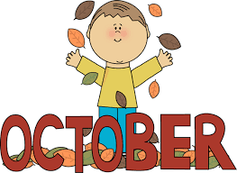  Class 1 – Parents’ Meeting  Monday 9th October 2-6pm  Harvest Service – St John’s Doddington  Harvest themed school lunch  Thursday 12th October 2pm  ‘Stay & Play’  Friday 13th October 9.00-10.15am  ‘Celebration of Learning’  Wednesday 18th October 3.00-3.34pm  Friends of Bridgemere – Cake sale  Thursday 19th October 3.15pm  Break up for half term  Friday 20th October  Staff Training Day –  Monday 30th October  Return to school  Tuesday 31st October    Read Write Inc Parent’s Meeting – Class 2  1st November 3.30pm Class 2  Bonfire themed school lunch  Friday 3rd November | Parents’ Meetings -Class 2, 3 & 4  Tuesday 7th November – online  4-6pm  Wednesday 8th November – in school 3.30-7pm  ‘Stay & Play’  Wednesday 15th November 9.00-10.15am  Book Fair  Thursday 16th November – 23rd November  Children in Need Day  Friday 17th November    Flu immunisations  Tuesday 5th December  Non-Uniform day – for Tombola Prizes for Christmas Fair  Friday 8th December  Nativity – Class 1 & 2  Tuesday 12th December 2pm  Nativity – Class 1 & 2  Wednesday 13th December 5pm  KS2 Carol Service –  Thursday 14th December at St John’s Doddington 2pm  ‘Stay & Play’  Friday 15th December 9.00-10.15am  Friends of Bridgemere – Christmas Fair  Friday 15th December  Whole school Panto visit –  Tuesday 19th December  Christmas lunch & parties  Break up for Christmas –  Thursday 21st December

