Bridgemere CE Primary School
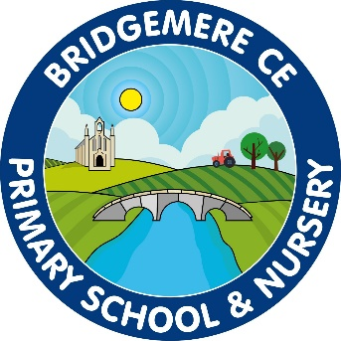

Assessment Policy

I can do all things through Christ who strengthens me’
Philippians 4 v 13

Confirmation that the Assessment Policy has been discussed and approved by the Staff and Governing Body.
March 2025

To be reviewed: March 2027

Bridgemere Primary School - Assessment Policy

Introduction:
Assessment is viewed as essential to, and an integral part of, effective teaching and learning. The purpose of assessment is to provide information to enable teachers to decide upon the next steps for children to take in order to make the best possible progress. This is assessment for learning, and supports the learning process in the short, medium and long term. The product of assessments and records of children’s attainment and achievement over time form an essential part of the school self evaluation process.

Through assessment, we aim:
- To gather a range of information about the performance of individuals, groups of pupils, cohorts, phases, key stages and whole school information so that it can be used to inform target setting at a range of levels and provide high teaching and learning for our pupils.
- To gather information to inform teachers as to what should be taught next for all children to succeed
- To ensure that assessment, recording and reporting is an integral part of the performance management system.
- To provide information to inform the school’s self evaluation process that will then be built into the school’s SID
- To track the individual progress of every child
.
We ensure our assessment procedures are:
- fit for their intended purpose
- used to focus on monitoring and supporting children’s progress, attainment and wider outcomes.
- reliable and free from bias and used to inform teaching and learning.
- informative and allow productive conversations with pupils and parents to take place
- supportive for our pupils to take responsibility for their own learning
- minimal in terms of additional workload required

Assessment will be used in the following ways:
- Formative (ongoing assessment) – marking, observations, discussions which may affect the next learning experience.
- Diagnostic – finding out what attitudes, knowledge, understanding and/or skills are not properly embedded or acquired and are therefore preventing pupils making the expected progress across the subject area.
- Evaluative – informing the strategic planning and direction of the whole school by evaluating the impact of planning, teaching and the curriculum on pupils’ achievements.
- Summative – systematic recording of information which provides a summary of where the pupils are working at a point in time. This is an essential tool for identifying progress over sustained periods of time.

Implementation of assessment:
At Bridgemere CE primary we have embedded a clear system of assessment to ensure all pupils are learning key knowledge.
The use of REACH is used:
Retrieval use of retrieval strategies to retain 5 essential pieces of key knowledge
Explain use of Kagan strategies to discuss 5 essential pieces of key knowledge
Access Vocabulary linked to oracy – speaking and listening opportunities
Complete everyone completing the same work
How much have I learnt? self / peer assessment /learning maps

This gives a consistent approach to assessment across all subjects.

Retrieval is used at the beginning and end of a lesson as an assessment tool and to embed learning.

“Let’s start with our rapid retrieval”

“Let’s finish with our rapid recall”


Children are given time to retrieve past learning or embed present learning using a range of different strategies:
Retrieval Practice:
- Daily warm up quizzes
Begin each class with a brief quiz covering previous lessons' key concepts.
Encourage students to recall information without referring to their notes.
- Peer teaching sessions
Assign students to pair up and take turns quizzing each other on specific topics.
This collaborative retrieval process reinforces memory through active recall.

Scaffolded Retrieval:
- Interactive Questioning Techniques
During discussions, use probing questions to guide students towards recalling relevant information.
Gradually reduce the level of scaffolding as students become more proficient.
- Structured Worksheets
Provide worksheets with partially completed sentences or questions that require students to fill in missing information.
This scaffolding supports memory retrieval while allowing for independent completion.

Kagan strategies are used to support learning and assessment.
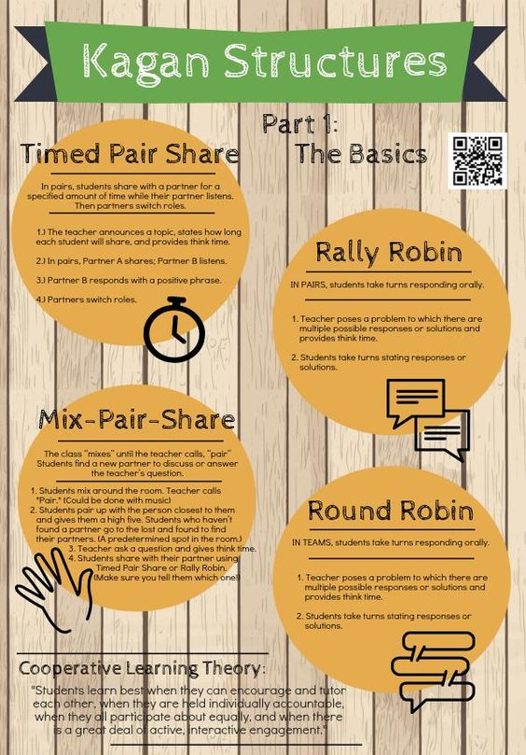

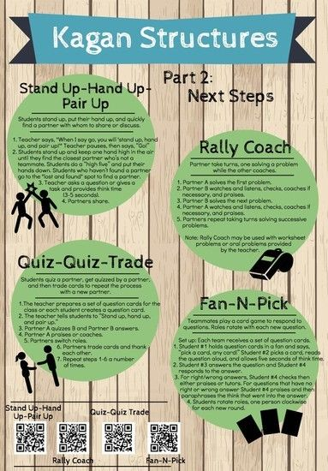

Assessment throughout the school:

Foundation Stage:
Within the first two weeks of school, there is a baseline assessment which enables a profile of a child to be made. After this point, all pupils are continuously assessed which informs the final judgement in all 7 areas and 13 strands of the curriculum. The children are tracked progressing through the early Years Foundation Stage Curriculum before transferring onto the ELGs (Early Learning Goals). The children will receive either an emerging or expected for all areas at the end of the year.

Statutory Assessments:

Year 1:
Pupils in Year 1 will sit a phonics screening test in June in which they endeavor to meet the externally set national standard.

Year 2:
There is now no expectation for pupils to sit formal tests in reading, spelling and grammar and mathematics.
At Bridgemere CE Primary we use these tests to support our ongoing teacher assessment.

Year 4:
Pupils in year 4 will sit a timetable test in June in which they endeavor to meet the externally set national standard.

Year 6:
Year 6 pupils sit formal tests in reading, spelling and grammar and mathematics. Science sampling could also be administered within randomly selected schools. These tests are externally marked and will provide a scaled score as an outcome following a raw score conversion.

In-school Assessments Year 1-6
The children will also sit tests for reading and mathematics. These are the Collins reading assessments and the Insight Maths assessments that take place twice a year in line with Singapore Maths scheme.
These tests will provide a standardised score and an age standardised score.
All other judgements are based on teacher assessment of the relevant year group curriculum objectives for each national curriculum subject.
In reading, from Year 2 onwards, children will also undertake Accelerated Reader STAR assessments each half term to track their reading progress and set new targets/book levels.

Monitoring and evaluation:

The Headteacher will ensure this policy is implemented consistently throughout the school using strategies such as discussion with teachers at half termly progress meetings, pupils and parents/carers, sampling pupil records and reports and sampling teacher’s planning and assessment records.

All assessment data is stored on the staff area and in an assessment file. This enables teachers and subject leaders to gain access to the wealth of data as and when required.

As a result of good assessments procedures:

Teachers will know:
- Where the pupils are starting from.
- Whether the class overall learned what was planned and taught
- Whether children are making sufficient progress in order to close the gap and reach national expectations
- Whether the pupils are making the progress expected to reach their challenging targets
- Whether pupils are applying their skills, knowledge and understanding across the curriculum
- Which pupils need more support and in which areas
- Whether planned activities are well resourced and staff are fully utilised to impact upon the progress that children make
- How the teaching can be modified and improved in the future

The SLT will know:
- If pupils are making the progress required for them to reach or exceed their targets
- Whether the progress of the children in the school is in line with the school targets set How the schools compare with other schools nationally
- What aspects of teaching and the curriculum need to be developed and strengthened to meet the needs of all children

Parents and carers will know:
- How much progress their child is making.
- If the school has any particular concerns about their child.
- What they can do to help their child to make progress.
- Whether the attainment of their child is in line, below or above the expected level for their age.

The Governing body and the LA will know:
- How the schools are performing in terms of progress/attainment and narrowing the gap in relation to national expectations.
- Attainment in the school in terms of scaled scores and teacher assessments at the end of KS2.
- How the schools compare with similar schools, and other local schools.

Reporting to parents

We have a range of strategies that keep parents fully informed of their child’s progress in school. We encourage parents to contact the school if they have concerns about any aspect of their child’s work.

During the autumn term and spring term, we hold Parents/Carers Meetings whereby a ten minute appointment is made for parents/carers and pupils to discuss progress and set future targets.
A report is sent to parents/carers at the end of the autumn and spring term that progress profile of their child based on their coverage of age related objectives and confirms discussion in the meeting.
In the Summer Term we write a report for parents. Parents are then welcome to meet with the class teacher on an open evening following the distribution of the report.

Feedback to pupils

We believe that feedback to pupils is very important, as it tells them how well they have done and what they need to do next in order to improve their work. We have an agreed policy for Marking and Presentation, as this ensures that we all mark consistently across the school.

Review

This policy will be reviewed by staff every 2 years.

Caroline Middleton

March 2025

